Home Learning – Puffins – Week 7
Hi Puffins,
I hope you and your families are all keeping safe and well. Here is the home learning for week 7. The sheets from this pack can be stuck into homework books if you wish.
Please do not feel pressured to complete every piece of home learning on the website, Purple Mash, MyMaths and Timestable Rockstars (year 2). Please do what works best for your child and family.

Purple Mash 2Dos:
Phonics – ie, ea, oy (click the speaker to sing along with Miss Chandler)

Maths – Measurement

PSHE – All about me & My emotions
As part of Mental Health Awareness Week. Official resources are attached below.
Maths – Units of Measure
Online MyMaths homework focuses on measure. BBC Bitesize (Measure):
https://www.bbc.co.uk/bitesize/topics/zt9k7ty/resources/1
https://www.bbc.co.uk/bitesize/topics/zt9k7ty/articles/zp8crdm
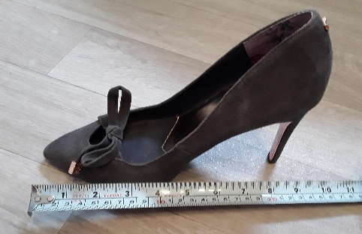
Can you measure items in your house? You can record this in your homework book and/or email me on Purplemash. You could take pictures and/or write your measurements down in a table, example:
Length | Measurement and Unit
Garden | 30m
Shoe | 25cm
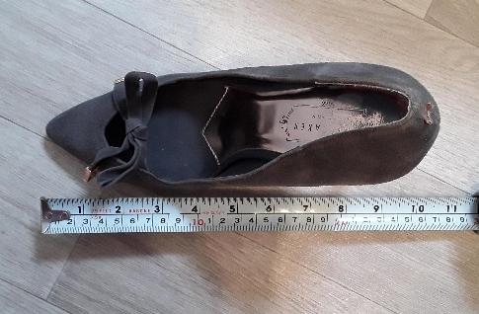
Here are some things you could measure at home:
Length – cm, m
- Stationary
- Room
- Garden
- Sofa
- Table
Weight – g, kg
- Ingredients when cooking/baking
- Fruit
- Stationary
- Toys
Capacity – ml, L
- Liquids when cooking/baking
- Cup of drink
- Watering plants
- Liquid in measuring jugs
Addition Methods +
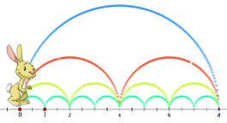

Choose a method to add and write in your homework book:
5g + 5g = 15cm + 4cm = 32ml + 25ml =

Subtraction Methods -
 |  | 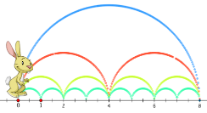 |  | 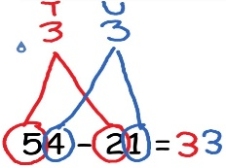

Choose a method to take away and write in your homework book:
8m - 3m = 18kg - 6kg = 40L – 25L =

Multiplication Methods x
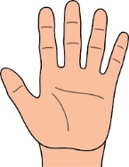

Choose a method to multiply and write in your homework book:
10 x 3 = 5 x 10 = 7 x 10 = 1 x 10 = 10 x 10 =

BBC Bitesize (10 times tables):
https://www.bbc.co.uk/bitesize/topics/zqbg87h/articles/zq3rk2p

Division Methods how many in each group?
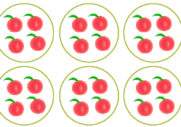

Choose a method to divide and write in your homework book:
30 ÷ 10 = 60 ÷ 10 = 20 ÷ 10 = 40 ÷ 10 =
Did you notice a pattern that helped you?
BBC Bitesize (division) https://www.bbc.co.uk/bitesize/topics/zqbg87h/articles/z9jxhv4
https://www.bbc.co.uk/bitesize/topics/zqbg87h/articles/z9pc8mn

English
Reading:
- Phonics 2Do on Purple Mash
- Re-read sentences to practice fluency and expression
- Highlight phonic sounds when reading
- Ask/answer comprehension questions about a book
- Read books, magazines, shopping lists, signs, subtitles, recipes
- Phonic games and activities - www.phonicsplay.co.uk where children can revise phase 3, phase 4 and phase 5 sounds.
Writing:
- Write spellings in sentences
- Remember: full stops, capital letters, finger spaces, handwriting
Spelling:
- Spellings – write in sentences
- Spellings – speed write (children have 1 minute to write one spelling word as many times as they can)
- Spellings – word search (template below)
Below are ALL the spellings for KS1. Please practice the highlighted words for this week.

KS1 Spellings
Year 1 Year 2
the  a  do  to  today  of  said  says  are  were  was  is  his  has  I  you  your  they  be  he  me  she | we  no  go  so  by  my  here  there  where  love  come  some  one  once  ask  friend  school  put  pull  full  house  our | door  floor  poor  because  find  kind  mind  behind  child  children  wild  climb  most  only  both  old  cold  gold  hold  every  everybody  even  great  break  steak  pretty  beautiful  after  fast  past  last | father  class  grass  pass  plant  path  bath  hour  move  prove  improve  sure  sugar  eye  could  would  should  who  whole  any  many  clothes  busy  people  water  again  half  money  Mr  Mrs  Parents  Christmas
Blank word search for spellings:
My Words Search

Words hidden in my word search
Science Topic – Plant Life
BBC Bitesize (KS1 Plants) https://www.bbc.co.uk/bitesize/topics/zpxnyrd
Your Mission: Miss Chandler needs your help. She would like to fill her garden with plants. BUT ... Miss Chandler has forgotten how to grow plants! She needs you to teach her, can you help?
Grow a plant: It would be great if you could grow something (flowers/vegetables/fruit) and take pictures to go in your book. Then you could show Miss Chandler when you are back at school.

WEEK 7: What could you measure?
- Height of plant (cm)
- How much are you watering your plant (ml)?

Research: Over the next few weeks, please research and answer these questions to help Miss Chandler:
- What do plants need to grow?
- What are the parts of a plant?
- What is the typical life cycle of a plant?
- How do plants reproduce?
- What is ‘germination'?
You may have other questions that you might want to research such as:
- If you grow a plant, where in the world does it grow naturally?
- What plants grow in the desert?
- Can plants grow in water? What plants?
- How do fruit and vegetables get to the shops? (You may wish to focus on 1 fruit or vegetable)
Presentation: Choose a way to present your work. This could be in your homework book or a portfolio. Here are some of the things you could put in your book; writing, typing, drawings, pictures, plant diary and anything else you think of.
If you have any questions related to any of the home learning tasks you can email me directly on Purple Mash. Many thanks and take care, Miss Chandler x

Mental Health Awareness Week; Kindness
May 18th- 24th 2020

Random Act of Kindness

You can pick from the list below or think of your own! Do one or more daily for MHAW.

- Tidy your room without being asked
- Wash someone's car
- Offer to make someone a cup of tea/ get them a drink
- Pick up leaves
- Pick up litter and throw it in the bin when you see it
- Post someone a letter, card or postcard to let them know you're thinking of them
- Call a relative, friend or neighbour
- Help set the table for dinner
- Write happy notes in chalk on the pavement to brighten someone's day
- Write thank you/appreciation notes to people who have helped you or been kind to you
- Help make dinner
- Draw a picture to brighten someone's day
- Load the dishwasher
- Help unpack the grocery shopping
- Make a friendship bracelet for a friend
- Pick something up if it's fallen on the floor
- Help tidy away
- Sharpen all the colouring pencils so they are ready to be used by someone else
- Feed your pet or clean out their cage without having to be told
- Read your little brother or sister a bedtime story
- Offer to walk your neighbour’s dog for them (only if your mum and dad say it’s okay and will go with you).
- Paint rocks with pretty pictures or positive sayings and hide them in your neighbourhood for other children to find.
- When you go shopping with your parent/ carer, choose an extra item of food to donate to a food bank (if your parent agrees to this too)
- Make bookmarks to give out at school or donate to your local library

What Kindness Means To You

Fill in and decorate our kindness hearts. You can do this on your own or in a group and create a kindness collage of all the things kindness means to you.

What kindness means to me….

Practice Kindness Towards Yourself

Self-compassion and kindness towards oneself if really important; it benefits our physical, mental and emotional wellbeing.

It's not always easy being kind to ourselves or putting our needs first but with practice this will help you to feel healthier and happier.

Here are some ideas of self-care activities to practice. See if you can practice every day of Mental Health Awareness Week and hopefully by the end of the week you will want to build it into your everyday routine:

- Have a bath or shower every day
- Make sure you have breakfast every day
- Limit the amount of time you spend on your phone/ using social media
- Connect with friends
- Let someone know/ ask for help if you are struggling
- Spend time doing a hobby or interest that you haven't done for a while
- Have an afternoon/ night off from studying
- Spend time doing activities that help relax you (e.g., listen to music)
- Get some fresh air or gentle exercise
- Try something new that you've always wanted to do (learn a new skill or hobby)
- Make a den
- Wash your hair
- Tidy and sort out your room (clean and organised paces can help make us feel calmer)
- Go to bed early and get a good night's sleep
- Be silly, do things that make you laugh
- Create a daily routine; get up and go to bed at similar times every day
- Plan things to look forward to
- Write down how you are feeling (e.g. diary, blog)
- Access self-help if you are struggling (www.hampshirecamhs.nhs.uk)
- Write a list of your positive qualities or things you are proud of; celebrate the uniqueness of you
- Unfollow or delete accounts/ apps that make you feel rubbish
- Make yourself a self-soothe coping box; https://youtu.be/OyfgodSSdV4
- Set yourself some goals to achieve (make sure they are realistic and achievable)
- Make a positive board; things that make you smile, motivate you or that make you feel good
- Look through photographs of fun times with friends and plan things to do with them
- Watch a favourite film, read a good book
- Bake or cook something with a friend or family member
- Spend time with a pet

Can you think of any others?

Kindness Pledge

Write down your pledge and display it for everyone to see!

This Mental Health Awareness Week, I pledge to be kind to others by….

Words of Kindness Activity

Complete this word search; how many words for kindness do you know?

K | A | L | Y | P | P | A | H | E | O | P | F | K | X | D
W | I | Z | E | O | D | S | U | T | C | A | R | E | J | A
E | P | N | N | J | G | A | G | E | D | E | I | C | L | H
B | X | F | D | N | U | T | S | M | Y | L | E | N | H | U
R | E | W | I | N | C | A | R | S | E | T | N | A | T | M
H | V | P | U | E | J | N | K | E | P | N | D | R | H | A
C | O | M | P | A | S | S | I | O | N | E | S | E | E | N
C | L | S | G | H | N | E | S | O | L | G | H | L | A | I
Z | E | D | T | Q | G | N | O | V | W | R | I | O | R | T
R | A | I | D | E | C | E | N | C | Y | I | P | T | T | Y
Y | T | O | G | E | T | H | E | R | B | R | F | C | S | P
E | G | N | I | D | N | A | T | S | R | E | D | N | U | M

Kindness Gentle Understanding
Love Tolerance Humanity
Compassion Coping
Care Happy
Friendship Together
Decency Heart
Respect Hugs

Use Your Words
Use the letters of the word Kindness to write a poem, a Kindness based acronym or just words associated with Kindness

K
I
N
D
N
E
S
S

Resources and Initiatives;

http://www.kindnessuk.com/ - you can request free School Kindness Packs (primary and secondary school) which are filled with ideas on how to spread kindness throughout your school.

https://acts.kindness.org/initiatives

https://thegreatkindnesschallenge.com/

https://www.actionforhappiness.org/

https://www.mentalhealth.org.uk/campaigns/mental-health-awareness-week

Video; Can I Help You With Anything? https://youtu.be/OBqfKUWaku8

Useful websites

All Subject Areas:
www.purplemash.com
Support videos and daily lessons -https://www.bbc.co.uk/bitesize/primary
Online lessons - https://www.thenational.academy/online-classroom/
English:
KS1 SATs - https://www.gov.uk/government/publications/key-stage-1-tests-2019-english-reading-test-materials
Phonics Revision - www.phonicsplay.co.uk
Maths:
KS1 SATs - https://www.gov.uk/government/publications/key-stage-1-tests-2019-mathematics-test-materials
Homework site - https://www.mymaths.co.uk/

