Kingfisher Class Home- Learning- Summer 1- Week 3
Kingfisher Class Home- Learning- Summer 1- Week 3- Maths
Monday:

Tuesday:

Wednesday:

Thursday:
Friday:

Kingfisher Class Home- Learning- Summer 1- Week 3- English
Monday:
Activity 1: You can either discuss the answers to the questions below with your family focussing on the picture or you can write your thoughts down.

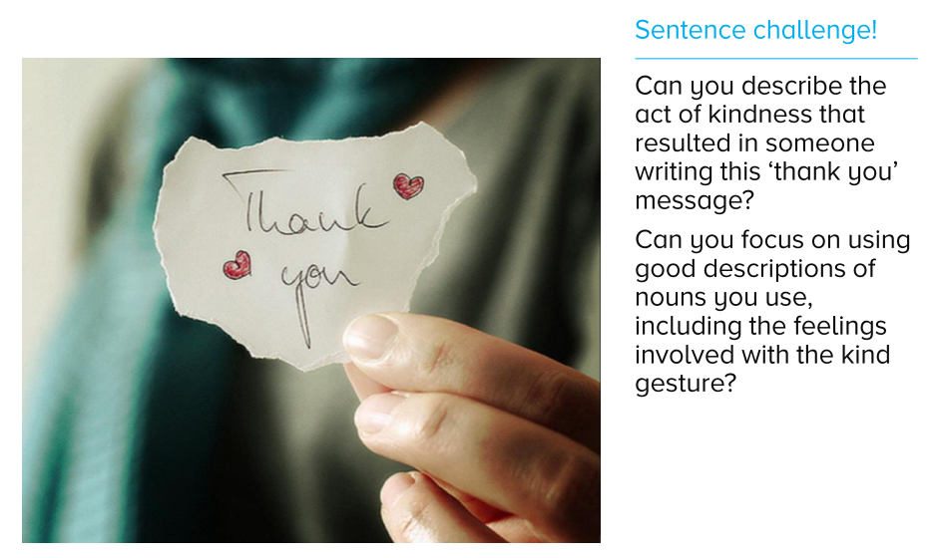
Activity 2: Please write your answers down for the next sentence challenge.
Activity 3: Please write your answers down and help Miss Brown improve the sentences below

Tuesday and Wednesday:
Can you remember the image I shared with you yesterday? This is actually an image from a story. Below I have given you a story starter yet I would like all of Kingfisher class to create the rest of the story. When we are back at school, we will be able to create our very own book with a title ‘Thank you’ with all of your different stories. I really cannot wait to read them and hear how unique they are. Take your time to plan, write, edit after each paragraph and write up in neat. You can use the computer to type up your best copy, if you would like to and have permission to. Please take your time on this, as I have given you two sessions.

Thursday:
To complete your story can you create your own front cover and back cover- containing a blur.

Friday:
On the next page, I have given you a snippet of another story and some questions. You can choose to read and answer the questions independently. Or read with your family and first answer the questions independently then discuss questions with your family. Please write your answers down neatly.

Friday: From ‘Listen to the Moon’ by Michael Morpurgo
Retrieving Information:
- Use a dictionary to find the definition of:
- fronds
- intently
- perplexed
- Find and copy a word that shows the noise that Alfie hears is a sad one.
- What is the relationship between Jim and Alfie?
Making Inferences:
- How do you know that Alfie spends a lot a time out on the coast?
- Have Alfie and Jim just arrived or have they been out for a while? How do you know?
- Why do you think that Alfie whispers to his father at the end of the extract?
Writer’s choices:
- Why do you think the writer has started with the line, “It was a long while later that Alfie first heard it.”? What mood does this create?
- Why do you think the author describes the weed as “waving mockingly”?
Challenge question:
- Why might Jim think that is not possible for a child to be on the island?

Kingfisher Class Home- Learning- Summer 1- Week 3- Foundation Subjects
Science
This term our new Science topic is ‘Light and Sound’. Just like we do at School, I would like you to create a front cover to start this new topic. I don’t mind if you do this on computer or by hand, that is your choice but I would really like you to think how you could present it, so it can be the best Science front cover of the year.

Topic
For this activity you will need someone else from your family to join in.
This is a drawing activity, so please make sure you have your equipment ready.
Without looking at anyone else’s drawings, I would like you all to draw a Mountain; however you only have five minutes to do so. (Read the rest of the instructions after the five minutes).

When the time is up, you all have to show your mountain pictures to each other. What are the similarities? What are the differences?
My question is... do all mountains look the same? Can you research at least two mountains, draw them to your best ability and label all the similarities and differences the mountains have. I cannot wait to see these so I can learn even more about mountains from you.

DT

ART
Please try this lesson if you have access to chalk and you tube so you can create something that looks like this (or even better!):
https://www.youtube.com/watch?v=nMiyNwQJ13w
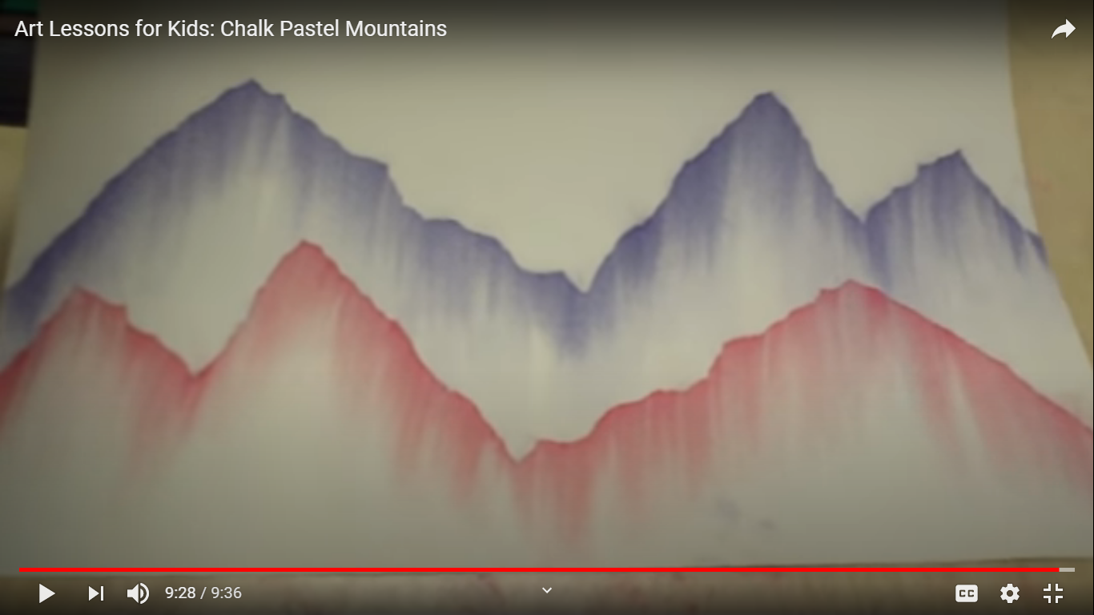

RE
‘In the beginning, God created the heavens and the earth’ (Genesis 1:1)- Can you draw a picture to support the reader to understand what it might of been like. Can you add a piece of music that might support this image?

PE

PSHE
Read and finish the sentences in the balloons below.

Miss Brown’s quote of the week.

Music
Learn and perform the song -‘you’ve got a friend’ to a small audience.

Computing
Please log on to Purple Mash to see the 2do’s set for the week (Please do at least one 2do- Make sure you press the ‘hand in’ button so that I am able to give you feedback). Also, remember to log onto My Maths weekly and practise times tables on Times tables Rockstars.

French
This lesson you will be able to create your own French Weather Fortune Teller.
Please take time to learn the French weather vocabulary, as it will help you in next week’s French lesson.
Just to let you know that I have planned a lot of activities but please don’t feel pressured to do them all. Do what is right for you and your family. I would rather you have too much then too little but it doesn’t mean you have to complete everything or you can save it for when you feel like doing something to keep you occupied. Please get outside in the fresh air if you can, in a safe way and be helpful to your family. Remember you can use the National Oak Academy lessons if you wish to, using this website: https://www.thenational.academy/online-classroom/schedule From Miss Brown

