Home Learning – Puffins – Week 6
Hi Puffins,
I hope you and your families are all keeping safe and well. Here is the home learning for week 6. The sheets from this pack can be stuck into homework books if you wish.
Please do not feel pressured to complete every piece of home learning on the website, Purple Mash, MyMaths and Timestable Rockstars (year 2). Please do what works best for the children and your family.

Purple Mash 2Dos:
Phonics – ay, ou (click the speaker to sing with Miss Chandler)

Maths – 2D & 3D sorting Game and 3D Shape Properties

Science – All about Germination

Maths
Online MyMaths homework for the next 2 weeks focuses on shape. There are 4 shape tasks that get progressively harder. BBC Bitesize support videos and tasks: https://www.bbc.co.uk/bitesize/topics/zjv39j6 (shape)

Addition Methods +
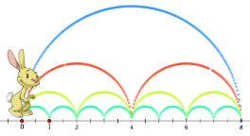

Choose a method to add and write in your homework book:
5 + 1 + 2 = 15 + 5 + 1 = 30 + 9 + 15 =

Subtraction Methods -
 |  | 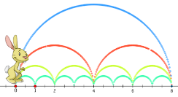 |  | 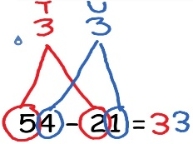

Choose a method to take away and write in your homework book:
8 – 3 – 3 = 18 – 6 – 1 = 40 – 6 – 21 =

Multiplication Methods x
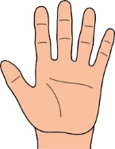

Choose a method to multiply and write in your homework book:
5 x 2 = 3 x 5 = 7 x 5 = 1 x 5 = 10 x 5 =

BBC Bitesize support videos and tasks: https://www.bbc.co.uk/bitesize/topics/zqbg87h/articles/zw8qxfr

Division Methods how many in each group?
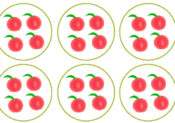

Choose a method to divide and write in your homework book:
6 ÷ 2 = 10 ÷ 2 = 18 ÷ 2 = 20 ÷ 2 =

BBC Bitesize support videos and tasks: https://www.bbc.co.uk/bitesize/topics/zqbg87h/articles/z9jxhv4
https://www.bbc.co.uk/bitesize/topics/zqbg87h/articles/z9pc8mn

English
Reading:
- Phonics 2Do on Purple Mash
- Re-read sentences to practice fluency and expression
- Highlight phonic sounds when reading
- Ask/answer comprehension questions about a book
- Read books, magazines, shopping lists, signs, subtitles, recipes
- Phonic games and activities - www.phonicsplay.co.uk where children can revise phase 3, phase 4 and phase 5 sounds.
Writing:
- Write spellings in sentences
- Remember: full stops, capital letters, finger spaces, handwriting
Spelling:
- Spellings – write in sentences
- Spellings – speed write (children have 1 minute to write one spelling word as many times as they can)
- Spellings – word search (template below)
Below are ALL the spellings for KS1. Please practice the highlighted words for this week.

KS1 Spellings
Year 1 Year 2
the  a  do  to  today  of  said  says  are  were  was  is  his  has  I  you  your  they  be  he  me  she | we  no  go  so  by  my  here  there  where  love  come  some  one  once  ask  friend  school  put  pull  full  house  our | door  floor  poor  because  find  kind  mind  behind  child  children  wild  climb  most  only  both  old  cold  gold  hold  every  everybody  even  great  break  steak  pretty  beautiful  after  fast  past  last | father  class  grass  pass  plant  path  bath  hour  move  prove  improve  sure  sugar  eye  could  would  should  who  whole  any  many  clothes  busy  people  water  again  half  money  Mr  Mrs  Parents  Christmas
Blank word search for spellings:
My Words Search

Words hidden in my word search
Science Topic – Plant Life
BBC Bitesize (KS1 Plants) https://www.bbc.co.uk/bitesize/topics/zpxnyrd
Your Mission: Miss Chandler needs your help. She would like to fill her garden with plants. BUT ... Miss Chandler has forgotten how to grow plants! She needs you to teach her, can you help?
Grow a plant: It would be great if you could grow something (flowers/vegetables/fruit) and take pictures to go in your book. Then you could show Miss Chandler when you are back at school.
Research: Over the next few weeks, please research and answer these questions to help Miss Chandler:
- What do plants need to grow?
- What are the parts of a plant?
- What is the typical life cycle of a plant?
- How do plants reproduce?
- What is ‘germination'?
You may have other questions that you might want to research such as:
- If you grow a plant, where in the world does it grow naturally?
- What plants grow in the desert?
- Can plants grow in water? What plants?
- How do fruit and vegetables get to the shops? (You may wish to focus on 1 fruit or vegetable)
Presentation: Choose a way to present your work. This could be in your homework book or a portfolio. Here are some of the things you could put in your book; writing, typing, drawings, pictures, plant diary and anything else you think of.

If you have any questions related to any of the home learning tasks you can now email me directly on Purple Mash.
Many thanks and take care,
Miss Chandler
Useful websites

All Subject Areas:
www.purplemash.com
Support videos and daily lessons -https://www.bbc.co.uk/bitesize/primary
Online lessons - https://www.thenational.academy/online-classroom/
English:
KS1 SATs - https://www.gov.uk/government/publications/key-stage-1-tests-2019-english-reading-test-materials
Phonics Revision - www.phonicsplay.co.uk
Maths:
KS1 SATs - https://www.gov.uk/government/publications/key-stage-1-tests-2019-mathematics-test-materials
Homework site - https://www.mymaths.co.uk/

