Home Learning – Puffins – Week 12
Hi Puffins,
I hope you and your families are all keeping safe and well. Here is the home learning for week 12. The sheets from this pack can be stuck into homework books if you wish.

Purple Mash 2Dos:
Phonics – a-e, e-e, i-e (click the speaker to sing along with Miss Chandler)

Song of Sounds Stage 2: https://m.youtube.com/watch?v=6UQHdBMLk-M
Song of Sounds Stage 3: https://m.youtube.com/watch?v=Gwluz7yHW0g

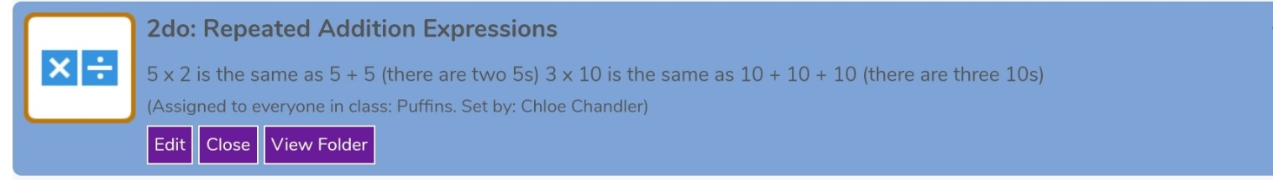
Maths – Repeated Addition

MyMaths Timetable
Week 11: Place Value tens and ones
Week 12: Number bonds to 10 and 20
Week 13: Commutativity: Multiplication
Week 14: Mixed Tables 2, 5, 10
Week 15: Patterns and Sequences

Maths – Multiplication as Repeated Addition
BBC Bitesize (repeated addition Teaching Video): https://www.bbc.co.uk/bitesize/articles/zn7kwty
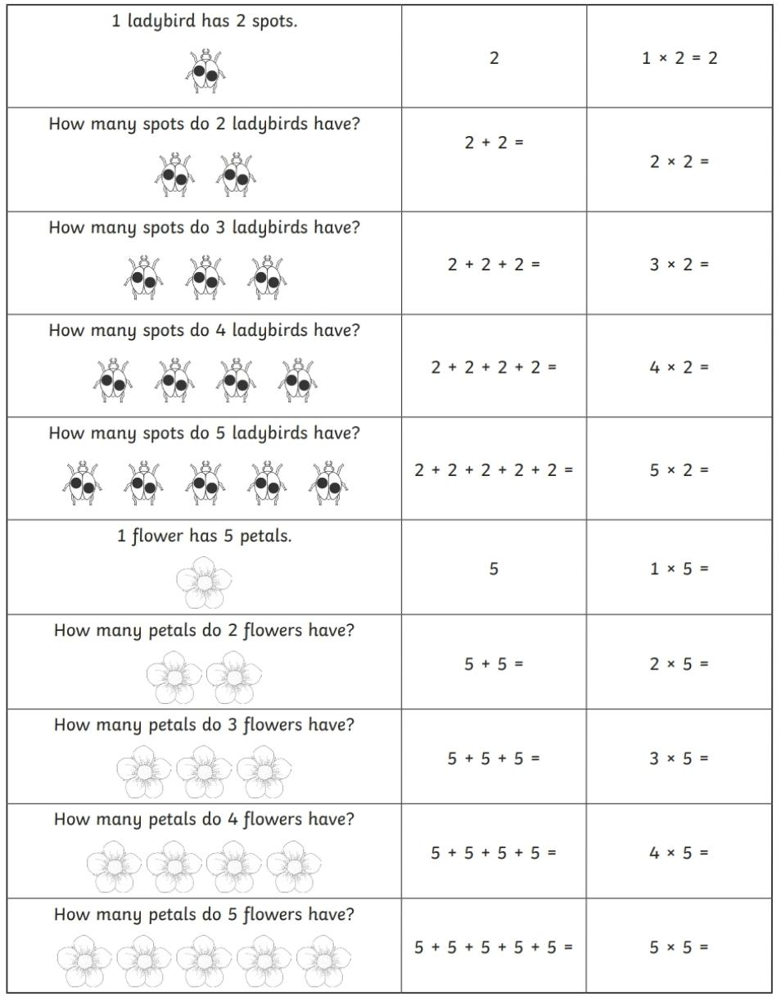
Year 1
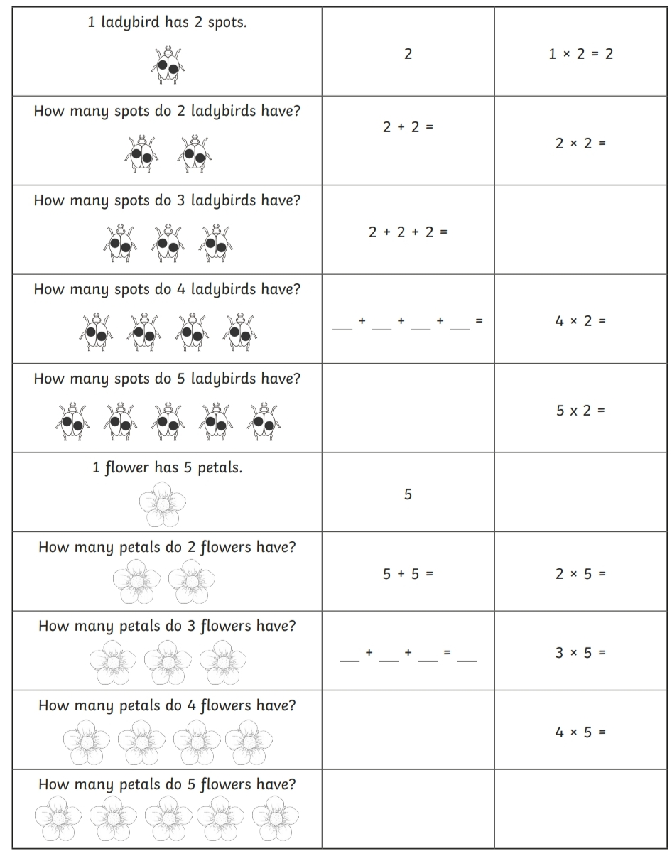
Year 2

Addition Methods +
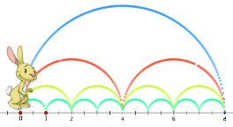
Choose a method to add and write in your homework book:
5 + 5 + 5 = 2 + 2 + 2 + 2 = 10 + 10 + 10 =

Subtraction Methods -
 |  | 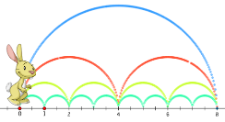 |  | 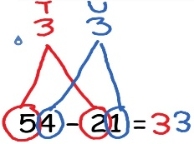
Choose a method to take away and write in your homework book:
20 – 3 – 2 = 34 – 4 – 2 = 69 – 11 – 8 =

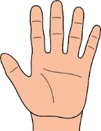
Multiplication Methods x

Choose a method to multiply and write in your homework book:
Write 5 + 5 + 5 + 5 = as a multiplication sentence _____________________
Write 2 + 2 + 2 = as a multiplication sentence _____________________
Write 10 + 10 + 10 + 10 + 10 = as a multiplication sentence _____________________

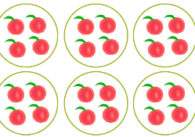
Division Methods how many in each group?

Choose a method to divide and write in your homework book:
25 ÷ 5 = 60 ÷ 10 = 12 ÷ 2 =

English
Reading:
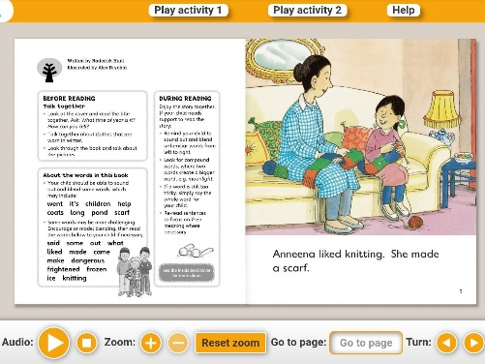
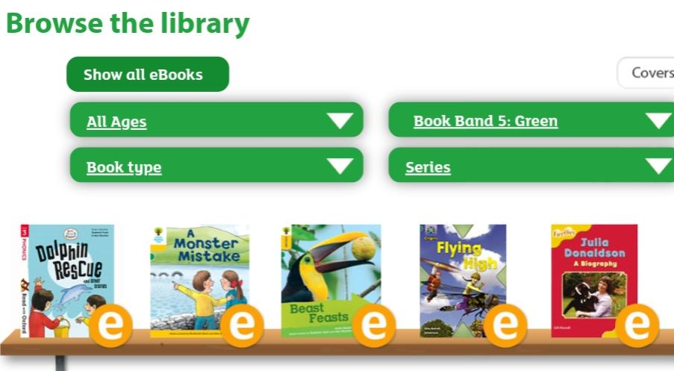
- Oxford Owl books https://www.oxfordowl.co.uk/for-home/find-a-book/library-page/
Filter by book band colour

- Phonics 2Do on Purple Mash
- Re-read sentences to practice fluency and expression
- Highlight phonic sounds when reading
- Ask/answer comprehension questions about a book
- Read books, magazines, shopping lists, signs, subtitles, recipes
- Phonic games and activities - www.phonicsplay.co.uk (phase 3-5 sounds).
Writing:
- Write spellings in sentences
- Remember: full stops, capital letters, finger spaces, handwriting
Spelling:
- Spellings – write in sentences
- Spellings – speed write (children have 1 minute to write one spelling word as many times as they can)
- Spellings – word search (template below)
Below are ALL the spellings for KS1. Please practice the highlighted words for this week.
KS1 Spellings
Year 1 Year 2
the  a  do  to  today  of  said  says  are  were  was  is  his  has  I  you  your  they  be  he  me  she | we  no  go  so  by  my  here  there  where  love  come  some  one  once  ask  friend  school  put  pull  full  house  our | door  floor  poor  because  find  kind  mind  behind  child  children  wild  climb  most  only  both  old  cold  gold  hold  every  everybody  even  great  break  steak  pretty  beautiful  after  fast  past  last | father  class  grass  pass  plant  path  bath  hour  move  prove  improve  sure  sugar  eye  could  would  should  who  whole  any  many  clothes  busy  people  water  again  half  money  Mr  Mrs  Parents  Christmas
Spelling Tests
Year 1: You will have a spelling test in school
Year 2: I will create weekly Spelling Test videos on Google Classroom.

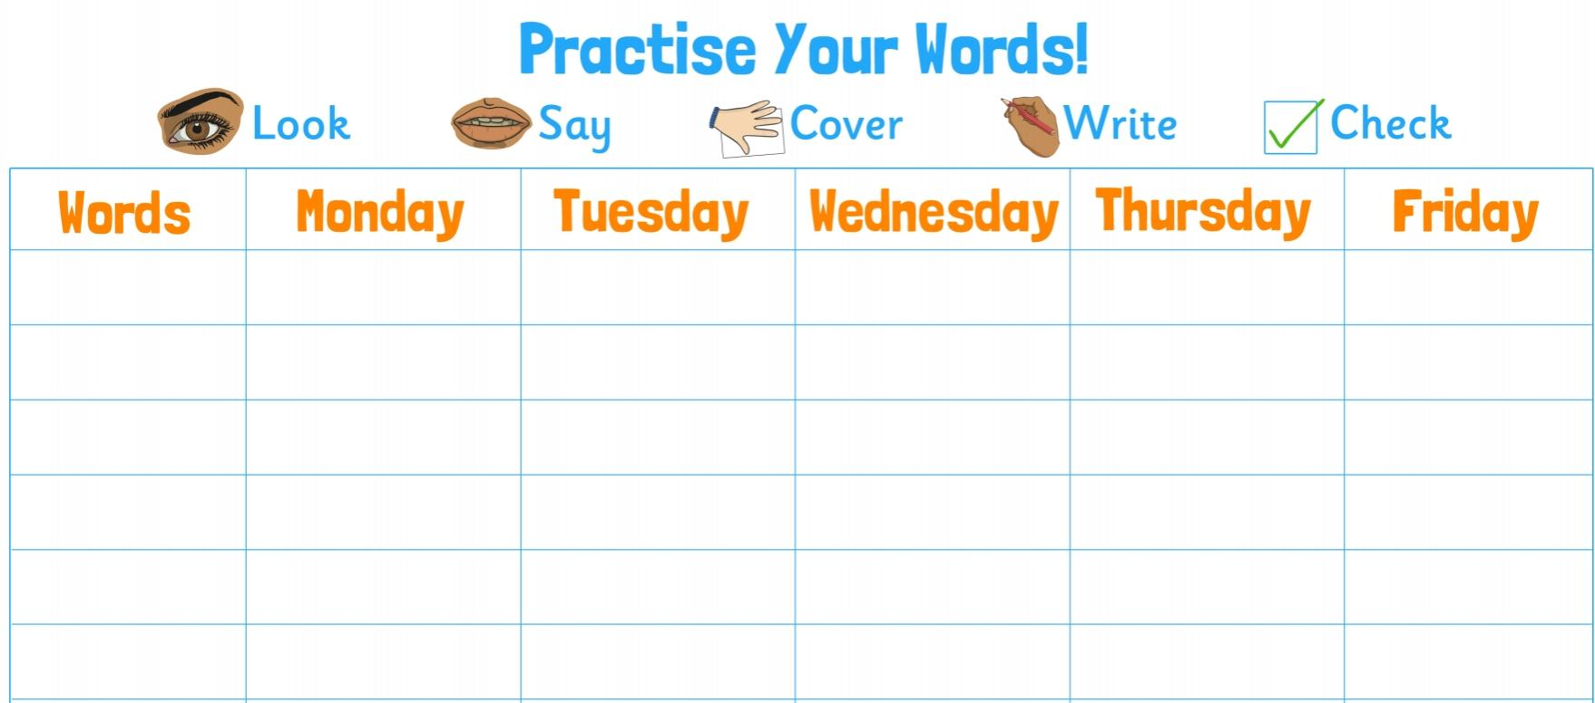

Blank word search for spellings:
My Words Search

Words hidden in my word search

Geography – Matching OS Map Symbols
Remember: A symbol on a map represents the location of human and physical features
Cut out and match each symbol with the correct picture. You will use some of these symbols next week to make your own map.
Extension task: Research other symbols local to where you live.
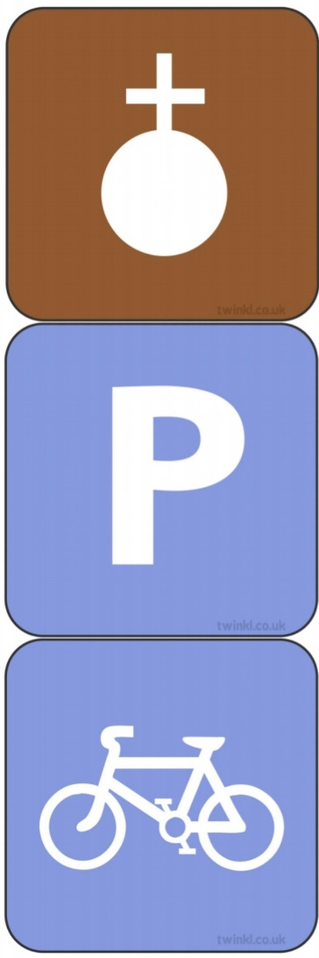
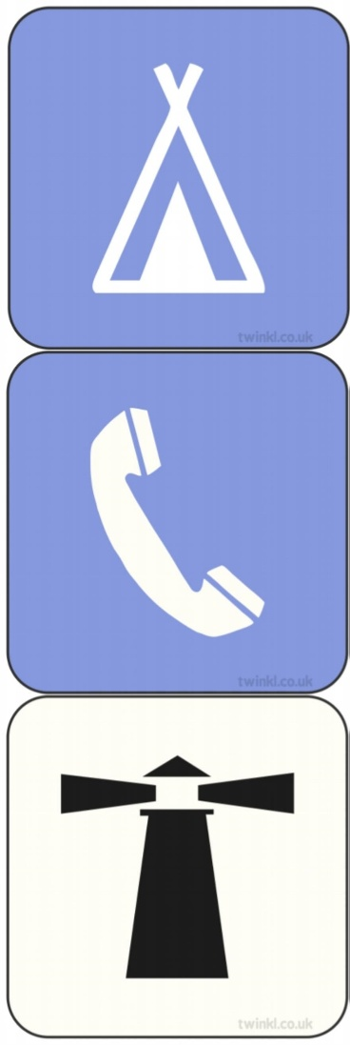
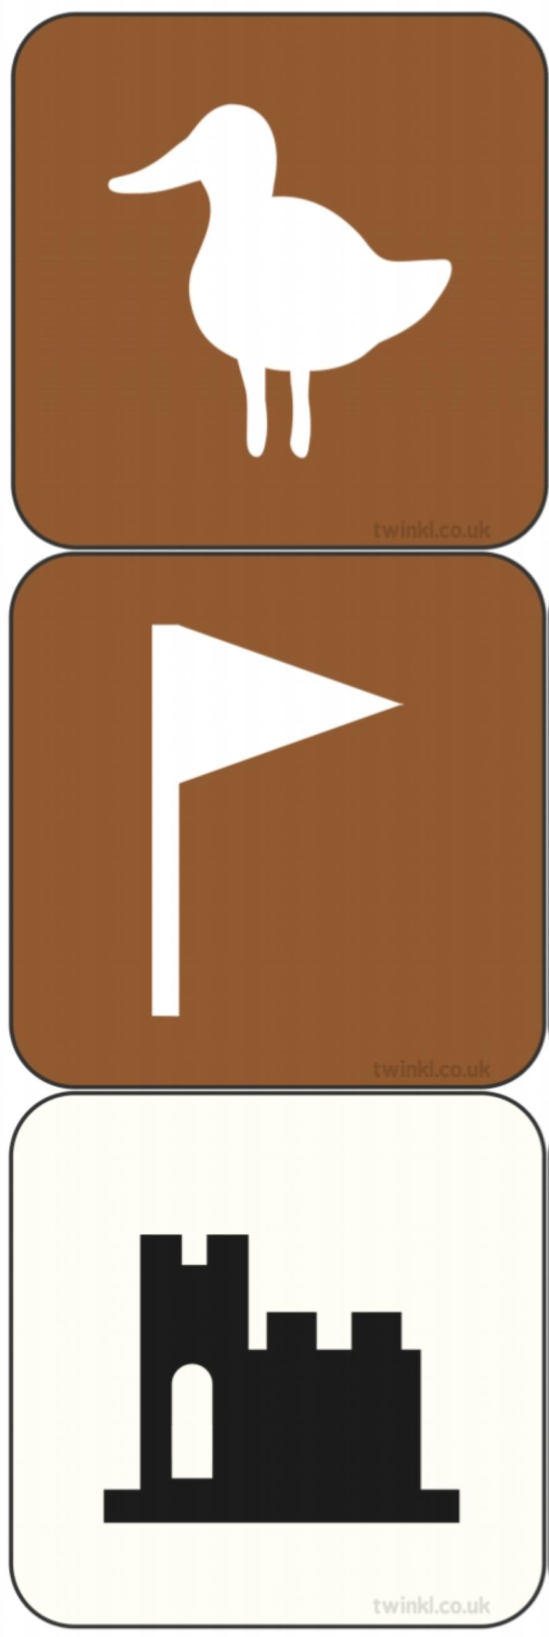

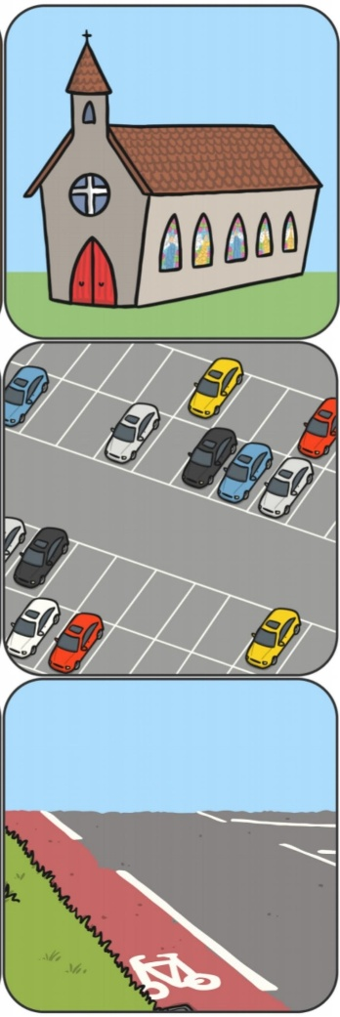
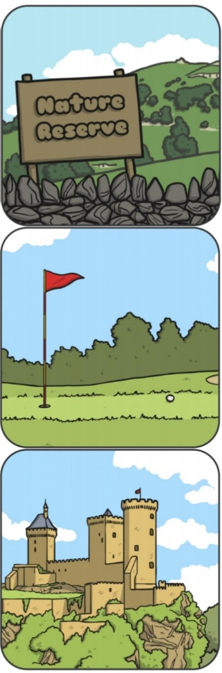

Useful websites

All Subject Areas:
www.purplemash.com
Support videos and daily lessons -https://www.bbc.co.uk/bitesize/primary
Online lessons - https://www.thenational.academy/online-classroom/
English:
Oxford Owl - https://www.oxfordowl.co.uk/for-home/find-a-book/library-page/
KS1 SATs - https://www.gov.uk/government/publications/key-stage-1-tests-2019-english-reading-test-materials
Phonics Revision - www.phonicsplay.co.uk
Maths:
KS1 SATs - https://www.gov.uk/government/publications/key-stage-1-tests-2019-mathematics-test-materials
Homework site - https://www.mymaths.co.uk/

