Robin’s Home Learning Work

Maths

Please complete the following tasks.

1. Continue to practise your times tables on Times Table Rockstars.

2. Please complete the following worksheets (on the next few pages). Please then rate how you found the worksheets using the smiley system (on some of the worksheets).

Please also check MyMaths for any set tasks.

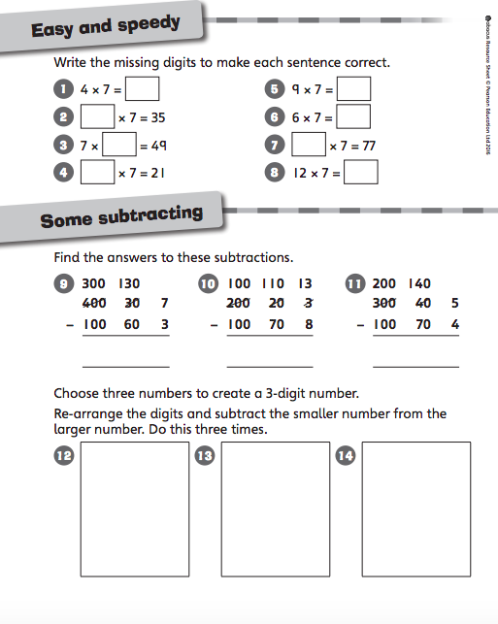

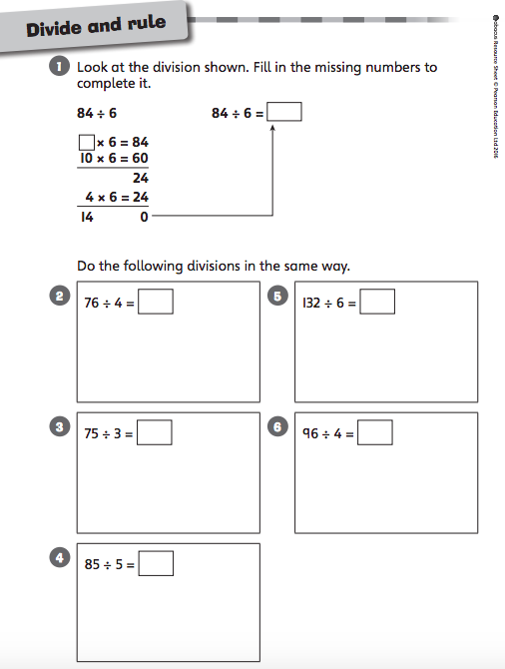

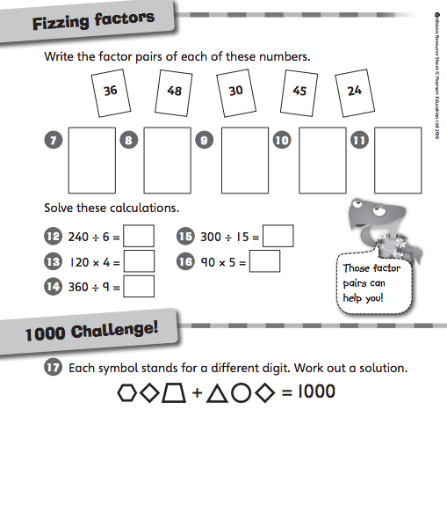

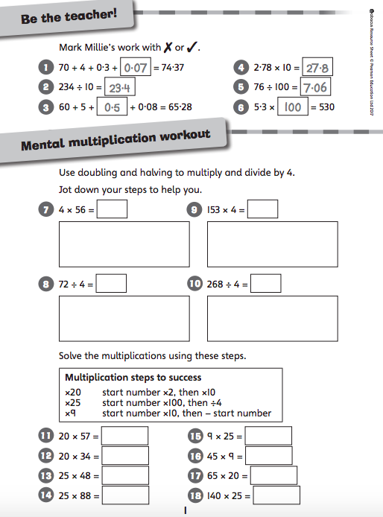

English – Writing

Please complete the following tasks.

1. Create a mind-map of different modal verbs (you will need to research them) and find out how they are used. Then use the modal verbs to write sentences about Darkus, Dr. Barty Cuttle and Lucretia Cutter.
For example, Darkus might be able to save his Dad from the dreadful Lucretia Cutter. (Please highlight your modal verbs).

2. Choose a character from Beetle Boy and write a character description. Remember to this about emotive language and how you want your reader to feel about them after reading your description.

3. Use the planning format (on the next page) to plan your persuasive letter to the police persuading them to arrest Lucretia Cutter. You will be writing from Darkus’ point of view. Remember to think about your choice of vocabulary, use emotive language!

Purpose:
Audience:
Form:
Conventions of Letters:
Vocabulary:
English – Reading

Please complete the following tasks.

1. Think about the narrative of Beetle Boy. Choose key events from the story and create a diamond nine. Put the event that you think is the most significant at the top and the event that you think is least significant at the end. Then please write a few sentences explaining your choices.

2. Make sure that you are reading to an adult at least twice a week and recording this in your reading record.

3. If you have not completed your story wings, complete at least one story wings task.

Science

Please complete the following task.

1. Research the question ‘How Do Plants Reproduce?’ Then present your findings. This should include a labelled diagram of all of the scientific parts of a flower (pollen, petal, anther, filament, sepal, stigma, style, ovary, ovule and stem).

Geography

Please complete the following tasks.

1. Research the tundra biome. What is it like to live in this biome? Which countries are located in this biome? How does this biome affect vegetation, animals, jobs and people?

2. Choose an animal from the tundra biome. Draw a picture of it and label it with how it has adapted to live in the tundra biome.

Food Technology

Please complete the following task.

1. Create your healthy snack and evaluate it based on taste, texture, smell, and sight. Remember to take photos!

ICT

Please check Purple Mash using your log-in for any 2-Dos.

Evaluation of my healthy snack

Star Rating:

Taste/Texture:

Did my snack look and smell appealing?

What went well?

What difficulties did you have?

Please either draw a picture of your healthy snack or stick in a picture.

French

Please complete the following task.

1. Using the window template below, please draw a picture that represents the weather you might find in each season. You should then research the French vocabulary to label the different types of weather.

Spring | Summer
Autumn | Winter

Useful Websites

Maths

https://ttrockstars.com/

https://www.topmarks.co.uk/maths-games/hit-the-button

Spelling

https://www.topmarks.co.uk/english-games/7-11-years/spelling-and-grammar

https://www.purplemash.com/sch/preston-rg25

Science

https://www.scienceabc.com/nature/how-do-plants-reproduce.html

https://www.bbc.co.uk/bitesize/guides/zykp34j/revision/1

https://www.bbc.co.uk/bitesize/topics/zgssgk7/articles/zqbcxfr

Geography

https://www.bbc.co.uk/bitesize/guides/zpkbp39/revision/1

https://www.bbc.co.uk/bitesize/topics/z849q6f/articles/zvsp92p

https://earthobservatory.nasa.gov/experiments/biome/biotundra.php

https://www.nationalgeographic.com/environment/habitats/tundra-biome/

