Home Learning – Puffins – Week 9
Hi Puffins,
I hope you and your families are all keeping safe and well. Here is the home learning for week 9. The sheets from this pack can be stuck into homework books if you wish.
Please do not feel pressured to complete every piece of home learning on the website, Purple Mash, MyMaths and Timestable Rockstars (year 2). Please do what works best for your child and family.

Purple Mash 2Dos:
Phonics – aw, ew (click the speaker to sing along with Miss Chandler)

Maths – Data Handling

Geography – World Tour Destinations

Maths – Data Handling (statistics)
Online MyMaths homework focuses on Statistics. BBC Bitesize (Data Handling): https://www.bbc.co.uk/bitesize/clips/zkf34wx
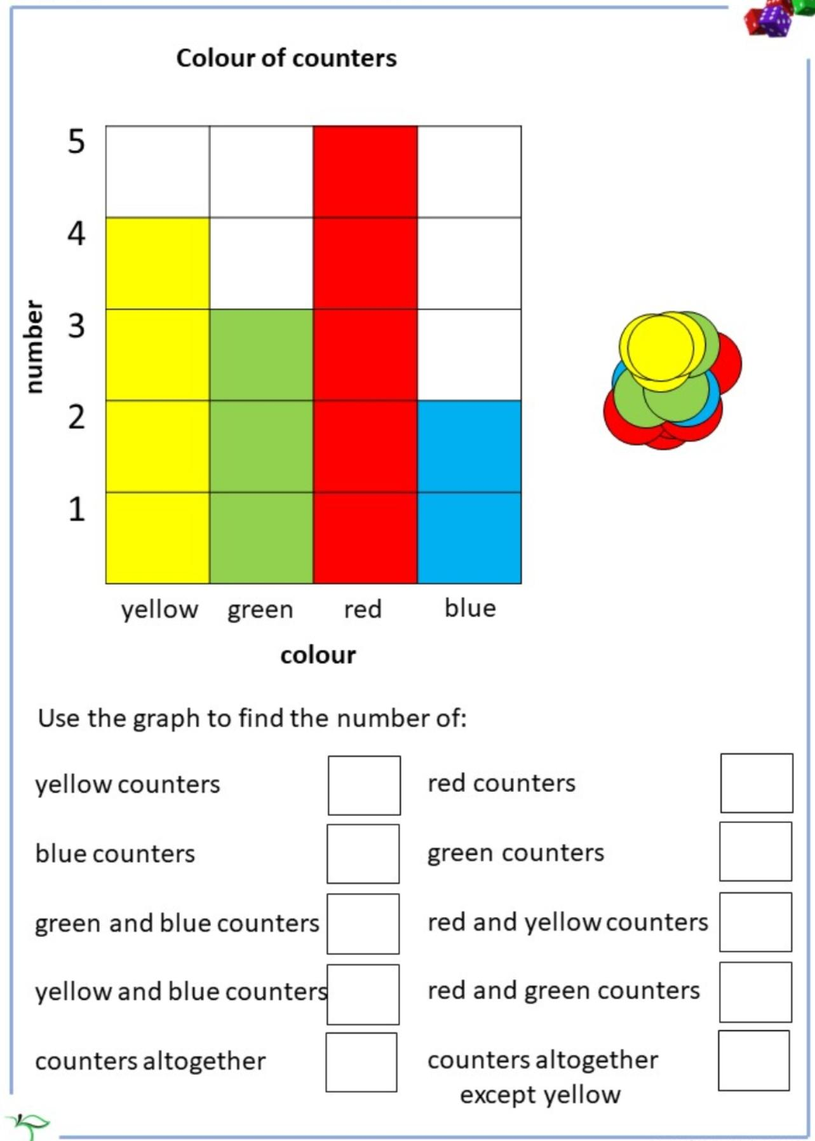
Have a look at this block graph and answer the questions:
How many different colours of counters?

Now create your own block Graph. You can show data about anything you wish (favourite family colour, foods, bird watch, pets ect)
Question___________________________________________________________________________
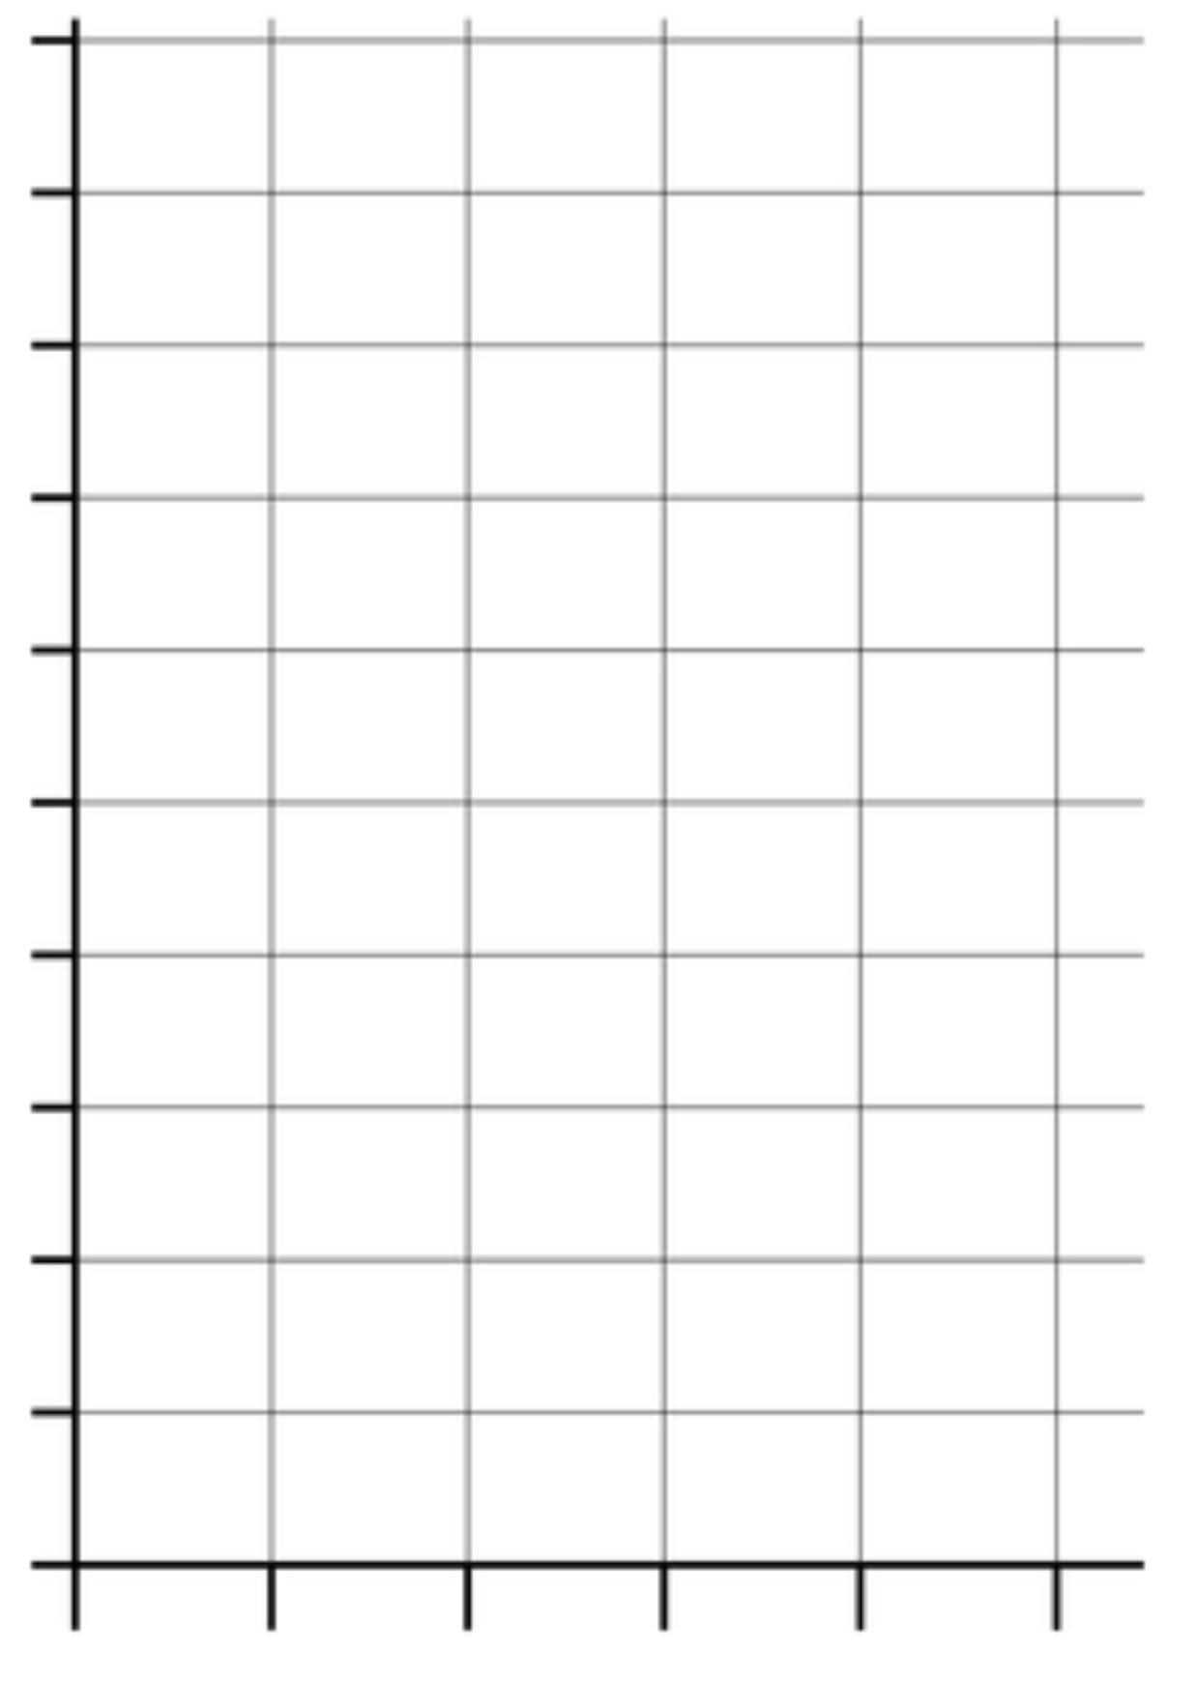

Number

Label __________________________
Addition Methods +
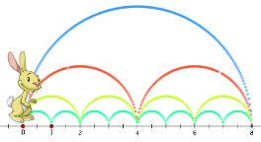

Choose a method to add and write in your homework book:
There are 3 green counters and 2 blue counters. How many counters altogether?

There are 3 green counters, 5 red counters and 2 blue counters. How many counters are there in total?

Subtraction Methods -
 |  | 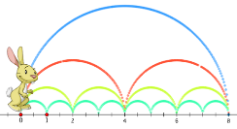 |  | 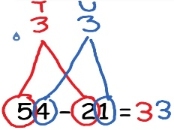

Choose a method to take away and write in your homework book:
There are 17 birds in my garden, 6 flew away. How many birds are left?

Miss Chandler had 28 dresses. She gave 9 dresses to Mrs Croombs. How many dresses does Miss Chandler have now?

Multiplication Methods x
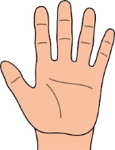

Choose a method to multiply and write in your homework book:
(Remember double means x 2)
Double 2 = Double 6 =

Mrs Defferding has 2 horses. Miss Chandler has double the number of horses. How many horses does Miss Chandler have?

Division Methods how many in each group?
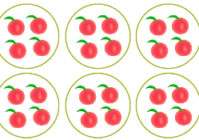

Choose a method to divide and write in your homework book:
(Remember half means ÷ 2)
Half of 8 = Half of 12 =

Miss Chandler has 20 shoes. Mrs Croombs has half the number of shoes. How many shoes does Mrs Croombs have?

English
Reading:
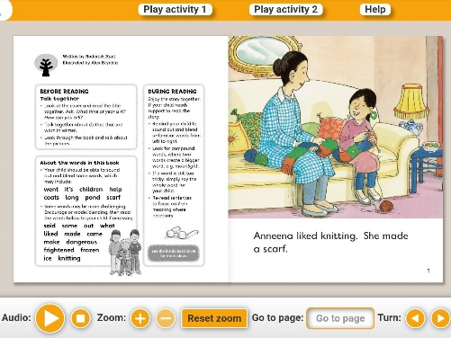
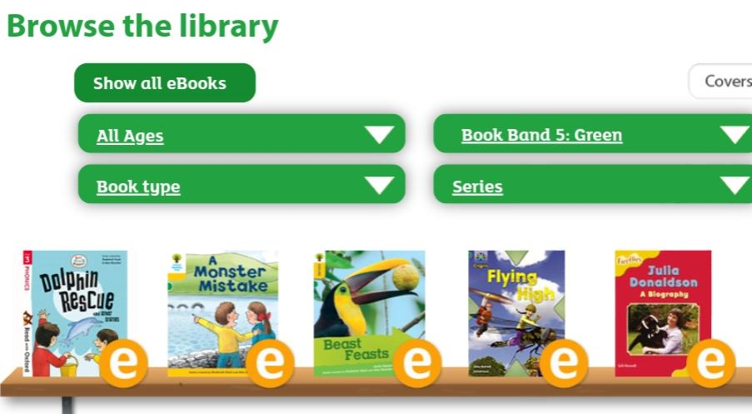
- Oxford Owls books https://www.oxfordowl.co.uk/for-home/find-a-book/library-page/
Filter by book band colour

- Phonics 2Do on Purple Mash
- Re-read sentences to practice fluency and expression
- Highlight phonic sounds when reading
- Ask/answer comprehension questions about a book
- Read books, magazines, shopping lists, signs, subtitles, recipes
- Phonic games and activities - www.phonicsplay.co.uk (phase 3-5 sounds).
Writing:
- Write spellings in sentences
- Remember: full stops, capital letters, finger spaces, handwriting
Spelling:
- Spellings – write in sentences
- Spellings – speed write (children have 1 minute to write one spelling word as many times as they can)
- Spellings – word search (template below)
Below are ALL the spellings for KS1. Please practice the highlighted words for this week.
KS1 Spellings
Year 1 Year 2
the  a  do  to  today  of  said  says  are  were  was  is  his  has  I  you  your  they  be  he  me  she | we  no  go  so  by  my  here  there  where  love  come  some  one  once  ask  friend  school  put  pull  full  house  our | door  floor  poor  because  find  kind  mind  behind  child  children  wild  climb  most  only  both  old  cold  gold  hold  every  everybody  even  great  break  steak  pretty  beautiful  after  fast  past  last | father  class  grass  pass  plant  path  bath  hour  move  prove  improve  sure  sugar  eye  could  would  should  who  whole  any  many  clothes  busy  people  water  again  half  money  Mr  Mrs  Parents  Christmas
Blank word search for spellings:
My Words Search

Words hidden in my word search

Geography Topic – Continents and Oceans – 2 Week Project
Not long ago we learned about the World’s Continents and Oceans BUT ... Miss Chandler has forgotten what the Continents and Oceans are called and what they are like!
Can you help Miss Chandler?
Week 8 – Continents
Continent Song – https://m.youtube.com/watch?v=K6DSMZ8b3LE
Cut out and label the World map:
Asia | Africa | North America | South America
Antarctica | Europe | Australia

Week 9 – Oceans
Ocean song – https://m.youtube.com/results?search_query=5+oceans
Cut out and label the World map:
Pacific Ocean | Atlantic Ocean | Indian Ocean | Southern Ocean
Arctic Ocean

Create a Destination Guide for Miss Chandler
Where do you think Miss Chandler would like to visit?
You can make a poster or booklet or complete the 2Do. Choose and research a holiday destination and create a travel guide, you could include:
- Its Continent - Size (Miles or Kilometres)
- Its Ocean - Distance from your house (Miles or Kilometres)
- Climate and Weather - Food delicacies

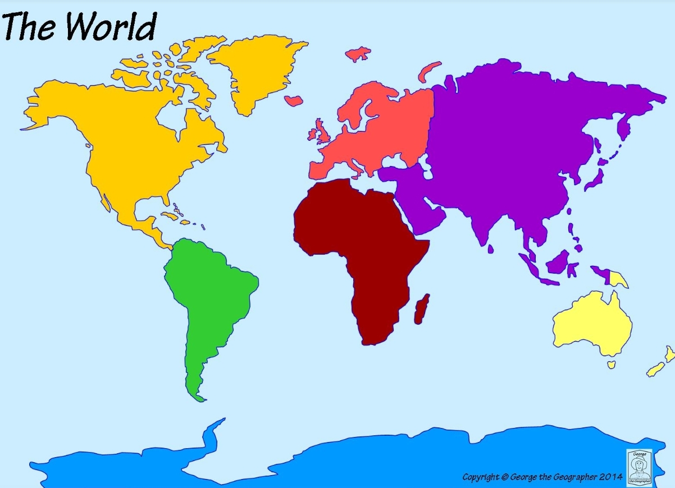

Useful websites

All Subject Areas:
www.purplemash.com
Support videos and daily lessons -https://www.bbc.co.uk/bitesize/primary
Online lessons - https://www.thenational.academy/online-classroom/
English:
Oxford Owl - https://www.oxfordowl.co.uk/for-home/find-a-book/library-page/
KS1 SATs - https://www.gov.uk/government/publications/key-stage-1-tests-2019-english-reading-test-materials
Phonics Revision - www.phonicsplay.co.uk
Maths:
KS1 SATs - https://www.gov.uk/government/publications/key-stage-1-tests-2019-mathematics-test-materials
Homework site - https://www.mymaths.co.uk/

