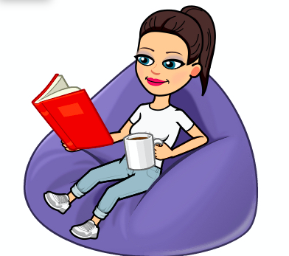
Robin Class Home Learning

English - Reading

Please complete the following tasks:

1. Read the setting description. Using five different colours (one for each of the five senses) highlight what you can see, hear, smell, touch and taste.

The narrow path had opened suddenly on to the edge of a great black lake. Perched atop a high mountain on the other side, its windows sparkling in the starry sky, was a vast castle with many turrets and towers. …The fleet of boats moved off all at once, gliding across the lake, which was as smooth as glass. Everyone was silent, staring up at the great castle overhead. It towered over them as they sailed nearer and nearer to the cliff on which it stood. …She pulled the door wide. The Entrance Hall was so big you could have fitted the whole of the Dursleys’ house in it. The stone walls were lit with flaming torches like the ones at Gringotts, the ceiling was too high to make out, and a magnificent marble staircase facing them led to the upper floors. …Harry had never imagined such a strange and splendid place. It was lit by thousands and thousands of candles which were floating in mid-air over four long table, where the rest of the students were sitting. These tables were laid with glittering golden plates and goblets. At the top of the hall was another long table where the teachers were sitting.
Harry looked upwards and saw a velvety black ceiling dotted with stars. …There were a hundred and forty staircases at Hogwarts: wide, sweeping ones; narrow, rickety ones; some that led somewhere different on a Friday; some with a vanishing step halfway up that you had to remember to jump.

2. Answer the following questions in full sentences:

a) How does JK Rowling use vocabulary to set the scene for the reader?

b) Which descriptive sentence is your favourite? Why?
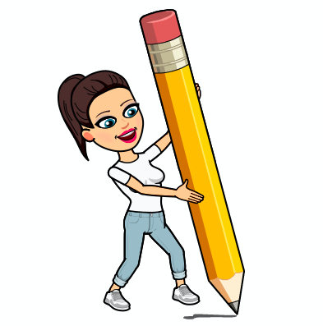
English – Writing

Please complete the following tasks:

1. Look back on your planning from last week (to your mundane setting and your extraordinary object mind-maps). Draw a picture of your setting, like Shaun Tan does, this will help you to visualise it in your mind.

2. Using your vocabulary from last week write your setting description (at least two paragraphs). Remember to think about painting the picture in the mind of the reader using the five senses. I’m looking forward to reading them!!

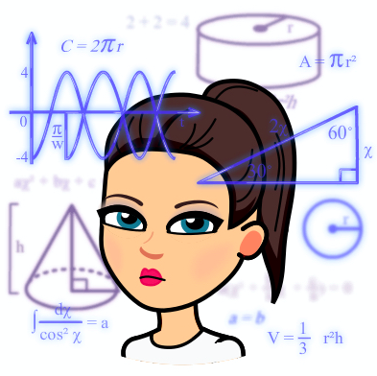
Maths

Please complete the following tasks:

1. Use 2email on Purple Mash to make a list of three areas of Maths you feel least confident in. Please then email this to me on Purple Mash so that I can see it

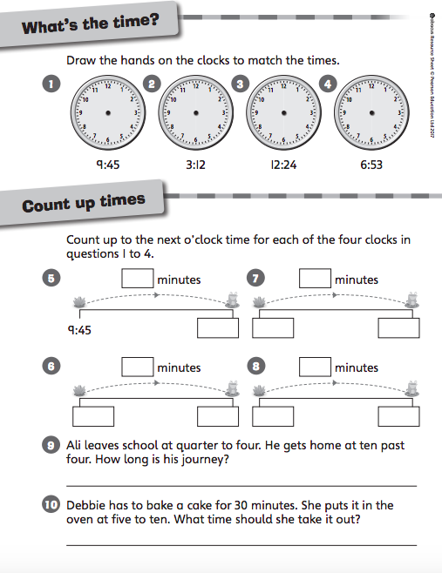
2. Maths this week focuses on some more angle work and revision of time and measure. Complete the following worksheets:

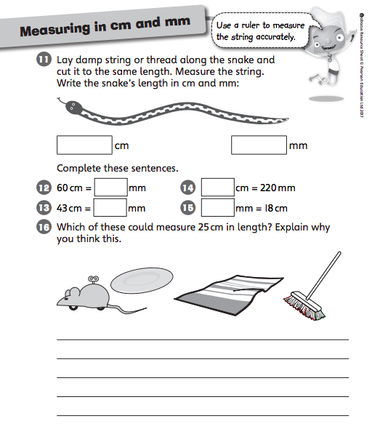

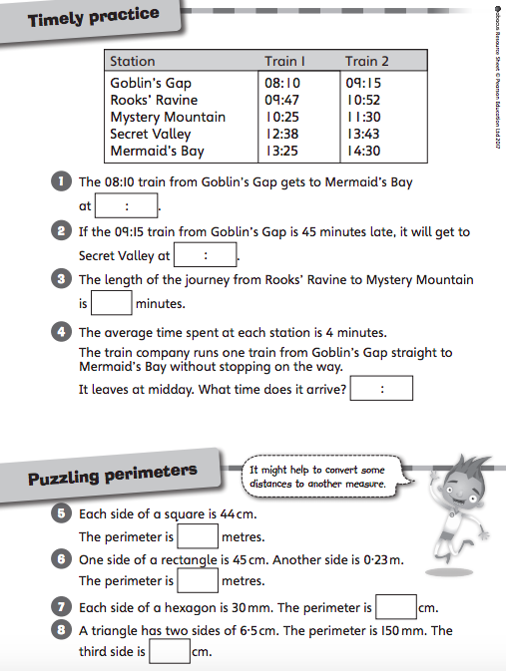

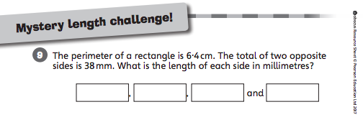

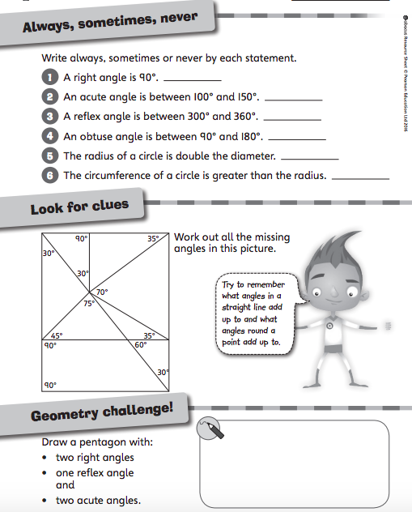

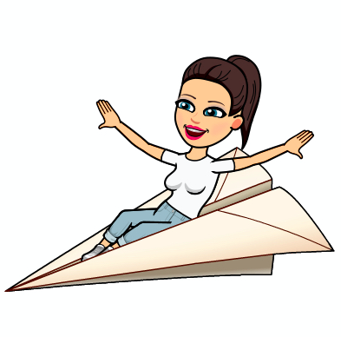
Science

What is the optimum wing length for a paper helicopter?

Please complete the following tasks:

1. Think back to last week’s experiment on water resistance. Using what you learned, what do you think is meant by the term ‘air resistance’? Write down a prediction and then look up a definition to see if you were correct! Can you draw a diagram to represent it?

2. Think about our investigation question. What do we mean by the word optimum? Using the planning model below, plan an experiment to test our question.
What is the optimum wing length for a paper helicopter?
MEASURE
- what are you going to be measuring?
- what unit of measure will you use?
- how many times will you measure each test? Why?
CHANGE
- what will you change each time you carry out your experiment?
- Hint: think about the difference between fresh water and salty water!
SAME
- what will you be keeping the same each time you carry out your experiment?
- Hint: you should only be changing one thing!

3. Make your paper helicopters like this (you will want to change how far down you cut to change the length of the wings for your experiment!):
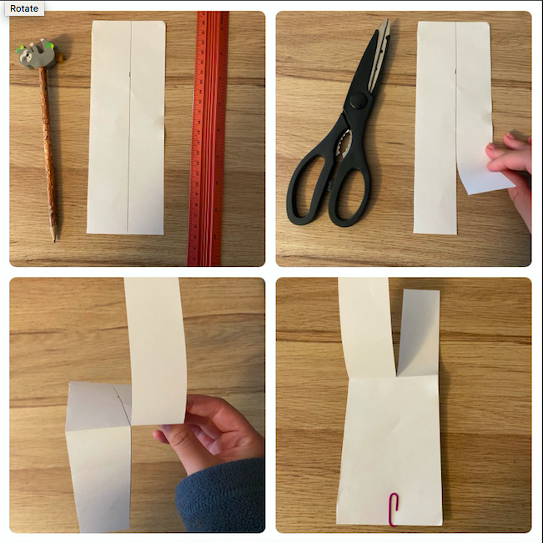
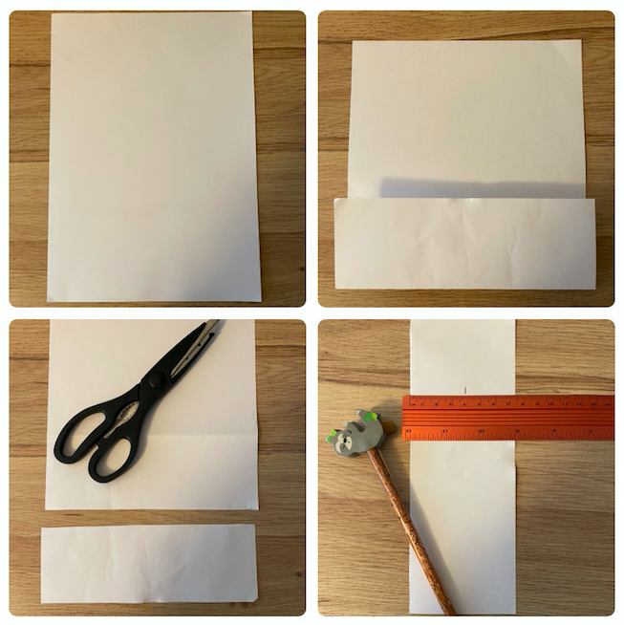
4. Carry out your experiment. Make sure you record your results in a table and that you repeat each wing length test three times.
Challenge: can you work out the mean for each wing length and turn this into a graph?
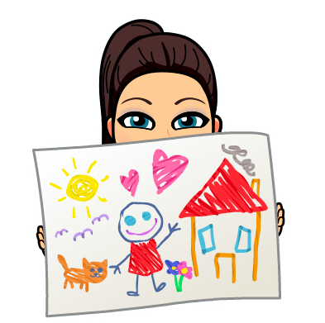
Art

Please complete the following tasks:

1. Follow these steps to create your own Picasso self-portrait in the Cubist style. You can draw the features however you like just remember to colour it bright and bold!
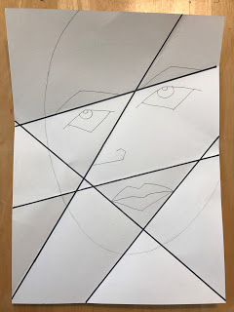
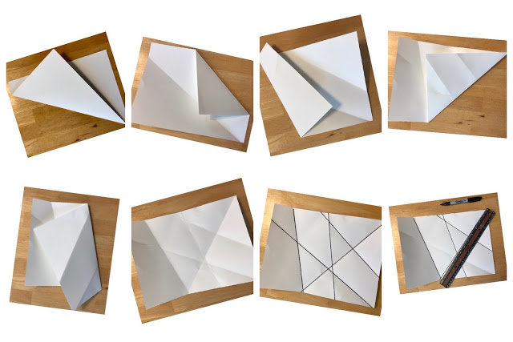

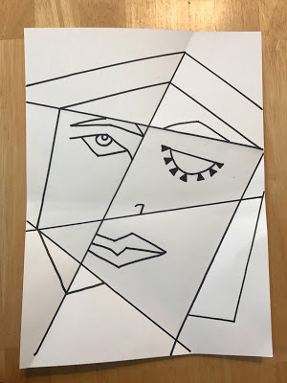
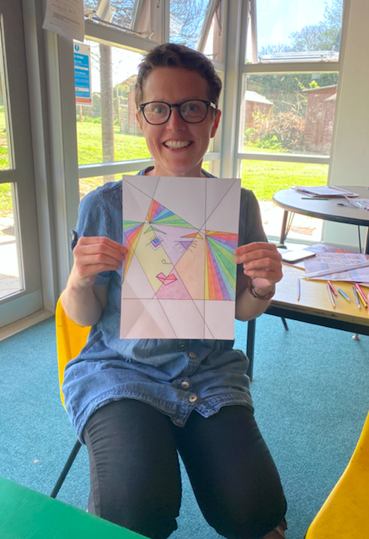

PSHE

Please complete the following tasks:

1. We are going to be thinking about dares. Create a mind-map of all the different reasons you can think of that someone might dare you to do something.

2. Read the following story and then think about these questions:

a) How does it feel to be dared to do something that you don’t want to do. Do you feel uncomfortable? Do you feel like you can say no?

b) Was it fair for Eleiyah’s friends to dare her to steal the pens? Do you think Eleiyah made the right decision? Why?

‘These notebooks are so cool!’ said Tan.
‘Yeah’ agreed Barja, ‘and I love this pencil case. Look it has secret compartments in it.’
‘Ooooh that is nice’ said Eleiyah. ‘I want these pens, I asked for them for my birthday but I didn’t get them. Look how many colours you get.’
‘No wonder you didn’t get them for your birthday’ replied Tan. ‘Look how much they are. Why do they cost that much?’
‘I know right, they are so expensive, but they are so nice!’ said Eleiyah, still holding the set of pens and gazing at them longingly. ‘If I were you,’ said Barja, ‘I’d just take them. They’re overpriced anyway. The shop is being greedy charging that much for them.’
‘There’s no one around,’ added Tan, ‘Go on, we won’t tell. It’ll be fun and you do really
want them. I dare you!’
‘We’ll look out. Just hide them under your coat,’ said Barja, nudging Eleiyah.
Eleiyah felt hot and dizzy and her heart started beating faster. She really wanted these pens – she had wanted them for ages – and at that price she couldn’t afford to buy them. There was no one looking, so she could probably get away with hiding them under her coat and walking out of the shop unnoticed. Something didn’t feel right. She glanced at Barja and Tan, who looked at her expectantly. ‘Come on,’ said Tan, ‘You’re not too scared, are you? It’s only a set of pens.’
‘Yeah,’ said Barja, ‘Don’t be a baby. It’s not like you’re robbing a bank. If you get away with it, we’ll know we can get more stuff.’ Eleiyah didn’t like being called scared or a baby but even if she stole the pens and didn’t get caught, she knew it was the wrong thing to do. ‘No, I’m not a thief,’ said Eleiyah, placing the set of pens back on the shelf. Tan started making chicken sounds and Barja laughed and joined in. ‘Very funny!’ said Eleiyah, ‘But it doesn’t feel right to just take them, so I’m not going to.’
‘But no one would know, except us,’ said Barja.
‘I’d know,’ said Eleiyah, ‘and every time I used the pens I’d be reminded that I took them without paying for them. I’ll start saving up for them.’
Eleiyah took one last look at the pens and headed for the shop door. Her heart rate had calmed back down to normal and she felt much better.
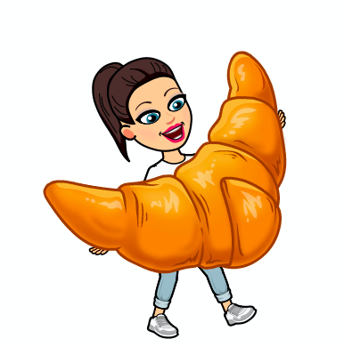
French

Please complete the following tasks:

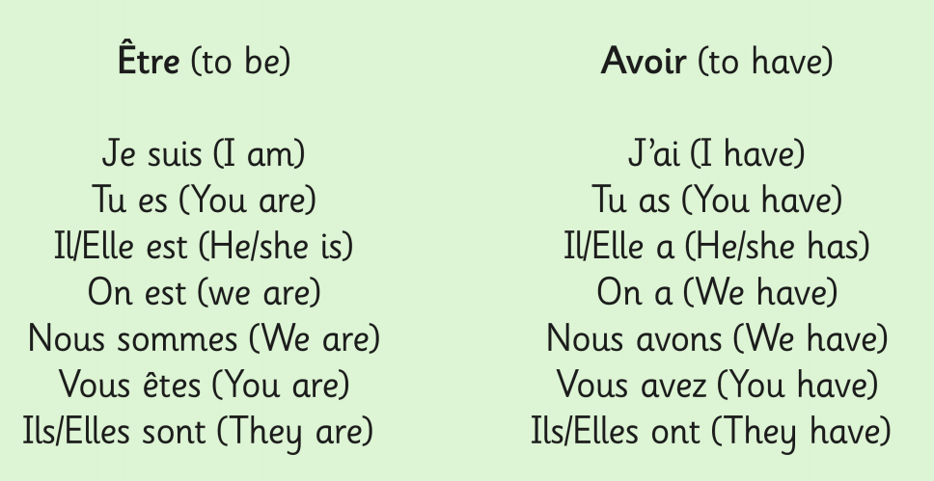
We are going to be looking at two French verbs être (to be) and avoir (to have). Here is word mat that shows the different forms for each verb.

1. Have a go at saying all of these phrases out loud.

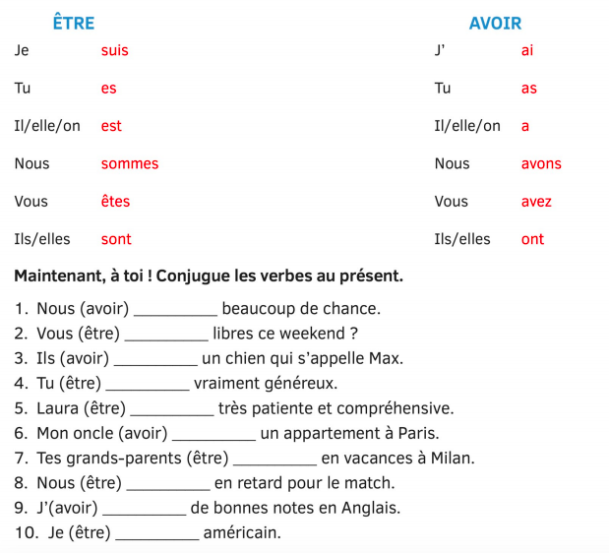
2. Using the word mat see if you can place the correct verb form into the sentence (you should be able to do this even if you don’t understand the rest of the sentence!).

3. Translate each sentence into English using a French dictionary and underline the English translation of the verbs être and avoir.

