Home Learning – Puffins – Week 4
Hi Puffins,
I hope you and your families are all keeping safe and well. Here is the home learning for week 4. The sheets from this pack can be stuck into homework books if you wish.

Please log in to Purple Mash and complete the following 2dos:

Week 3: English – Use Commas to list
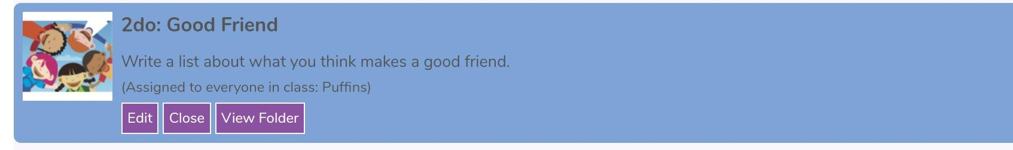
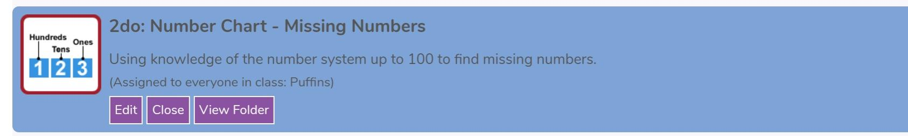
Week 4: Maths – Place Value – Missing numbers

Week 5: History - Titanic – Newspaper

Maths
Online MyMaths homework this week is ‘Telling the Time’ and ‘Comparing Time'. This will be updated every Friday.
Addition Methods +
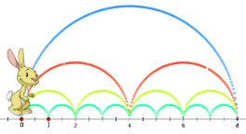

Choose a method to add and write in your homework book:
Miss Chandler bought 13 blue toilet rolls and 21 pink toilet rolls. How many toilet rolls did Miss Chandler buy altogether?

Subtraction Methods -
 |  | 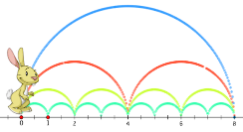 |  | 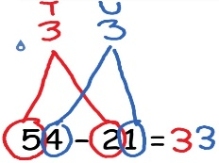

Choose a method to take away and write in your homework book:
Bob has 36 pencils and gives 11 to Jen. How many pencils does Bob have left?

Multiplication Methods x
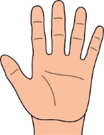

Choose a method to multiply and write in your homework book:
There are 6 shelves. Each shelf has 5 Easter eggs. How many Easter eggs are there all together?

Division Methods how many in each group?
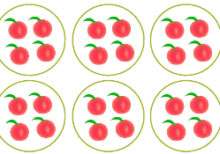

Choose a method to divide and write in your homework book:
12 children are going camping. There are 3 tents. How many children will sleep in each tent?

English
Reading:
- Research Titanic facts – remember your Phonic sounds to decode new unfamiliar words
- Ask/answer comprehension questions about Titanic reading
- Phonic games and activities - www.phonicsplay.co.uk where children can revise phase 3, phase 4 and phase 5 sounds.
Writing:
- Titanic English writing activities (below)
Spelling:
- Spellings – write in sentences
- Spellings – speed write (children have 1 minute to write one spelling word as many times as they can)
- Spellings – word search (template below)
Below are ALL the spellings for KS1. Please practice the highlighted words for this week.

KS1 Spellings
Year 1 Year 2
the  a  do  to  today  of  said  says  are  were  was  is  his  has  I  you  your  they  be  he  me  she | we  no  go  so  by  my  here  there  where  love  come  some  one  once  ask  friend  school  put  pull  full  house  our | door  floor  poor  because  find  kind  mind  behind  child  children  wild  climb  most  only  both  old  cold  gold  hold  every  everybody  even  great  break  steak  pretty  beautiful  after  fats  past  last | father  class  grass  pass  plant  path  bath  hour  move  prove  improve  sure  sugar  eye  could  would  should  who  whole  any  many  clothes  busy  people  water  again  half  money  Mr  Mrs  Parents  Christmas
Blank word search for spellings:
My Words Search

Words hidden in my word search
History – Titanic (3 Week Project)
Titanic Research Project – It’s your turn to teach me!
I am super excited about this project! Please create a portfolio or Scrapbook all about the Titanic. 3 weeks is a rough time frame, you can take longer if you need. You will be able to bring in and show off your portfolio when we are back at school.
You can search the internet to research the Titanic alongside your grown up. Please ask your grown up to check websites and videos before watching to make sure they are appropriate.
Your portfolio could include work, drawings, photos and things you have made. Here are some things we intended to do in school, you may want to include some of them in your portfolio:
Maths
- Above Maths sheets
English
- Titanic fact sheet
- Acrostic poem
- Letter - to a passenger/Captain Smith/your family
- Dinner Menu – Be as creative as you like. What are your favourite or worst foods?
Science
- Melt an iceberg – what is the quickest way to melt an iceberg (ice-cube)? Maybe the sun, hand heat, a radiator ect. Can you record your findings on a graph or table?
Geography
- Plot the Titanic's journey - Can you print a world map and plot its journey
Art/DT
- Portfolio front cover
- Masquerade Ball Mask – Can you design and/or create a mask that covers your eyes for a masquerade ball
- Draw, colour or paint the Titanic
- DT - Lego or junk model Titanic. Can you create a working door?
Computing
- Newspaper article – There is a 2Do on Purple Mash that you could use to create a newspaper article. This could be printed off for your portfolio.
PSHE
- Pack a Suitcase (wants vs needs) – Can you draw a suitcase or pack a real suitcase and take a picture. What would you pack? What do you want and what do you need?
- Ice Bucket (empathy) – Can you step into a bucket of cold water and ice. What do you think it felt like for the passengers in the Atlantic Ocean?

If you have your own ideas - Great! Go for it! Try and make your portfolio or scrapbook as exciting as possible. I can't wait to see them when we are back at school.
Keep safe and well,
From Miss Chandler xx

Useful websites

All Subject Areas:
www.purplemash.com
Online lessons - https://www.thenational.academy/online-classroom/
English:
KS1 SATs - https://www.gov.uk/government/publications/key-stage-1-tests-2019-english-reading-test-materials
Phonics Revision - www.phonicsplay.co.uk
Maths:
KS1 SATs - https://www.gov.uk/government/publications/key-stage-1-tests-2019-mathematics-test-materials
Homework site - https://www.mymaths.co.uk/

