Home Learning – Puffins – Week 2
Please use the provided homework book to record home learning. The sheets from this pack can be stuck into homework books if you wish.

Maths
Online MyMaths homework will be updated every Friday.
Addition Methods +
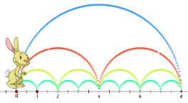

Choose a method to add and write in your homework book:
29 + 27 = 36 +36 = 45 + 28 =

Subtraction Methods -
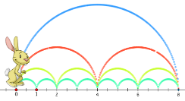
Choose a method to take away and write in your homework book:
23 - 14 = 48 - 19 = 75 - 26 =

Multiplication Methods x how many times will you count?
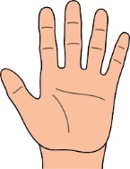

Choose a method to multiply and write in your homework book:
5 times tables - 3 x 5 = 1 x 5 = 10 x 5 =
2 times tables - 1 x 2 = 8 x 2 = 7 x 2 =
10 times tables -2 x 10 = 3 x 10 = 9 x 10 =

Division Methods how many in each group?
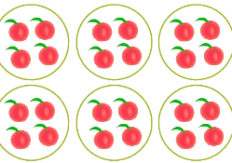

Choose a method to divide and write in your homework book:
15 5 = 6 2 = 20 5 =

English
Reading:
- Search for our Phonic sounds
- Ask/answer comprehension questions about the book.
- Phonic games and activities - www.phonicsplay.co.uk where children can revise phase 3, phase 4 and phase 5 sounds.
Writing:
- Adding suffixes to words (see sheet below)
- Use apostrophe to contract words (see sheet below)
- Spellings – write in sentences
- Spellings – speed write (children have 1 minute to write one spelling word as many times as they can)
- Spellings – word search (template below)
Spellings:
Below are ALL the spellings for KS1. Please practice the highlighted words for this week.

Year 1 |  | Year 2
the  a  do  to  today  of  said  says  are  were  was  is  his  has  I  you  your  they  be  he  me  she | we  no  go  so  by  my  here  there  where  love  come  some  one  once  ask  friend  school  put  pull  full  house  our | door  floor  poor  because  find  kind  mind  behind  child  children  wild  climb  most  only  both  old  cold  gold  hold  every  everybody  even  great  break  steak  pretty  beautiful  after  fats  past  last | father  class  grass  pass  plant  path  bath  hour  move  prove  improve  sure  sugar  eye  could  would  should  who  whole  any  many  clothes  busy  people  water  again  half  money  Mr  Mrs  Parents  Christmas
Suffixes:
In your homework book please read and write words in sentences.
ing  ed (past tense)  est | Examples:  Running  Jumping  Talking  Skipped  Played  Hopped  Loudest  Biggest  Smallest | ly  ment  ness  ful | Examples:  Lovely  Happily  Friendly  Argument  Excitement  Achievement  Happiness  Illness  Awareness  Painful  Mouthful  Colourful

Contractions using an apostrophe:

Is not =
She will =
We are =
Could not =
He is=

Won’t =
Can’t =
She’s =
We'd =
They're =

Blank word search for spellings:
My Words Search

Words hidden in my word search

Geography
- Keep a weather diary to record daily weather

Art
- Draw a self-portrait in the mirror (Remember how we draw eyes, nose and mouth)
- Create the Union Jack in of choice of media (draw, paint, collage, print, pencil, pen)

Useful websites
English:
KS1 SATs - https://www.gov.uk/government/publications/key-stage-1-tests-2019-english-reading-test-materials
Phonics Revision - www.phonicsplay.co.uk
Maths:
KS1 SATs - https://www.gov.uk/government/publications/key-stage-1-tests-2019-mathematics-test-materials
Homework site - https://www.mymaths.co.uk/

