Topic - Colour Wrens home learning WB: 20.4.20
Big Enquiry question – How useful is colour in our world?
Subject/area | Activities
Maths | YR- Revise counting to 100. (can use 100 square to help). Find up to 100 objects, depending on confidence with counting, ( 1p coins, stones, leaves etc) Group them in piles of 10 and practise counting in 10’s to show how we can count in tens to count the objects quicker. Practise counting objects accurately (touch and say).  Estimation- Using a clear plastic bag of small animals / 1p coins/ stones,/counters, guess how many are in the bag. Was your guess a sensible guess? Repeat this and record on paper.  Y1-Revise counting to 100. (can use 100 square to help) Using 110 square, can you add 10 from a given number? For example what 1s 10 more than 16 /23/35/42? Etc  Notice how the answer is always below the given number.  Revise counting in 2’s, 5’s and 10’s using a variety of objects. Coins, pebbles, counters etc.  Simple fractions- Go outside and find a stick. Can you break the stick in half (2 equal parts). How many equal parts? Can you break the stick into quarters? How many equal parts now?  Cut out 2 paper circles and fold one in half and the other into quarters. Shade/colour half the circle and label ½ (1 part of 2). Now do the same for the ¼ circle. (1 part of 4).  Using a variety of objects, count out a number of these up to 10 and find ½ of that number of objects. ( sharing them into 2 equal parts) . What is ½ of 2/4/6/8/10?. Continue to 20. You can also find ¼ of a number of objects by sharing them into 4 equal parts. What is ¼ of 8/ 12/16/20?  Play ‘Fractonio’s Pizzeria’ on Purple Mash.
English | All  Read/listen to the book- The mixed up Chameleon by Eric Carle on Youtube  Look at some pictures of Chameleons and see what you can find out about them online.  The chameleon wanted to be lots of different things- think about an animal you would like to be. Draw it and write the reason you would like to be that animal (a cheetah so I could run fast etc). Think about using your sounds independently in your own writing. You can use the template attached if you wish.  Year 1’s- remember to use a capital letter, full stop, spaces and joined up writing in your work.  Year 1- Draw a picture of a chameleon and create a non fiction factfile about them- think about different headings you can use- what they are/what they eat etc and see if you can find out where in the world they are found in the wild. You can use the template attached if you wish  Explore compound words- see table below  Remember to read daily/share stories at home and carry on with your storywings if you have not yet completed it.
Science/Understanding the World | Animals and camouflage- Link to ‘The Mixed up Chameleon’.  Discuss what ‘camouflage’ means. Why is it so important for the survival of animals, whether predators or prey?  Either using a small cardboard box (3D environment) or drawing on paper, create an environment for the chameleon (or other animal) to hide within by using appropriate colours to allow animal to blend into it’s background.
Geography/Understanding the World | Go on colour walk around your garden/local area if it is safe to do so and record where the chameleon could hide- eg a yellow place/red place etc- discuss how colour is useful for him for camouflage
Art/Expressive arts and design | Use paint to invent new colour - use dishes, and brushes to dab a small amount of different colours in and mix to invent a new one. Once you have made a new colour can you name it (sapphire blue/ grass green etc) and use your new colours to produce a painting of your choice.
Music/ Expressive arts and design | Make up words to fit a familiar tune that you know. Could be a song or nursery rhyme tune.
PSHE/Personal, social & emotional development | The Mixed up Chameleon was happiest when he was just himself. We are all unique and special and should be happy being ourselves. Draw a picture of yourself and write what is special and unique about you- writing in the sentence format I am special because I am... You can use the attached template if you wish.  Year 1’s can you think of at least 3 ideas to write out for this.

Phonics – Year R
For the next 2 weeks our phonic focus will be to practise reading these words with two syllables. To extend and challenge your child see if they can write the words and then write a sentence for each word.

elbow | corner | shampoo | coffee
stocking | picnic | farmer | sandwich

On the Phonics play website play some of the Phase 2 and 3 games each day

Year 1- key words
Each day revise spelling 6 words from the previously sent out high frequency word list.
Focus on 1 word at a time - In 1 minute how many times can you write that word? Write each word in a sentence- think of a different sentence for each word each day.
On the phonic play website, play some of the Phase 3,4,5 sound games each day.
Year 1 – exploring compound words
Compound words are words that are made by joining 2 words together to make a new word.
See if you can match the words in the 2nd part of the table to one in the first to create a new word. Then can you write a sentence using the new word you have created each time- remember to use a capital letter, full stop, spaces between your words and join up your writing.

Word 1 | Word 2
black | light
green | sight
sun | berry
eye | house
fire | yard
farm | man

Word 1 | Add word 2 | = new word….

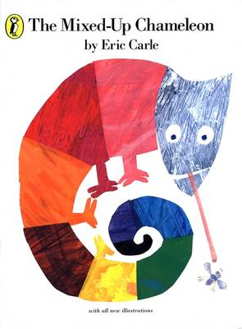
W/C 24.4.20. After reading the Mixed Up Chameleon write about which animals I would like to be like and why

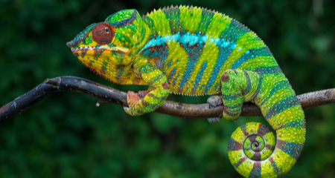
Year 1 -W/C 24.4.20.
Create a factfile about chameleons- what do they eat? Where in the world can they be found etc
Make different subheadings in your work for your factfile

W/C 16.4.20
Draw a picture of yourself and write what is special and unique about you- writing in the sentence format I am special because I am...
