Home Learning – Puffins – Week 10
Hi Puffins,
I hope you and your families are all keeping safe and well. Here is the home learning for week 10. The sheets from this pack can be stuck into homework books if you wish.
Please do not feel pressured to complete every piece of home learning on the website, Purple Mash, MyMaths and Timestable Rockstars (year 2). Please do what works best for your child and family.

Purple Mash 2Dos:
Phonics – oe, au, ey (click the speaker to sing along with Miss Chandler)

Maths – Tally Charts

Maths – Data Handling (statistics): MyMaths - Statistics. BBC Bitesize (Organised Tally) https://www.bbc.co.uk/bitesize/clips/z7r9jxs
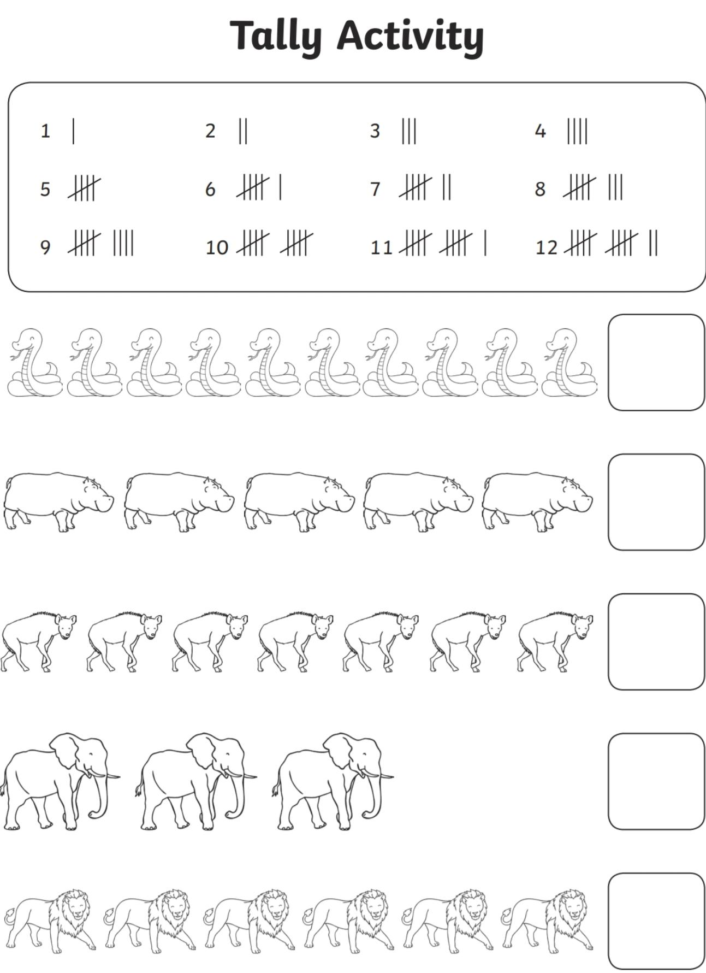
Tally Activity - Remember we count tally marks in 5’s

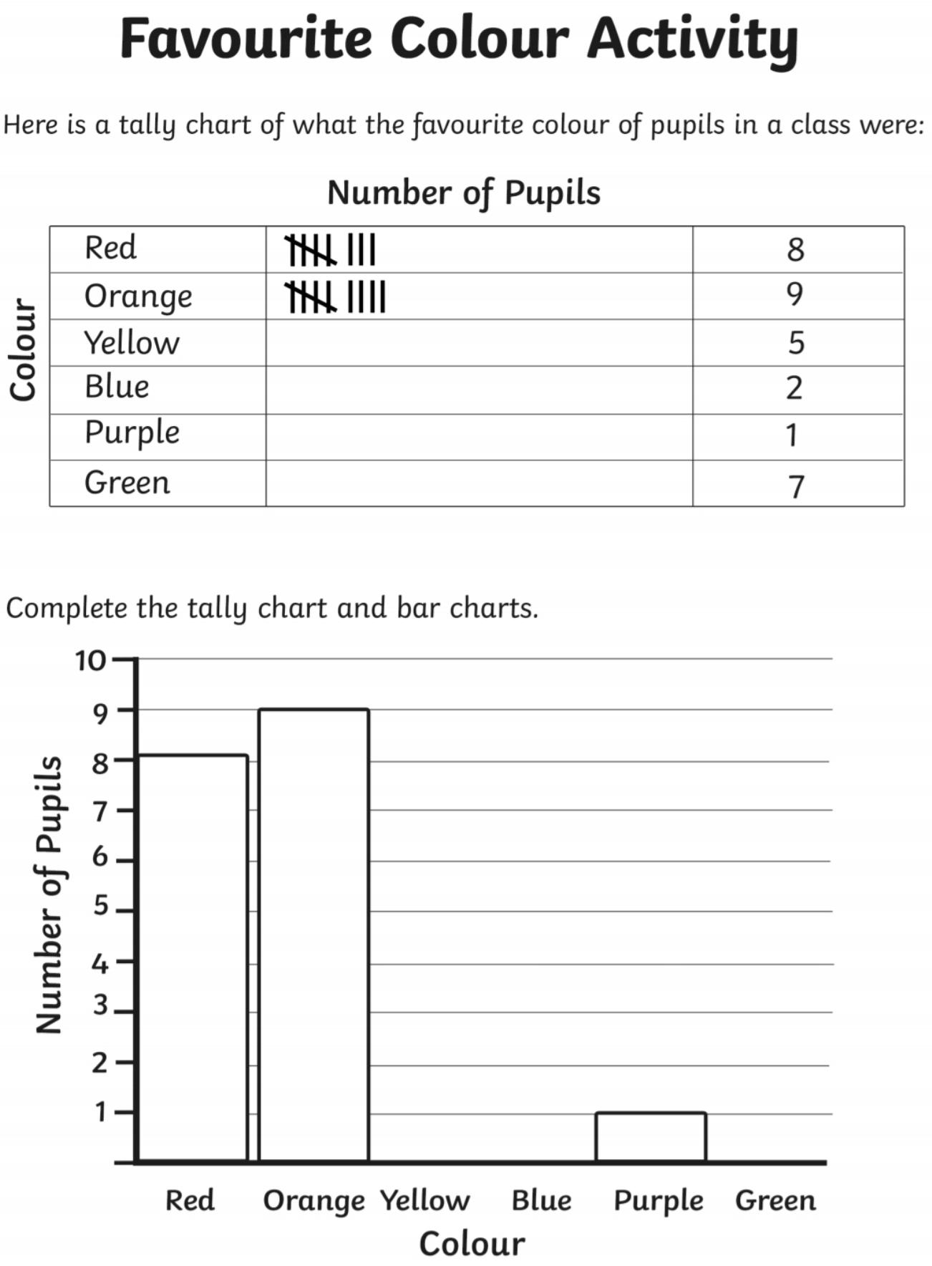
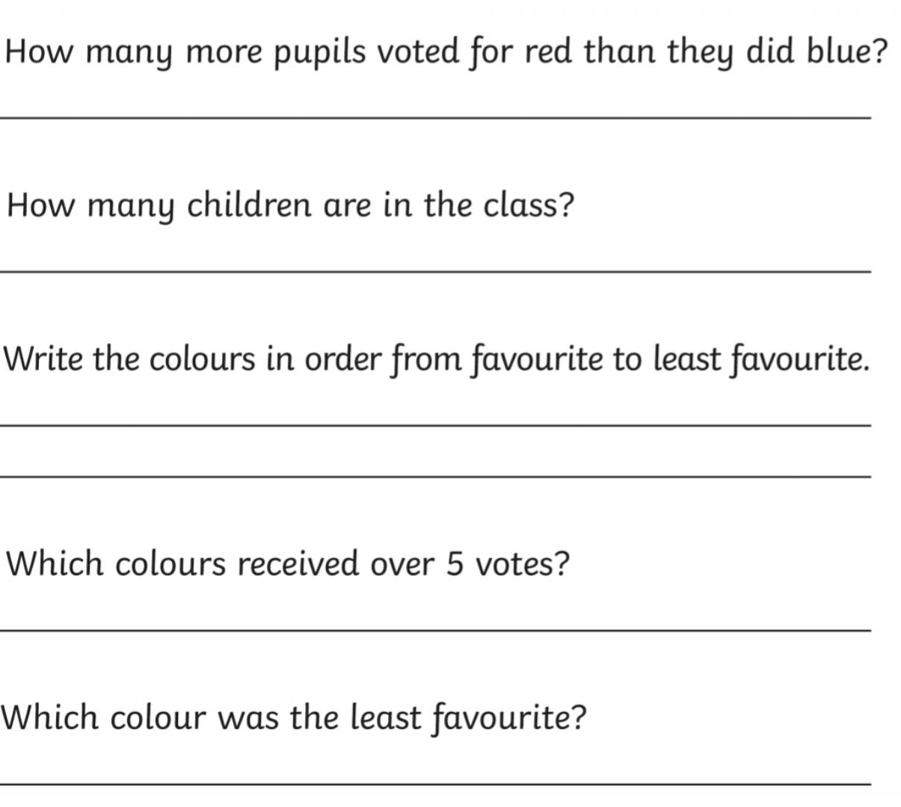

Addition Methods +
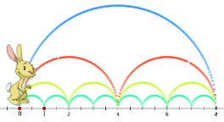
Choose a method to add and write in your homework book:
Add twenty-six and nine ____________
Add ten and thirty-one ____________

Subtraction Methods -
 |  | 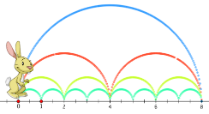 |  | 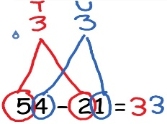
Choose a method to take away and write in your homework book:
Subtract five from eleven ___________
Take away sixteen from twenty ___________

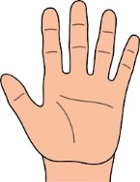
Multiplication Methods x

Choose a method to multiply and write in your homework book:
Multiply three by five ____________
Multiply eight by five ____________
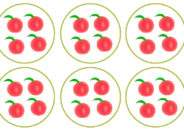
Division Methods how many in each group?

Choose a method to divide and write in your homework book:
Divide ten by five ______________
Divide thirty by five _____________

English
Reading:
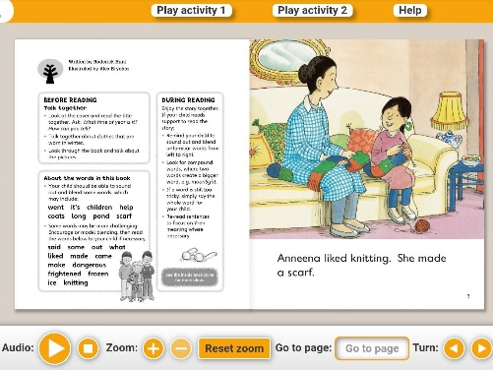
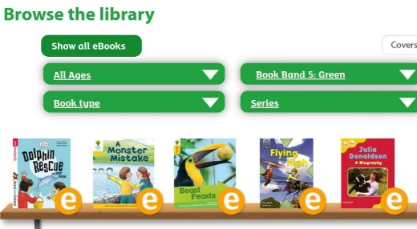
- Oxford Owls books https://www.oxfordowl.co.uk/for-home/find-a-book/library-page/
Filter by book band colour

- Phonics 2Do on Purple Mash
- Re-read sentences to practice fluency and expression
- Highlight phonic sounds when reading
- Ask/answer comprehension questions about a book
- Read books, magazines, shopping lists, signs, subtitles, recipes
- Phonic games and activities - www.phonicsplay.co.uk (phase 3-5 sounds).
Writing:
- Write spellings in sentences
- Remember: full stops, capital letters, finger spaces, handwriting
Spelling:
- Spellings – write in sentences
- Spellings – speed write (children have 1 minute to write one spelling word as many times as they can)
- Spellings – word search (template below)
Below are ALL the spellings for KS1. Please practice the highlighted words for this week.
KS1 Spellings
Year 1 Year 2
the  a  do  to  today  of  said  says  are  were  was  is  his  has  I  you  your  they  be  he  me  she | we  no  go  so  by  my  here  there  where  love  come  some  one  once  ask  friend  school  put  pull  full  house  our | door  floor  poor  because  find  kind  mind  behind  child  children  wild  climb  most  only  both  old  cold  gold  hold  every  everybody  even  great  break  steak  pretty  beautiful  after  fast  past  last | father  class  grass  pass  plant  path  bath  hour  move  prove  improve  sure  sugar  eye  could  would  should  who  whole  any  many  clothes  busy  people  water  again  half  money  Mr  Mrs  Parents  Christmas

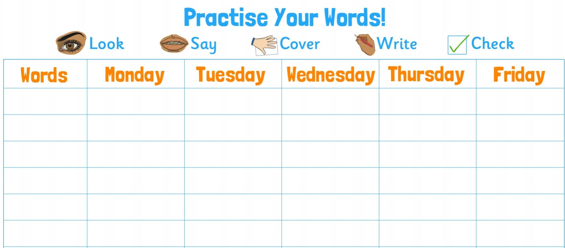

Blank word search for spellings:
My Words Search

Words hidden in my word search

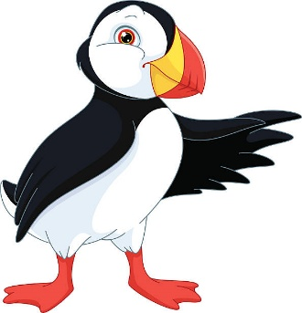
French Topic – Colours
Bonjour Puffins!
Bonjour Puffins!

Revise and label each colour in French:
Les Couleurs Song: https://m.youtube.com/watch?v=H-5vyAgoHm8&t=19s
BBC Bitesize: www.bbc.co.uk/teach/class-clips-video/french-ks2-painting-together/z72gd6f
Geography - Where is France? Put a circle around France.
Europe
Which Continent is France on? _________________________________

What Ocean is next to France? ____________________________________

Is France North or South of the Equator? ________________________________

Useful websites

All Subject Areas:
www.purplemash.com
Support videos and daily lessons -https://www.bbc.co.uk/bitesize/primary
Online lessons - https://www.thenational.academy/online-classroom/
English:
Oxford Owl - https://www.oxfordowl.co.uk/for-home/find-a-book/library-page/
KS1 SATs - https://www.gov.uk/government/publications/key-stage-1-tests-2019-english-reading-test-materials
Phonics Revision - www.phonicsplay.co.uk
Maths:
KS1 SATs - https://www.gov.uk/government/publications/key-stage-1-tests-2019-mathematics-test-materials
Homework site - https://www.mymaths.co.uk/

