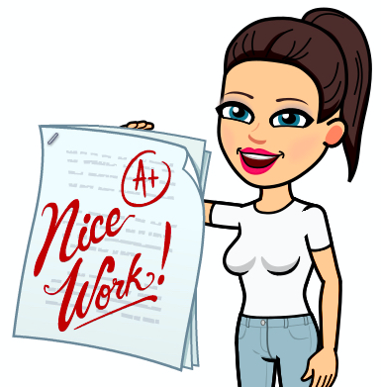
Robin Class Home Learning

English – Reading

The Amnesia Machine
It comes to me uninvited at the breakfast table, the recollections of a recurring dream so vivid that it feels almost like a real memory. It goes like this:

I AM STANDING in the middle of our street. In the distance I can see an enormous metal object, some kind of machine creeping down the road on the back of a long truck. It’s the sweltering long weekend before the last election, and everyone has stopped washing cars, reading papers, watching sport or renovating bathrooms to come out and enjoy this unexplained spectacle. And to receive a free ice-cream, available from a colourful van that is never far away. It’s playing a catchy jingle, one I know I’ve heard before.
A spectator in front of me says, ‘Makes you truly appreciate the beauty of human engineering.’
The machine is close enough now to eclipse the sky, and I have to agree with him. It is massive, awe-inspiring, beyond the comprehension of ordinary tax-payers.
Further along, the truck backs into the treeless park behind out shopping centre. A team of construction workers are already waiting with an array of cranes and cables, and they set about shifting this monstrous thing onto an area of grass marked out with oily lines. There’s a cacophony of hammering and welding. A big sign is bolted to a razor-wire fence: ‘KEEP OUT’. Then there is silence. The workers are nowhere to be seen. I realise that it’s already dark and everyone has gone home to eat dinner and watch the news.
Deep within the metal structure, lights are blinking to life and there’s an electric humming noise, a thin vibration I can feel in my back teeth, and another swooshing sound, like cars on a freeway at night. Somewhere far away, a dog is barking.

I only recall this upon reading a newspaper article about the recent election result, an unsurprising government victory, and some other stories about media ownership, missing government revenue, corruption and so on, all quite boring. Almost every page features a full colour advertisement for a new, bright pink ice-cream.
Coming home from my weekly trip to the supermarket I decide to go the long way, by the park, out of curiosity. Of course there’s nothing to see, just an empty square of freshly mown grass surrounded by a razor-wire fence, with a single sign that says ‘KEEP OUT’. I think it’s always been there, though I can’t imagine why.
Now I’m here again in the kitchen, listening to the faint drone of a neighbour’s TV (yet another current affairs show with a catchy jingle) and the soft rush of late evening traffic; an ocean of white noise.
I’m trying to recall my dream about that thing, that machine, but even now the details are elusive and my memory feels more and more like an emptying room.
All I can think about is the ice-cream cone right here in my hand, melting. Is it meant to be strawberry or raspberry?

Please complete the following tasks:

1. Look up the definition of any unfamiliar words in a dictionary.

2. Thinking back to your learning last week about the mundane (boring) and the extra-ordinary, highlight both of these features in The Amnesia Machine. Which parts of the story are mundane? Which parts are about the extra-ordinary?

3. You have now read three stories by Shaun Tan: The Water Buffalo, Undertow and The Amnesia Machine. Choose your favourite and write a short book review recommending it to a friend. (As a minimum you should include, the name and author of your story, a summary of what the story is about, what you liked about it and why you are recommending it to your friend).
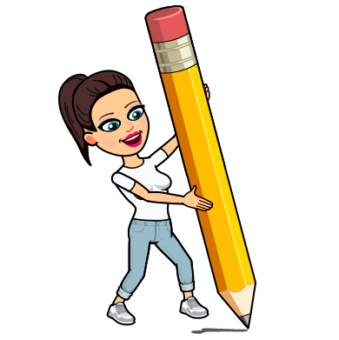
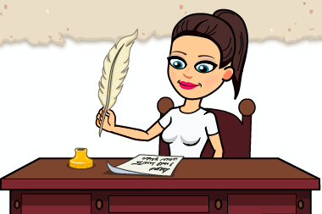
English – Writing

Please complete the following tasks:

Next week we are going to be writing our own fantasy setting descriptions using the mundane and the extra-ordinary. When writing a setting description, we need to paint a picture for our reader. We can do this by using exciting and carefully chosen vocabulary. A lot of authors also focus on the five senses.

1. Have a go at uplevelling these sentences. Add fronted adverbials, adjectives and adverbs to make these sentences better.

a) Miss Lock walked her dog.

b) The street was busy.

c) The book is old.

2. Choose a mundane place that you want to write about (a street, a shop, a beach, a garden, a room, etc.). Thinking about the five senses, mind-map about your mundane place. What can you see? What can you hear? What can you smell? What can you touch? What can you taste? Remember to make it sound ordinary and boring!

3. Choose or invent something EXTRA-ORDINARY to appear in your mundane setting. Mind-map exciting words and phrases to describe it. Remember to use a thesaurus to uplevel your word choices.
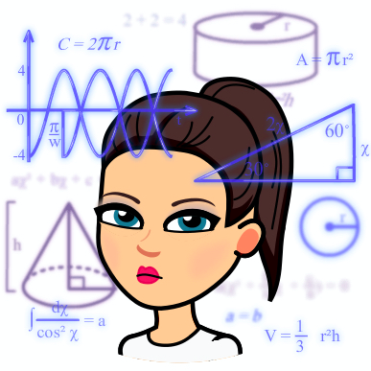
Maths

Please complete the following tasks:
(Remember to check Purple Mash and TT Rockstars)
1. We have already looked at the different types of angles this year. Using the sheet below, have a go at sorting the angles into three different groups (acute angle, right angle and obtuse angle).
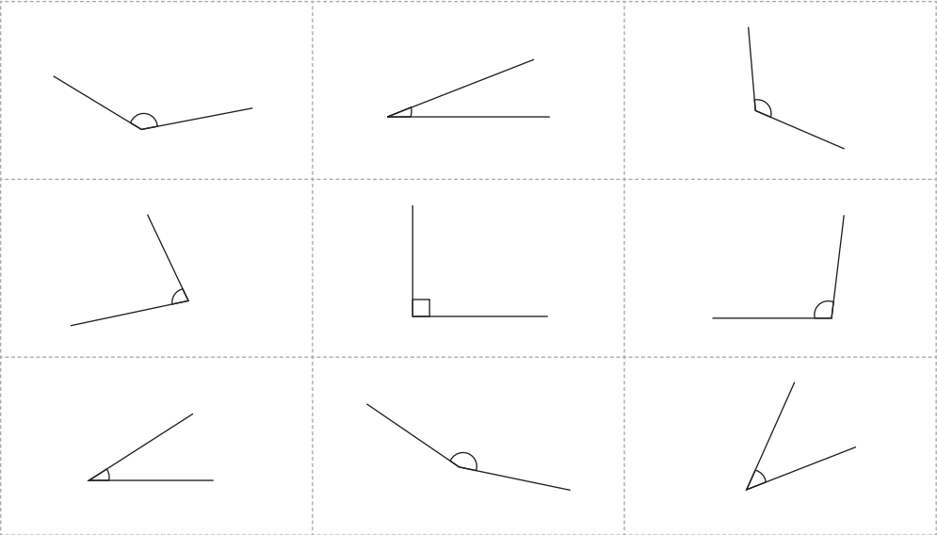

2. If you have a protractor at home, measure each of the angles above. If you do not have a protractor at home, make a reasonable estimate for each angle and explain why you have made that estimate.
For example: I have estimated 85 degrees because the angle is acute and slightly smaller than a right angle.

3. Write down all the fact about angles that you can find out! Challenge yourself to see how many you can get.
For example: the angles around a point add up to 360 degrees.
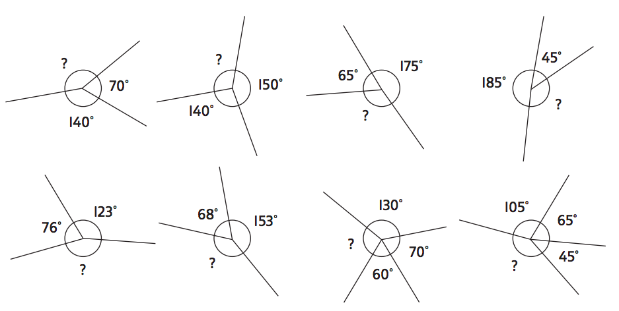

4. Using the fact that all angles around a point add up to 360 degrees, work out the missing angles.

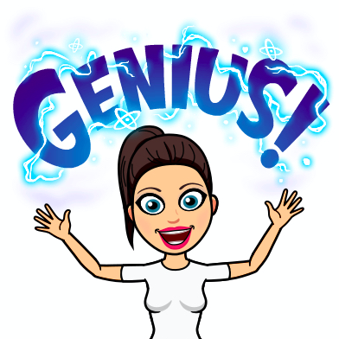
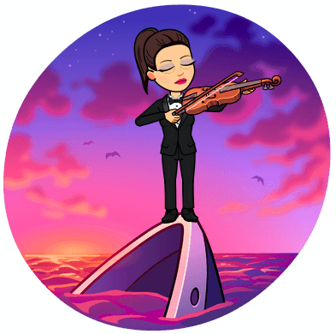
Science

Do ships sink quicker in fresh water or in salty water?

Please complete the following tasks:

1. What is meant by the phrase ‘water resistance’? Copy this definition and diagram into your book.

Water resistance occurs when objects have to move water out of their way.

For example: in the case of a sinking ship, the ship has to move the water particles out of its way in order to reach the bottom of the ocean.
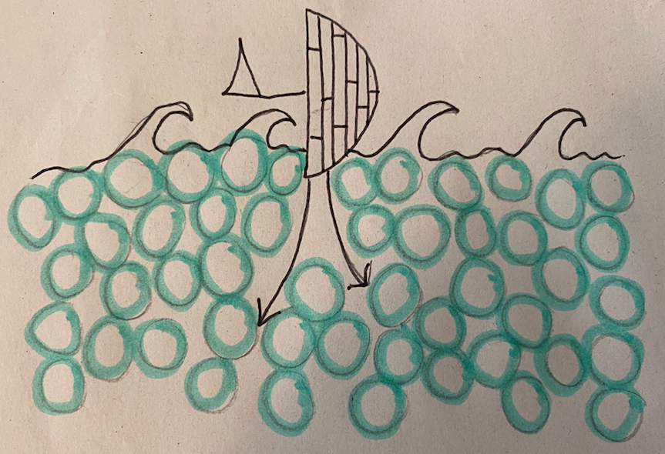

2. Using the planning model below, design an experiment to test our investigation question: do ships sink quicker in fresh water or in salty water?
Do ships sink quicker in fresh water or in salty water?
MEASURE
- what are you going to be measuring?
- what unit of measure will you use?
- how many times will you measure each test? Why?
CHANGE
- what will you change each time you carry out your experiment?
- Hint: think about the difference between fresh water and salty water!
SAME
- what will you be keeping the same each time you carry out your experiment?
- Hint: you should only be changing one thing!
Remember to make a prediction sentence!

3. Set up and carry out your experiment recording your results in a table. What did you find out? Was your prediction correct?

4. Write a few sentences answering the question do ships sink faster in fresh water or in salty water? Remember to use your results to back up your answer with evidence!
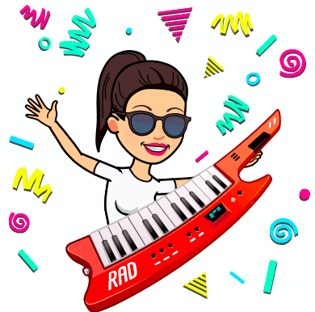

Music

Please complete the following tasks:
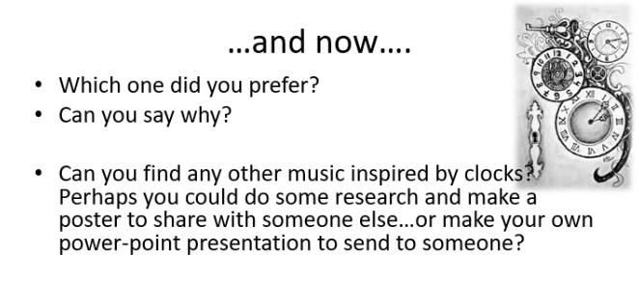
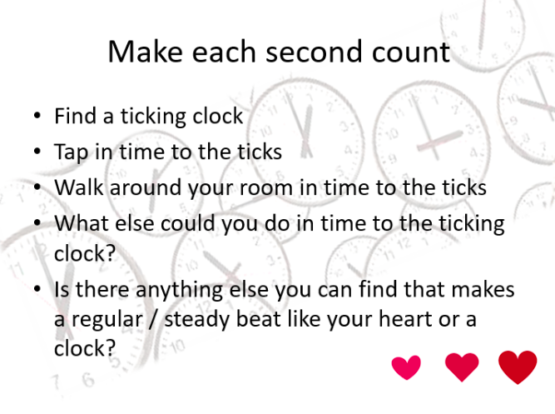
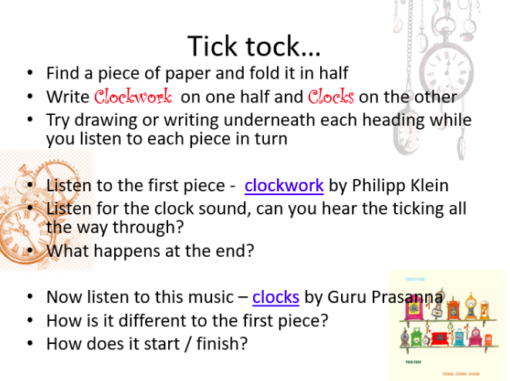
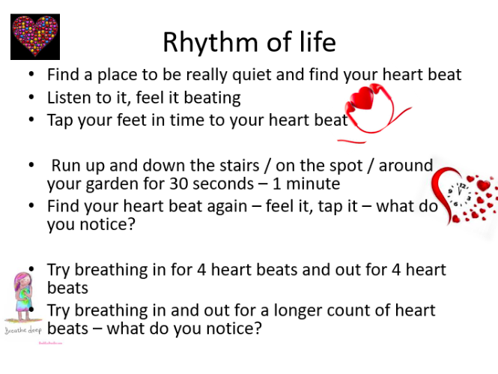

Clockwork (Klein) Link - https://www.youtube.com/watch?v=DTf_VYDqPuE

Clocks (Prasanna) Link - https://www.youtube.com/watch?v=wNunc0UN2Jo

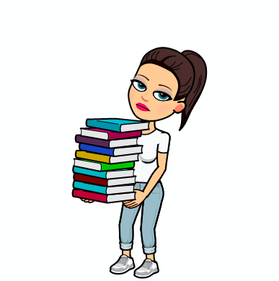
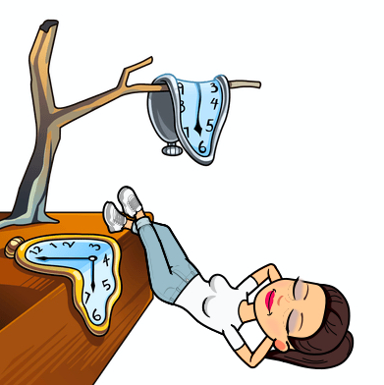
History

Please complete the following tasks:

1. Look at the picture of the Ancient Church of St. Mary the Virgin and the new church in Preston Candover. What similarities can you spot? What differences can you spot?

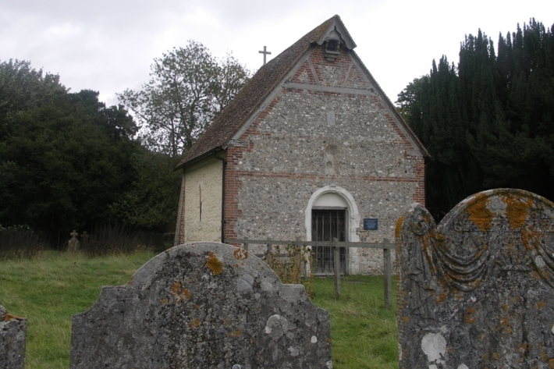
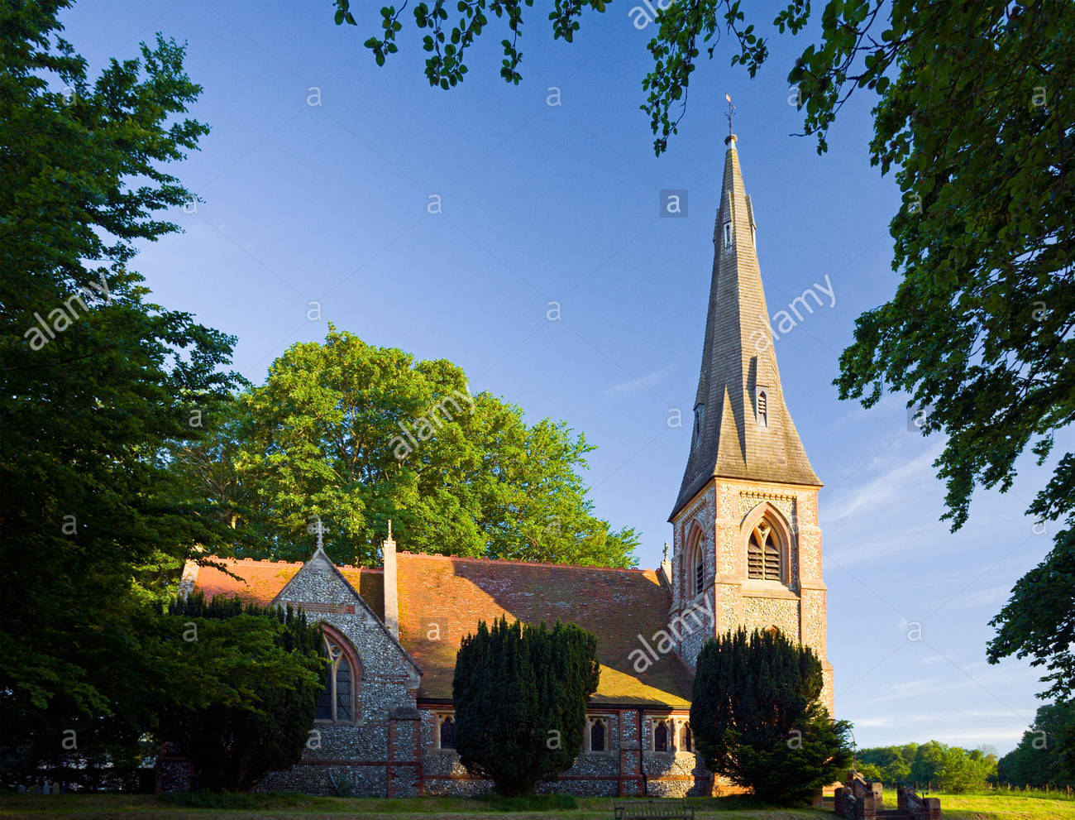

2. Think about why a new church might have needed to be built. Mind-map your ideas.

3. Think back to when you made a list of the things you wanted to find out about the Ancient Church of St. Mary the Virgin. Choose two items on your list and have a go at using your ICT effective searching skills to research them! Remember to write down what you find.
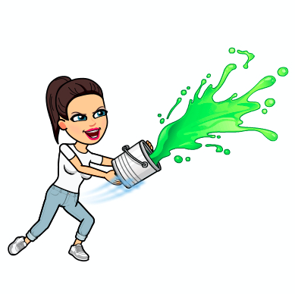

Art

Please complete the following tasks:

1. Choose your favourite animal. Draw or paint this animal on a piece of paper, it can be as big as you want! Think about the techniques of Cubism and make your animal bright and bold (you don’t have to stick to its usual colours!)

2. Once your drawing or painting is complete and dry, cut up your design into different geometric shapes (squares, triangles, try to avoid circles by using only straight lines!) Then rearrange your animal in a different way to create a Cubist collage.

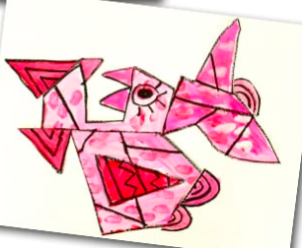
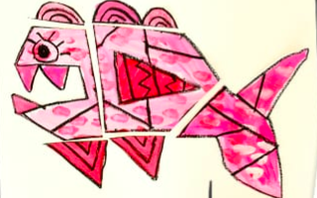
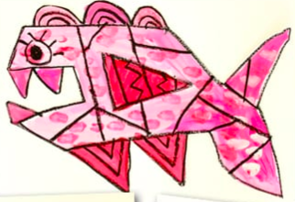
Here is an example:

