Kingfisher Class Home- Learning- Week 1- Maths

Kingfisher Class Home- Learning- Week 1- English

Writing ideas based on ‘Wonder’ by R. J. Palacio
Please choose at least three activities from below and use your writing checklist- if you have it to help you
- Choose a character from Wonder (your choice)-write a character description.

- Choose a setting from Wonder (your choice)- write a setting description.

- To write a formal letter to one of the teachers at Auggie’s school- what would you like to express to that teacher?

- Create a newspaper report for Auggie’s school, explaining the events you have read so far.

Kingfisher Class- Home learning- Foundation subjects- Week 1
Topic Activity:
- Create a presentation, information leaflet or poster about a civilisation you have not researched yet in class. Use this list to help you: Shang Dynasty of China, Indus Valley, Ancient Sumer and Ancient Egypt.

Science and Computing activities:
Animals: Respiration:
- Could you answer this question and present your findings?
Do different animals all have the same heart rate? Research heart rates of different animals and consider why they may or may not be different.

- Produce a healthy life style poster or leaflet to help people keep their hearts and lungs healthy. How could they do this?

Art and DT activities:
- Create a piece of art inspired by Bridget Riley- your choice how you present this and what materials you use.
- Create a health and safety poster for cooking in your kitchen.

Music:
- Learn and Perform the song-‘Livin’ On a Prayer’ to a small audience.

PE:
- Create your own Rugby Haka

PSHE:
Questions to think about and discuss with your family/ carer:
- What choices can people make to help their body and their mind?
- What choices do you make to help your body and your mind?
Could you create a leaflet, poster or guide book to help someone have a happier and healthier body and mind.

MFL
L0: to write simple dialogues to buy fruit
Chez le marchand de legumes = At the vegetable shop.
1 kilo de pommes de terre | 1,5€ | 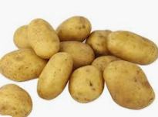
1 kilo de choufleur | 1€ | 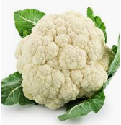
1 kilo de petits pois | 1€ | 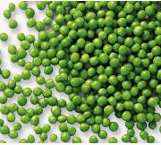
1 kilo de tomates | 1,50€ | 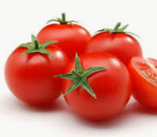
1 kilo de maïs | 1,50€ | 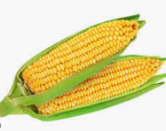
1kilo de carrottes | 0,5€ | 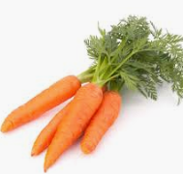
Un concombre (1 concombre) | 0,5€ | 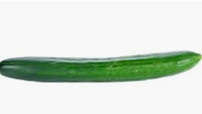
Write 2 dialogues of your own choosing different vegetables to buy.
Bonjour Madame / Monsieur
Bonjour Madame / Monsieur
Remember
Je voudrais = I would like
s’il vous plaît = please
c’est combien = how much
merci = thank you
voila = there you are

Je voudrais 2 kilos de carrottes et un concombre s’il vous plaît.
Voila!
Merci. C’est combien?
1.5€ s’il vous plait.
Voila.
Merci au revoir!
Au revoir!

