Robins Home Learning

This term our big enquiry question is ‘why is it good to be different?’

English (Reading)

In English we are going to be looking at fantasy stories that require us to use our imagination. I will share a story with you each week. These stories will come from Shaun Tan’s book ‘Tales From Outer Suburbia’.

The Water Buffalo
When I was a kid, there was a big water buffalo living in the vacant lot at the end of our street, the one with the grass no one ever mowed. He slept most of the time, and ignored everybody who walked past, unless we happened to stop and ask him for advice. Then he would come up to us slowly, raise his left hoof and literally point us in the right direction. But he never said what he was pointing at, or how far we had to go, or what we were supposed to do once we got there. In fact, he never said anything because water buffalos are like that; they hate talking.
This was too frustrating for most of us. By the time anyone thought to ‘consult the buffalo’, our problem was usually urgent and required a straightforward and immediate solution. Eventually we stopped visiting him altogether, and I think he went away some time after that: all we could see was long grass.
It’s a shame, really, because whenever we had followed his pointy hoof we’d always been surprised, relieved and delighted at what we found. And every time we’d said exactly the same thing – ‘How did he know?’.

Please complete the following tasks:

- Read this story aloud either to yourself or to someone else, focus on speaking really loudly and clearly, pausing for punctuation.

- Draw a picture of the buffalo as you imagine him, please then label your drawing using expanded noun phrases.

English (Writing)

Please complete the following tasks:

- Some people say that the water buffalo is a metaphor. Write down your ideas for what you think the buffalo is a metaphor for. Remember to explain your thinking.
- A metaphor is an example of figurative language. Figurative language helps the author to paint a picture in the mind of the reader. Research what other literary techniques are examples of figurative language, then write five of your own examples about the buffalo.
Maths

In Maths this week, we are going to be recapping our knowledge of how to calculate area and perimeter and properties of 2D and 3D shapes. Remember to keep practising your times tables on Purple Mash and Times Table Rockstars.

Please complete the following tasks:

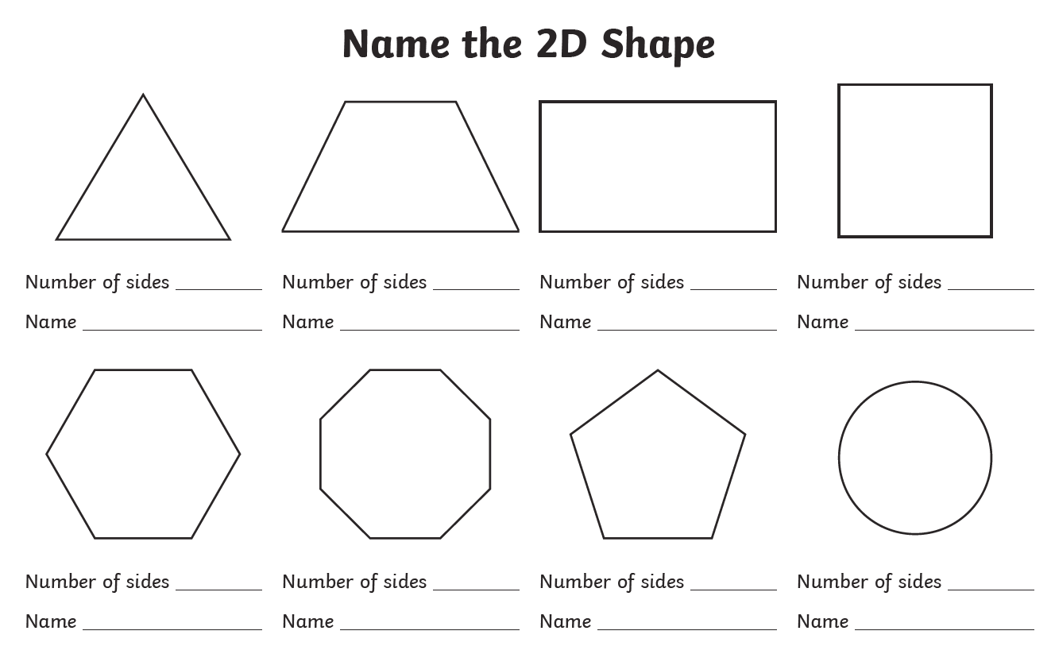
1)

2) Have a look at these different nets for 3D shapes (on the next two pages). Draw what you think the shape will look like when the net is put together and name it. Then cut out and put the net together to see if you were correct!

3) Have a go at the following sheets on area and perimeter. I have included a refresher sheet on how to solve area and perimeter problems to help you if you need it.
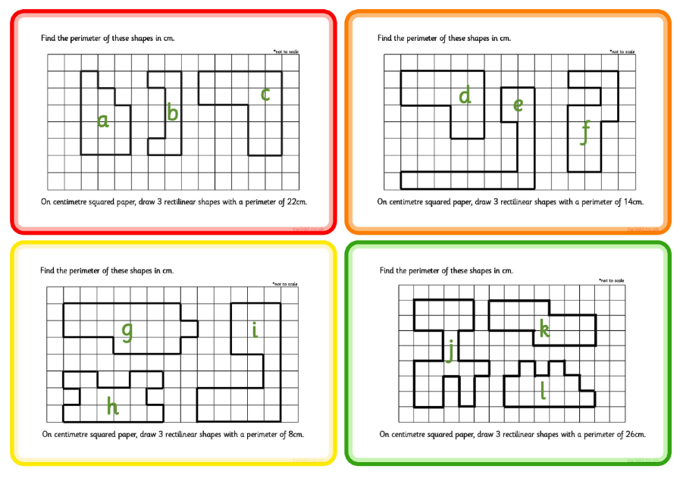
(Each square is 1cm)

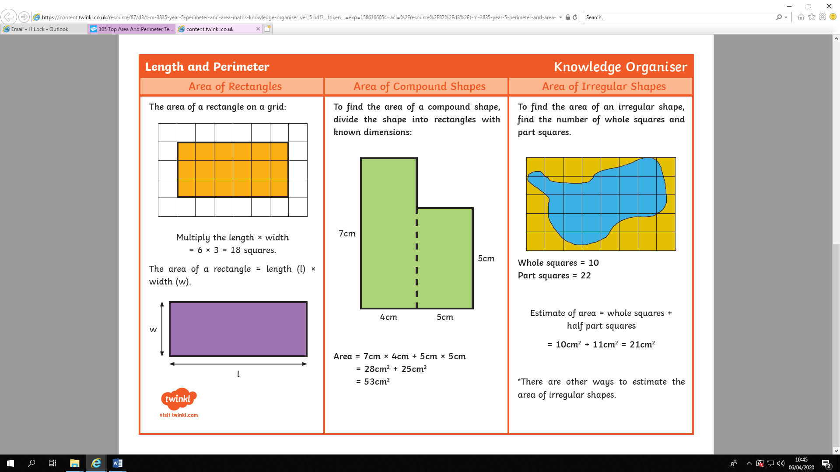
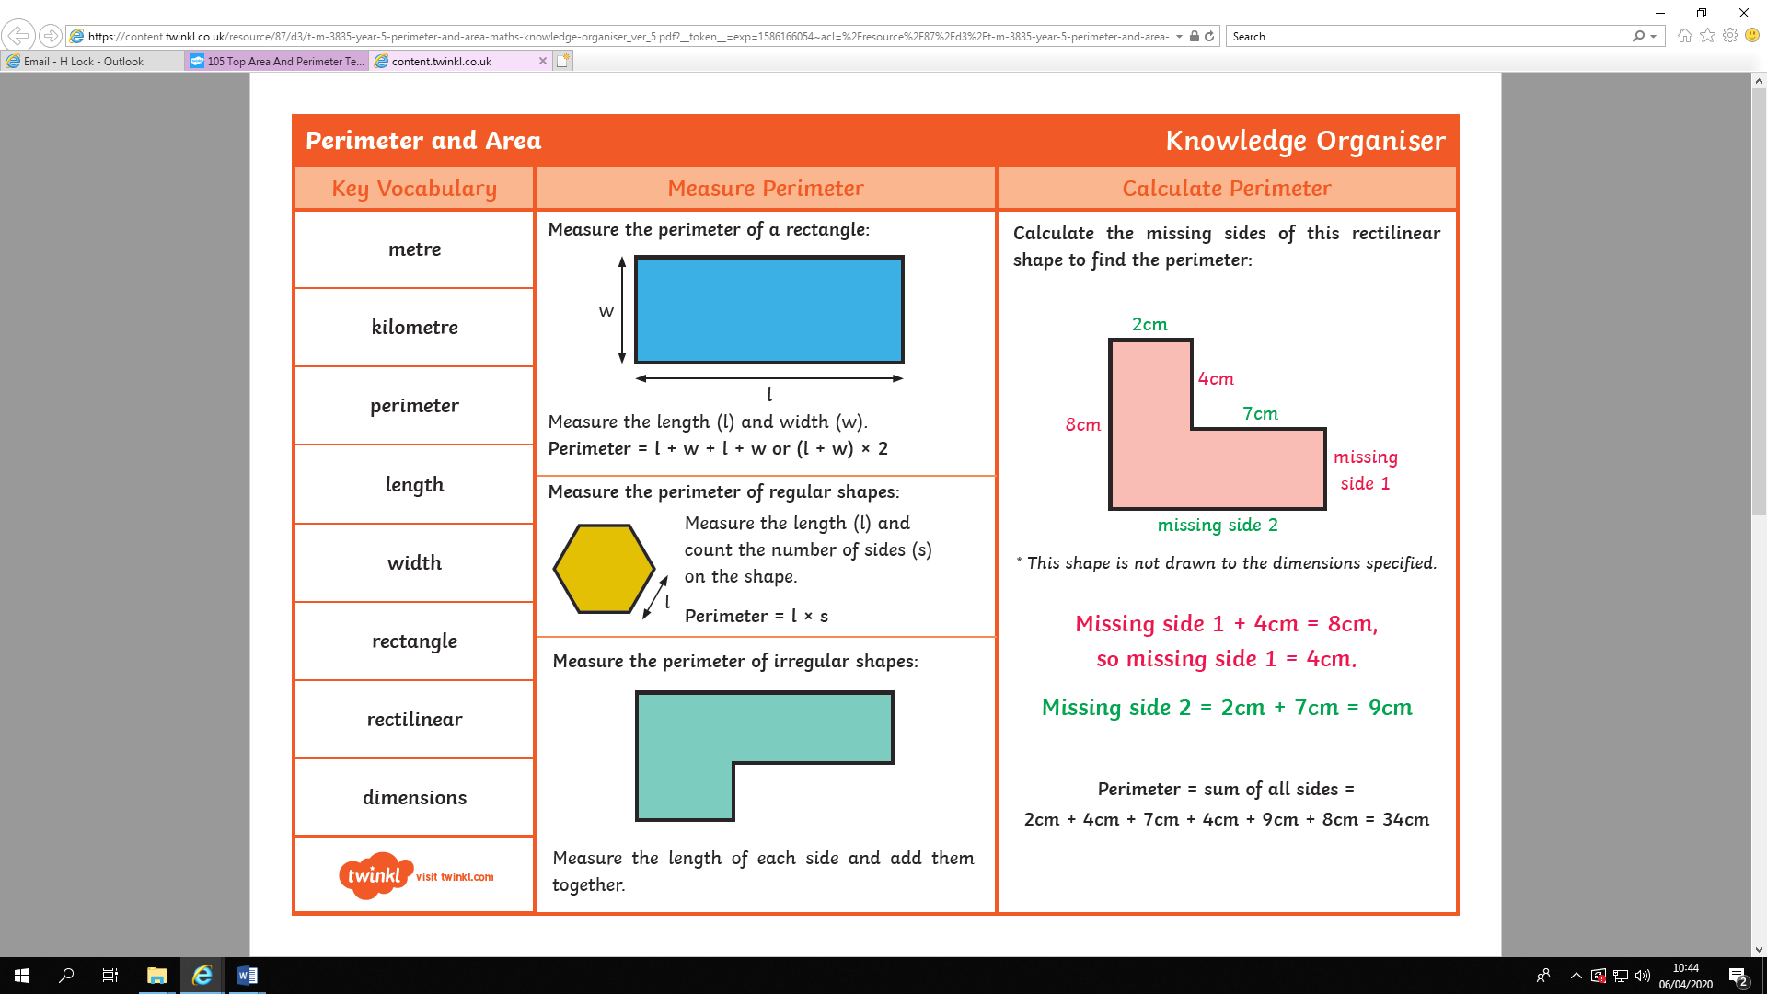
History

Please complete the following tasks:

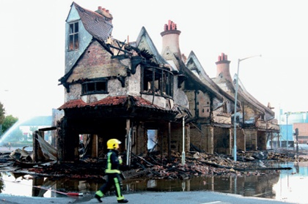
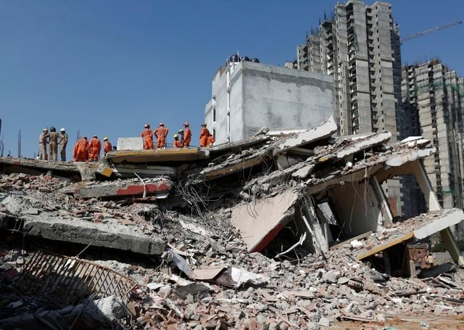
1) Look at the images below, write down the similarities and differences between them.
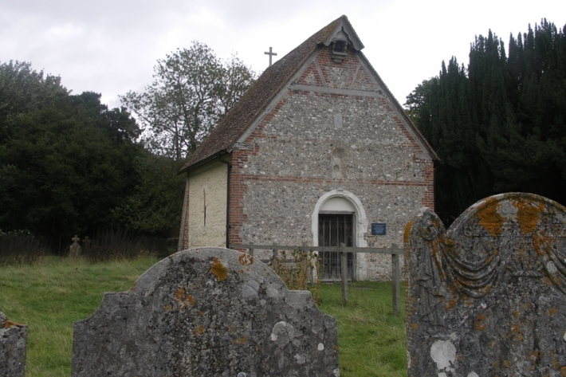
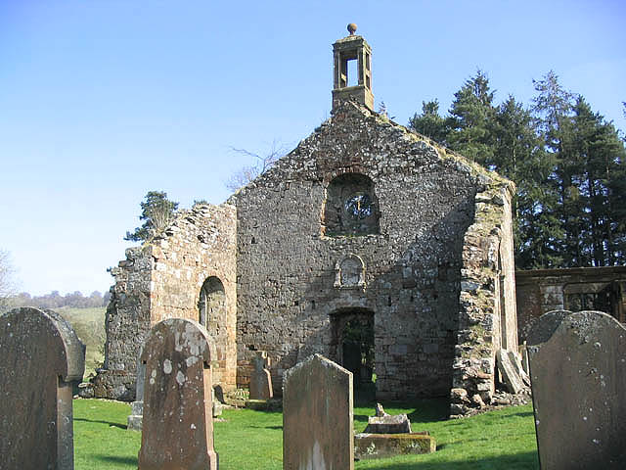

2) We are going to be completing a local study on the Ancient Church of Saint Mary the Virgin. Do you think this church is still used for worship today? Why? Why not? Write down your ideas.

3) Write down a list of questions you want to find out about this ancient church.

Science

In Science we are going to be looking at forces.

Please complete the following tasks:
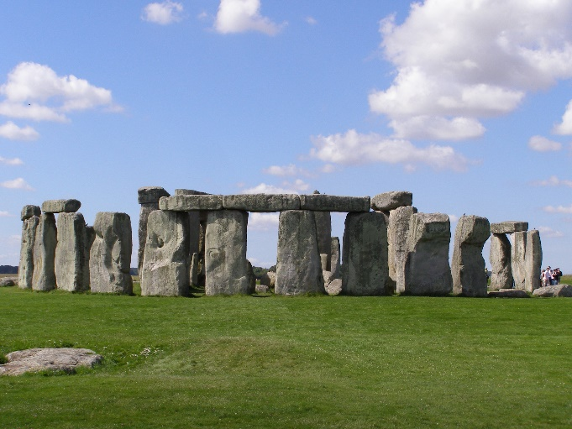

1) How did ancient people get these massive stones to stand on their ends? Write a few prediction sentences.

2) Archimedes once said ‘give me a lever long enough and a fulcrum on which to place it and I shall move the world’. Write down what you think this quote means. How can a lever help us to move something as heavy as the Earth?

3) Gears pulleys and levers can reduce the force needed to make things move. You are going to investigate how levers do this. Use a kitchen roll tube as a fulcrum and a ruler as a lever. Using a weight on one end of the ruler investigate how moving the fulcrum (to give a longer or shorter lever), affects the amount of weight and force needed to lift the weight. Record your findings and write down all of your ideas.

4) Write a conclusion. What did your results show? Does this change your mind on your earlier prediction of how ancient people got massive stones to stand on their ends?

Here is an example of a lever and fulcrum you can make, using things you might have in your recycling bin!

Computing

In computing we are looking at effective searching. Using Google have a go at finding the answers to the following questions. Record them on this sheet. Please also check Purple Mash for tasks.
PSHE

In PSHE we are going to be exploring what it means to have healthy relationships with others.

Please complete the following tasks:

1) Have a look at the picture below. Make a list of things you can control in your life and things that you cannot. (Some examples might be what you learn at school, what clothes you wear, whether you get your ears pierced, how you spend your pocket money).

2) We’re going to focus on the word consent. Use a dictionary to research what it means and write the definition down.

3) Look at the following pictures and discuss them with an adult. Talk about why consent is important.
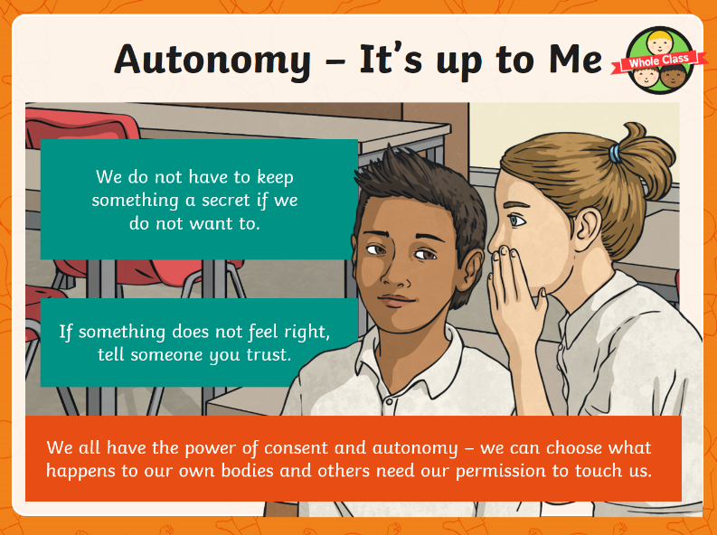
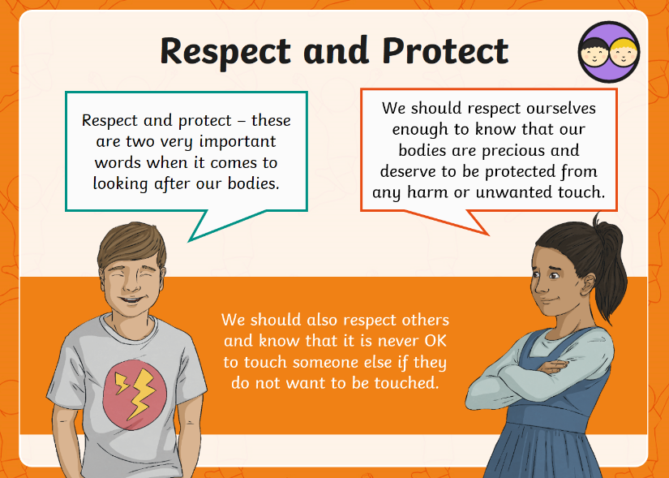
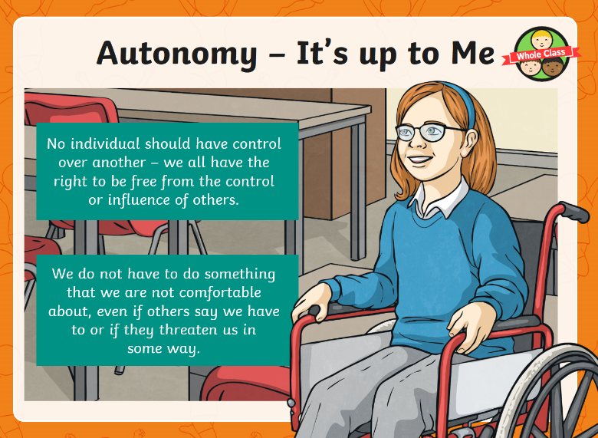
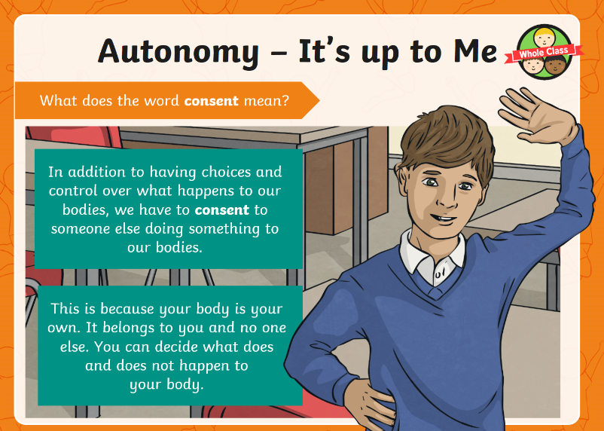
4) Talk about the following scenarios with a trusted adult. For each scenario try to think about these questions:

- Who is not being treating with respect?
- Who does not feel safe?
- -Who is being harmed?
- What can be done to protect the person who is being harmed?
- What rights does the person have?
- Who could help the person who is being harmed?
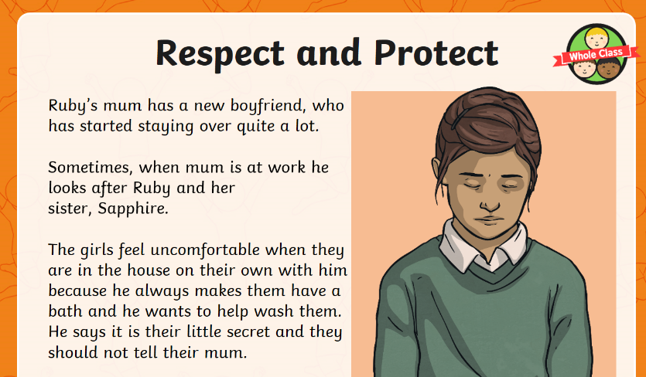

Religious Education

Please complete the following tasks:

Our topic this half term is pilgrimage.

1) Look up the meaning of the word pilgrimage and write a definition in your books.

2) Research one pilgrimage in each religion (two pilgrimages in total). You may present your research however you choose.

CHRISTIANITY: Pilgrimages to Lourdes, Vezelay or Santiago de Compostela

HINDUISM: Pilgrimages to The River Ganges or Varanasi

