Robin’s Home Learning Work

Maths

Please complete the following tasks.

1. Continue to practise your times tables on Times Table Rockstars.

2. Please complete the following worksheets (on the next few pages). Please then rate how you found the worksheets using the smiley system (on some of the worksheets).

Please also check MyMaths for any set tasks.

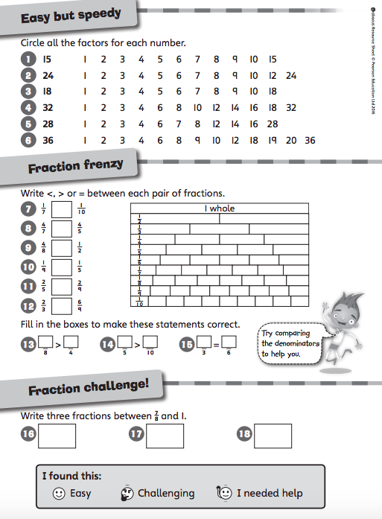

English – Writing

Please complete the following tasks.

1. Imagine that you are Darkus from Beetle Boy, you need to write a persuasive letter to the police persuading them to arrest Lucretia Cutter. Use everything we have learnt in this unit of work. Think about emotive language, conventions of letters, modal verbs and devices to build cohesion (first, next, then, etc.).

2. In a different colour pen please edit your letter. You should take a break in between writing your letter and editing it so that you are looking at it with fresh eyes. It might help to read it aloud to somebody. Remember to edit for capital letters, punctuation, spellings and word choices (adjectives).

English – Reading

Please complete the following tasks.

1. If you have not completed your story wings, complete at least one story wings task.

2. Choose a character from a book you are reading and use your inference skills to write a diary entry from their point of view for a particular event that happens in your story.

3. Make sure that you are reading to an adult at least twice a week and recording this in your reading record.

Geography

Please complete the following task.

1. Thinking about all the biomes we have studied (desert, tundra, rainforest and deciduous forest (England)), evaluate which biome you think is the easiest to live in for humans and why. You should write at least three paragraphs explaining your thinking. Why is this biome the easiest for humans to live in? How have humans adapted to live in this biome? Are there any difficulties in living in this biome? What makes living in the other biomes more difficult?

Food Technology

Please complete the following task.

1. Design a short presentation (no more than five minutes) to persuade potential customers to buy your healthy snack (you might want to use PowerPoint).

ICT

Please complete the following task.

1. Please check Purple Mash using your log-in for any 2-Dos.

RE

Please complete the following task.

1. Create an instructive leaflet for what to do in Lent, from Shrove Tuesday to Holy Week. This should include the importance of Lent to Christians, i.e. fasting helps Christians to focus on thinking and feel closer to God.

2. Identify a problem, something you do / don’t do that is wrong or affect others. Think about what action you could and will realistically do to alleviate the problems. Then, think about what will the result affecting you and others around you be?

Useful Websites

Maths

https://ttrockstars.com/

https://www.topmarks.co.uk/maths-games/hit-the-button

Spelling

https://www.topmarks.co.uk/english-games/7-11-years/spelling-and-grammar

https://www.purplemash.com/sch/preston-rg25

Science

https://www.scienceabc.com/nature/how-do-plants-reproduce.html

https://www.bbc.co.uk/bitesize/guides/zykp34j/revision/1

https://www.bbc.co.uk/bitesize/topics/zgssgk7/articles/zqbcxfr

Geography

https://www.bbc.co.uk/bitesize/guides/zpkbp39/revision/1

https://www.bbc.co.uk/bitesize/topics/z849q6f/articles/zvsp92p

https://earthobservatory.nasa.gov/experiments/biome/biotundra.php

https://www.nationalgeographic.com/environment/habitats/tundra-biome/

