Robins Home Learning Week Four

English – Reading

Undertow – Shaun Tan

The house at number seventeen was only ever mentioned with lowered voices by the neighbours. They knew well the frequent sounds of shouting, slamming doors and crashing objects. But one sultry summer night, something else happened, something far more interesting: the appearance of a large marine animal on the front lawn.
By midmorning, all the neighbours had spotted this mysterious, gently breathing creature. Naturally, they gathered around for a better look.
‘It’s a dugong,’ said a small boy. ‘The dugong is a rare and endangered plant-eating mammal that lives in the Indian Ocean, of the order Sirenia, family Dugongidae, genus dugong, spcies D.dugong.’
None of which explained how it came to be in their street, at least four kilometres from the nearest beach. In any case, the neighbours were far more concerned with attending to the stranded animal using buckets, hoses and wet blankets, just as they had seen whale-recuers do on TV.
When the young couple who lived at number seventeen finally emerged to survey the scene, bleary-eyed and confused, their immediate impulse was towards anger and recrimination. ‘It this your ideas of a JOKE?’ they shouted at each other, and at some of the neighbours as well. But this soon gave way to silent bewilderment when challenged by the sheer absurdity of the situation. There was nothing for them to do but assist the rescue effort by turning on the front sprinklers and calling an appropriate emergency service, if such a thing existed (a matter they debated at some length, impatiently grabbing the phone from each other’s hands).
While waiting for the experts, the neighbours took turns to pat and reassure the dugong, speaking to its slowly blinking eye – which struck each of them as being filled with deep sadness – and putting an ear against its warm wet hide to hear something very low and far away, but otherwise indescribable.
The arrival of the rescue truck was almost an unwelcome interruption, with flashing orange lights and council workers in bright yellow overalls ordering everyone to stand back. Their efficiency was impressive: they even had a special kind of hoist and a bath just big enough to comfortably hold a good-sized sea-going mammal. In a matter of minutes, they had loaded the dugong into the vehicle and driven away, as if they dealt with this sort of problem all the time.
Later that evening the neighbours switched impatiently between news channels to see if there was any mention of the dugong and, when there wasn’t, concluded that the whole event was possible not as remarkable as they had originally thought.

Please complete the following tasks:

1) Shaun Tan said that he likes to write in the fantasy genre because he can compare and contrast ‘the mundane (boring) with the extraordinary’. Write a list of all the ‘extraordinary’ events that happen in Undertow. Do you think that the front garden of a house on a quiet street is a good setting for these events? Why? Why not? In what setting might you expect these extraordinary events to occur?

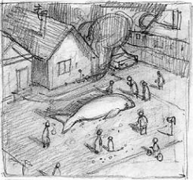
2) Each story in Shaun Tan’s book was inspired by a sketch. Here is the sketch for Undertow. You can see that his setting of a quiet street is ‘mundane’, and the dugong is ‘extraordinary’.

Please sketch out your own ‘mundane’ setting and add something ‘extraordinary’ to it. Then use some adjectives to label and describe both your setting and your ‘extraordinary’ thing.

English – Writing

Please complete the following tasks:

1) Underline the nouns, adjectives and adverbs in these sentences:

a) The black cat walked slowly down the road.
b) The red car sped down the road.
c) The quiet teacher suddenly chased a dog.
d) In the garden there were lots of pretty flowers.
e) The rubbish football team were playing badly.

2) Using these nouns, adjectives and adverbs, write five of your own sentences.

Maths

Please complete the following tasks:

This week in Maths we are looking at co-ordinates. We can use co-ordinates to help us plot, translate and reflect shapes on a grid. We will be using a two-quadrant grid like this one.
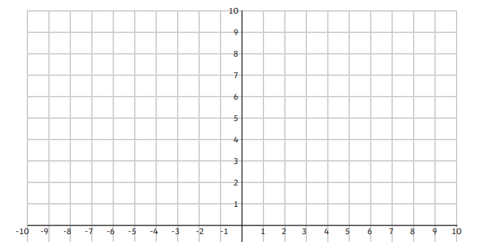
A
B
C
D

I have plotted a rectangle on this grid and want to know its co-ordinates for each corner.
To work out the co-ordinates you read the x-axis (horizontal) and then the y-axis (vertical). When we write co-ordinates, we put them inside brackets and separate them with a comma. So, the co-ordinates for A would be (-5,8).

1) Write down the co-ordinates for B, C and D.

2) Using the blank two-quadrant grid, draw your own rectangle and write out the co-ordinates.
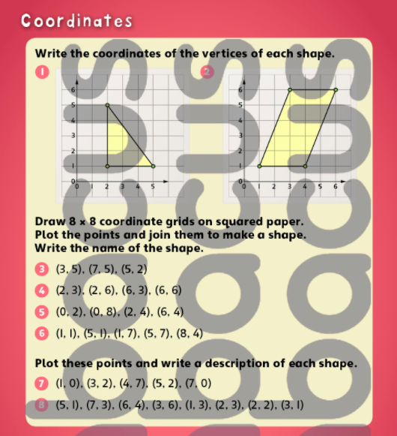
3) Complete the following sheet on squared paper.

4) The co-ordinates of my square are A (-3,8), B (3,8), C (-3,2) and D (3,2).
If I moved my shape, three squares to the left the new co-ordinate for A would be (-6,8). This is called a translation. Work out the new co-ordinates for B, C and D.
A
B
C
D

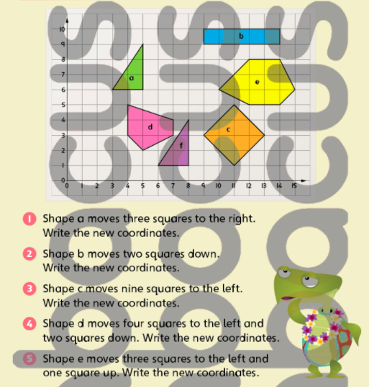
5) Complete this sheet on translations.

6) Now we are going to learn how to reflect a shape on a two-quadrant grid.
The co-ordinates of my shape are A (2,9), B (3,9), C (2,3), D (4,3), E (4,4) and F (3,4).
I have reflected my shape on the y-axis. The new co-ordinate for point A is (-2,9).
Write the new co-ordinates for B, C, D, E, and F.
A
B
C
D
E
F
A

7) Complete this sheet on reflections.

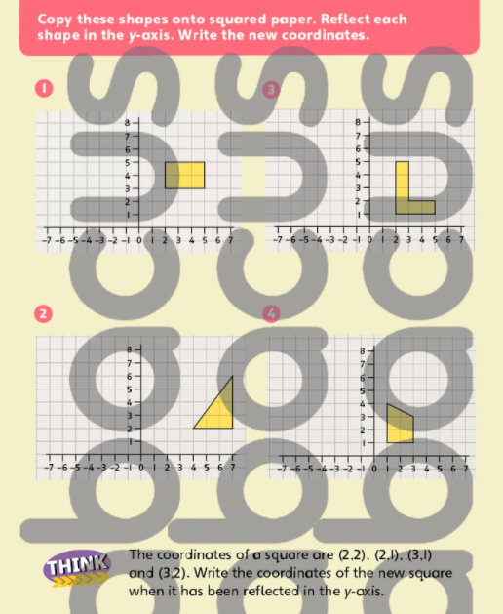

Science

Please complete the following tasks:

This week we are looking at the force of friction.

1) Look up a definition for friction and write it in your books.

2) Put a sock on one foot. Try and drag your foot over a carpet. How does it feel? Did it move easily or was it tricky? Then repeat this on a wooden or tiled floor. Which was the easier surface to slide your foot over? Thinking about the definition of friction, write a short paragraph explaining why you think this is.

3) Using your foot (with a sock on) or an object, choose five different surfaces around your house. These could be carpet, wood, grass, gravel, plastic, etc. Using the same amount of force, drag your foot or your object over each surface three times. Which surface was the easiest to drag something over? Which was the most difficult? You may present your findings however you wish.

4) Using your findings write a short prediction to the following question (remember to use scientific vocabulary):

‘In a race, would a balloon being blown along a lubricated string beat a balloon being blown along a non-lubricated string?’

History

Please complete the following tasks:

1) Using the following definitions, label this blueprint of a church.
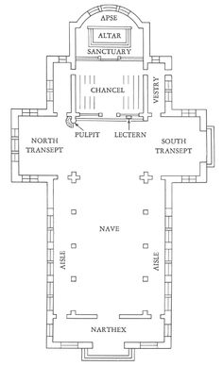

a) NAVE - The nave is the area of the church where parishioners, or members of the church, sit or stand.

b) AISLE – along the edge of the nave

c) ALTAR – a structure where offerings are made for religious purposes.

d) CHANCEL – the part of a church near the altar where the choir sits.

e) SANCTUARY – the space where the alter is kept.

f) APSE – the round hemi-spherical part of the church (always in the East).

g) PULPIT – a raised or enclosed platform where the preacher delivers his sermon.

h) NORTH TRANSEPT – the area of a cruciform church lying at right angles to the principal axis in the North.

i) SOUTH TRANSEPT – the area of a cruciform church lying at right angles to the principal axis in the South.
2) When the Ancient Church of St. Mary the Virgin was knocked down, the chancel was left standing (it is the only part of the Ancient Church still standing today). Why do you think this is?

French

Please complete the following tasks:

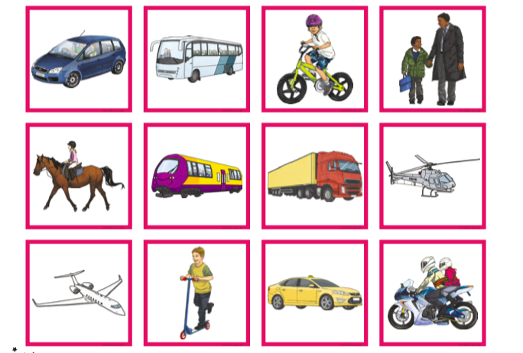
1) Using a French dictionary match these picture cards with the correct French vocabulary card. You can use the Collins online French dictionary (https://www.collinsdictionary.com/dictionary/english-french)
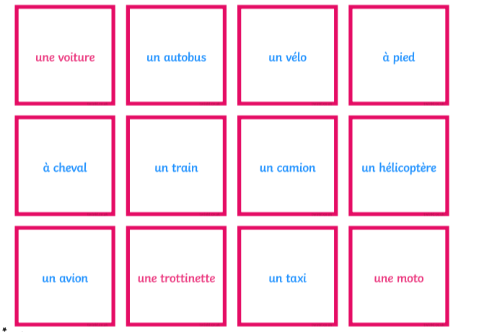

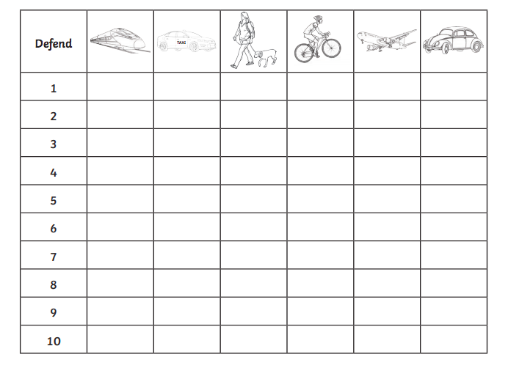
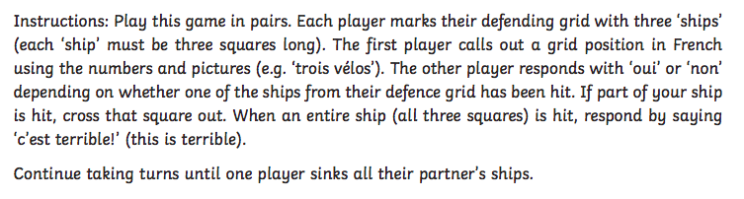
2) Following these instructions play French transport battleship with a partner.

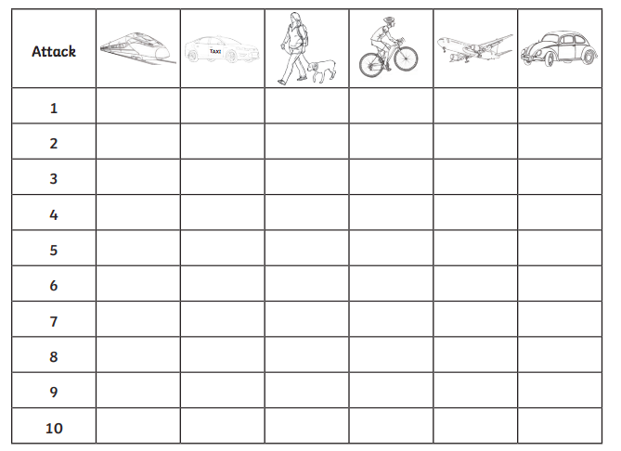

Art

Please complete the following tasks:

1) In Art this term we are looking at the Cubism movement, specifically the work of Pablo Picasso. Please use the internet to create a poster all about Pablo Picasso and Cubism.
Here are some key questions to think about:
a) What is Cubism?
b) Find some examples of Pablo Picasso’s work (his portraits are great!), what do you like or dislike about it? How is it different from other artists?
c) Who was Pablo Picasso? When was he born? Which country is he from?
d) What are the key ‘rules’ for creating a piece of Cubist artwork?
e) How does Pablo Picasso use colour? Is it bold block or small faded lines?

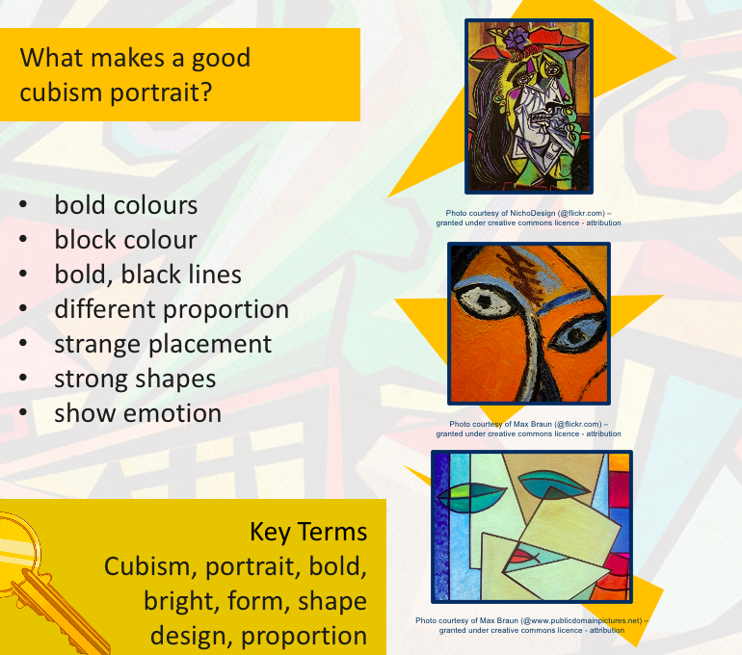
If you do not have access to the internet, please use the two resources below.

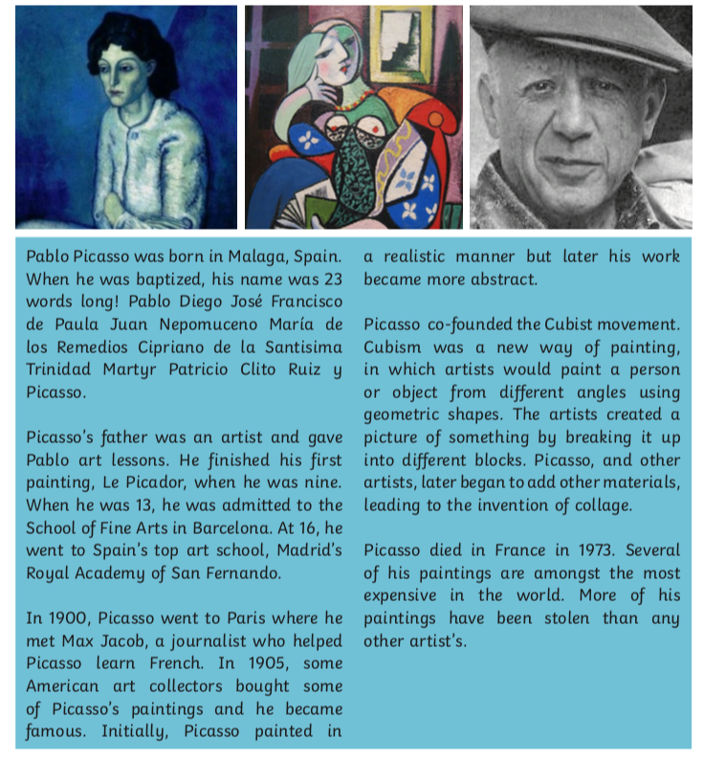

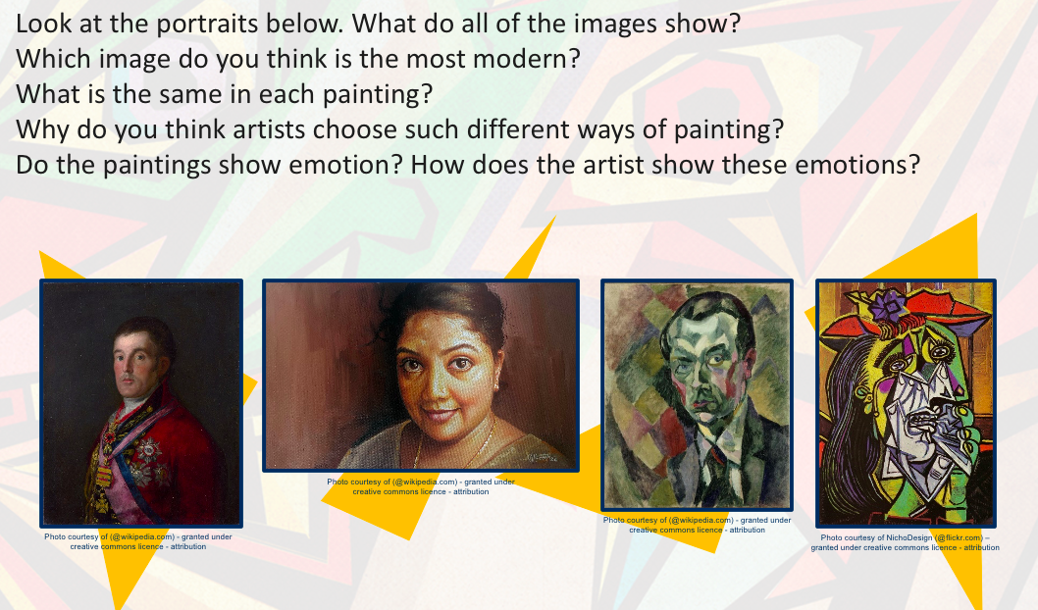
2) Complete the following sheet.

3) How many different ways can you use a pencil to create a different mark on a piece of paper? Create as many different kinds of marks as possible, think about texture, size and tone.
Challenge: what about with paint and a paintbrush?

