Home Learning – Puffins – Week 11
Hi Puffins,
I hope you and your families are all keeping safe and well. Here is the home learning for week 11. The sheets from this pack can be stuck into homework books if you wish.
Update: We are currently planning a way to gather homework books in school so I can mark and return them, further details will follow. I am very much looking forward to seeing all your hard work and lovely pieces of home learning.

Purple Mash 2Dos:
Phonics – wh, ph (click the speaker to sing along with Miss Chandler)
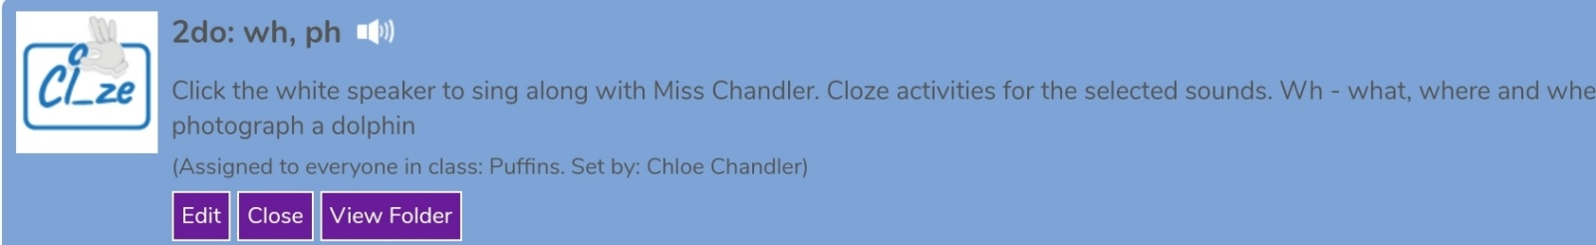

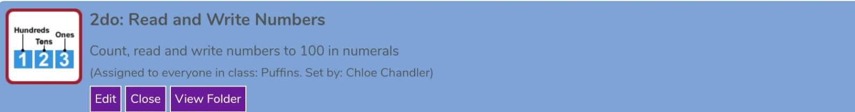
Maths – Number Knowledge (Reading and writing numbers to 100)

Maths – Number Knowledge
BBC Bitesize (Place Value): https://www.bbc.co.uk/bitesize/topics/z8sfr82/articles/zw4g2nb
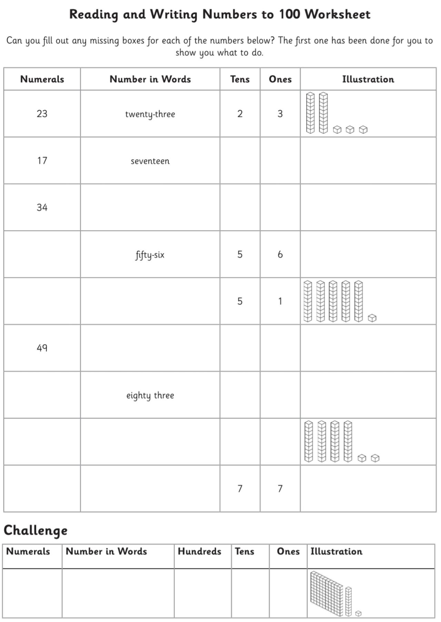
Read and Write Numbers to 100 - Fill in the missing boxes
Addition Methods +
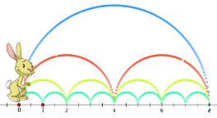
Choose a method to add and write in your homework book:
It may help to write the numeral underneath.

Add thirty-three and five ____________

Add forty and sixty ____________

Subtraction Methods -
 |  | 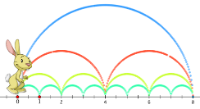 |  | 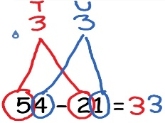
Choose a method to take away and write in your homework book:
It may help to write the numeral underneath.

You have twelve, subtract ten ___________

You have thirty, take away twenty-one ___________

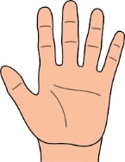
Multiplication Methods x

Choose a method to multiply and write in your homework book:
It may help to write the numeral underneath.

Multiply two by ten ____________

Multiply six by ten ____________

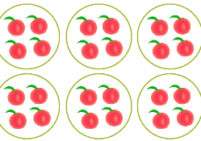
Division Methods how many in each group?

Choose a method to divide and write in your homework book:
It may help to write the numeral underneath.

Divide ten by five ______________

Divide ten by two _____________

English
Reading:
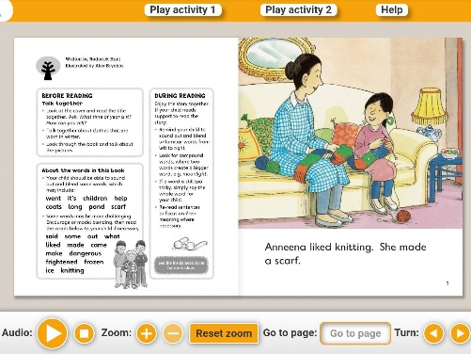
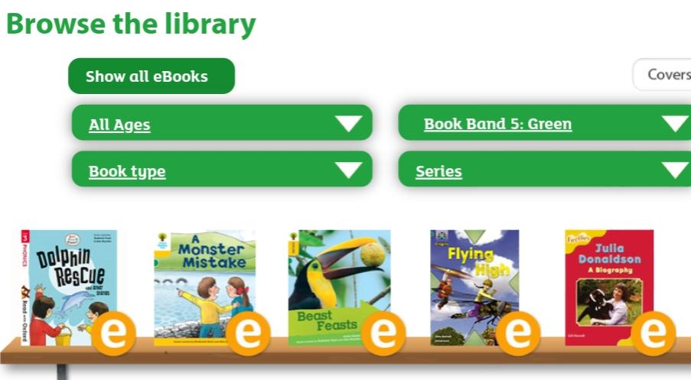
- Oxford Owls books https://www.oxfordowl.co.uk/for-home/find-a-book/library-page/
Filter by book band colour

- Phonics 2Do on Purple Mash
- Re-read sentences to practice fluency and expression
- Highlight phonic sounds when reading
- Ask/answer comprehension questions about a book
- Read books, magazines, shopping lists, signs, subtitles, recipes
- Phonic games and activities - www.phonicsplay.co.uk (phase 3-5 sounds).
Writing:
- Write spellings in sentences
- Remember: full stops, capital letters, finger spaces, handwriting
Spelling:
- Spellings – write in sentences
- Spellings – speed write (children have 1 minute to write one spelling word as many times as they can)
- Spellings – word search (template below)
Below are ALL the spellings for KS1. Please practice the highlighted words for this week.
KS1 Spellings
Year 1 Year 2
the  a  do  to  today  of  said  says  are  were  was  is  his  has  I  you  your  they  be  he  me  she | we  no  go  so  by  my  here  there  where  love  come  some  one  once  ask  friend  school  put  pull  full  house  our | door  floor  poor  because  find  kind  mind  behind  child  children  wild  climb  most  only  both  old  cold  gold  hold  every  everybody  even  great  break  steak  pretty  beautiful  after  fast  past  last | father  class  grass  pass  plant  path  bath  hour  move  prove  improve  sure  sugar  eye  could  would  should  who  whole  any  many  clothes  busy  people  water  again  half  money  Mr  Mrs  Parents  Christmas
UPDATE: Spelling Tests
Year 1: You will have a spelling test in school
Year 2: I will create weekly Spelling Test videos on Google Classroom.

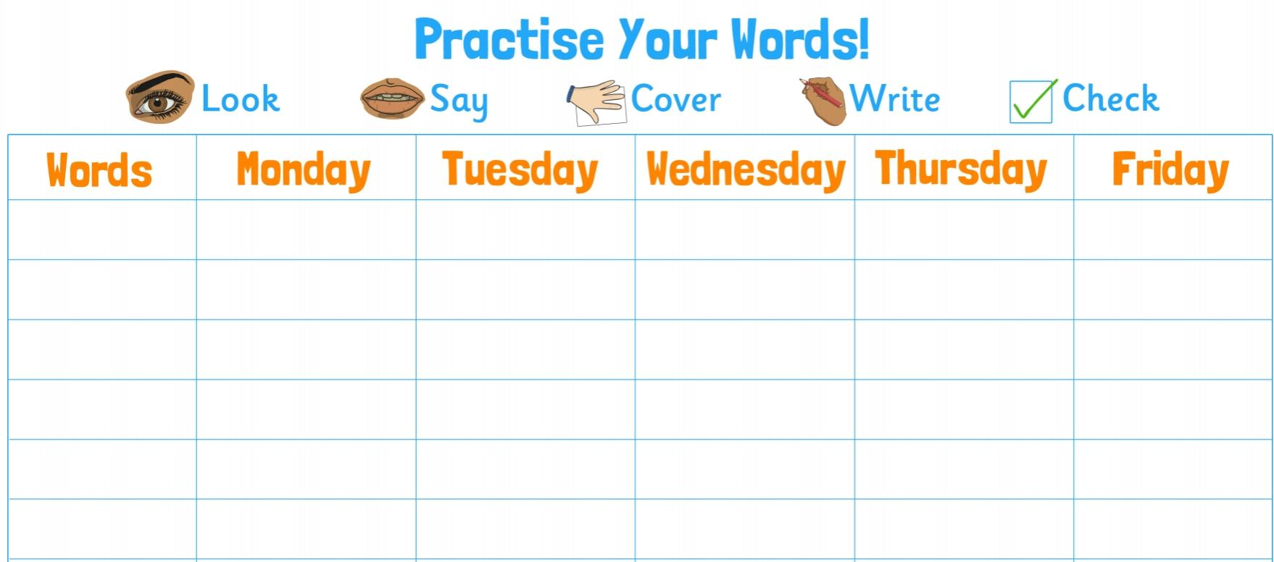

Blank word search for spellings:
My Words Search

Words hidden in my word search

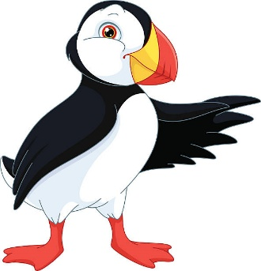
French/Geography – Human and Physical Features
Bonjour Puffins!
Bonjour Puffins!

Remember:
Human features: things built by people (humans)
Physical features: things that are natural
Here are some pictures of France. Cut and sort the human and physical features into the table below.
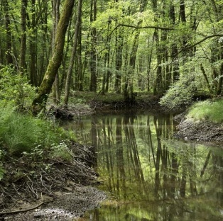

Forêt de Chaux Eiffel Tower Calais Beach
Notre Dame Cathedral French Alps Louvre Museum

Human Features | Physical Features

Useful websites

All Subject Areas:
www.purplemash.com
Support videos and daily lessons -https://www.bbc.co.uk/bitesize/primary
Online lessons - https://www.thenational.academy/online-classroom/
English:
Oxford Owl - https://www.oxfordowl.co.uk/for-home/find-a-book/library-page/
KS1 SATs - https://www.gov.uk/government/publications/key-stage-1-tests-2019-english-reading-test-materials
Phonics Revision - www.phonicsplay.co.uk
Maths:
KS1 SATs - https://www.gov.uk/government/publications/key-stage-1-tests-2019-mathematics-test-materials
Homework site - https://www.mymaths.co.uk/

