Home Learning – Puffins – Week 14
Hi Puffins,
I hope you and your families are all keeping safe and well. Here is the home learning for week 14. The sheets from this pack can be stuck into homework books if you wish.
Year 2: Please continue to check and complete the tasks on Google Classroom.

Purple Mash 2Dos:
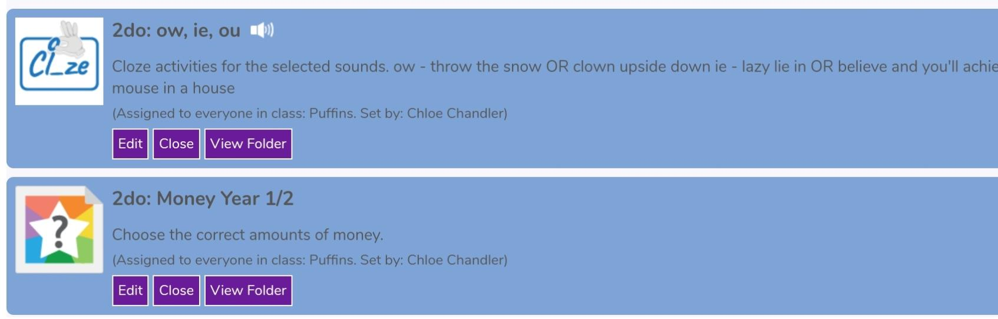
Phonics – ow, ie, ou (click the speaker to sing along with Miss Chandler)

Song of Sounds Stage 2: https://m.youtube.com/watch?v=6UQHdBMLk-M
Song of Sounds Stage 3: https://m.youtube.com/watch?v=Gwluz7yHW0g

Maths – Money Year 1/2

MyMaths Timetable
Week 11: Place Value tens and ones
Week 12: Number bonds to 10 and 20
Week 13: Commutativity: Multiplication
Week 14: Mixed Tables 2, 5, 10
Week 15: Patterns and Sequences
Maths – Money Tasks
Draw lines to match. BBC Bitesize (money): https://www.bbc.co.uk/bitesize/topics/zp8dmp3
10p

2p

5p

£1

1p

20p

£2

50p
Compare the values of money by writing in these symbols< > =
Remember:
76 < 89 15 > 6 90 = 90

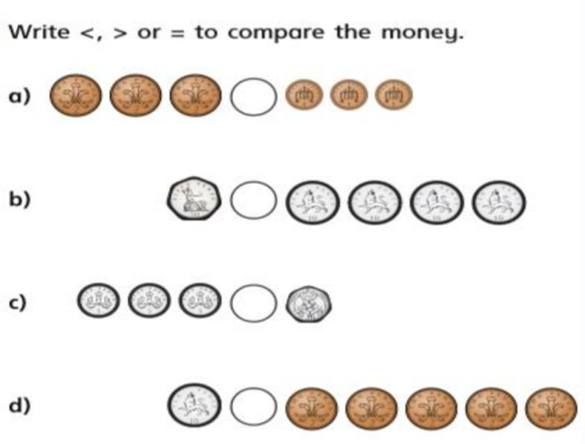

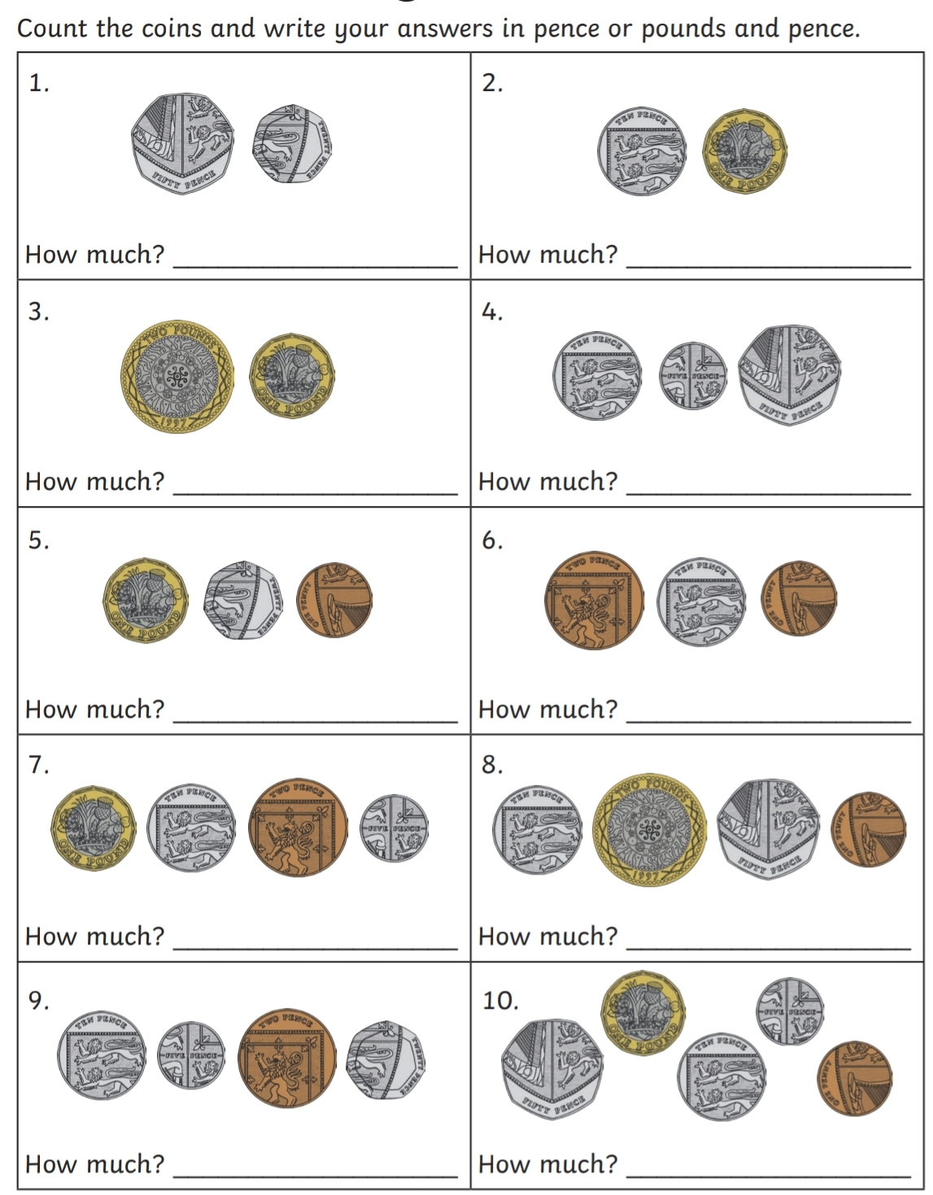
Add the coins and write your answer in pence OR pounds and pence.
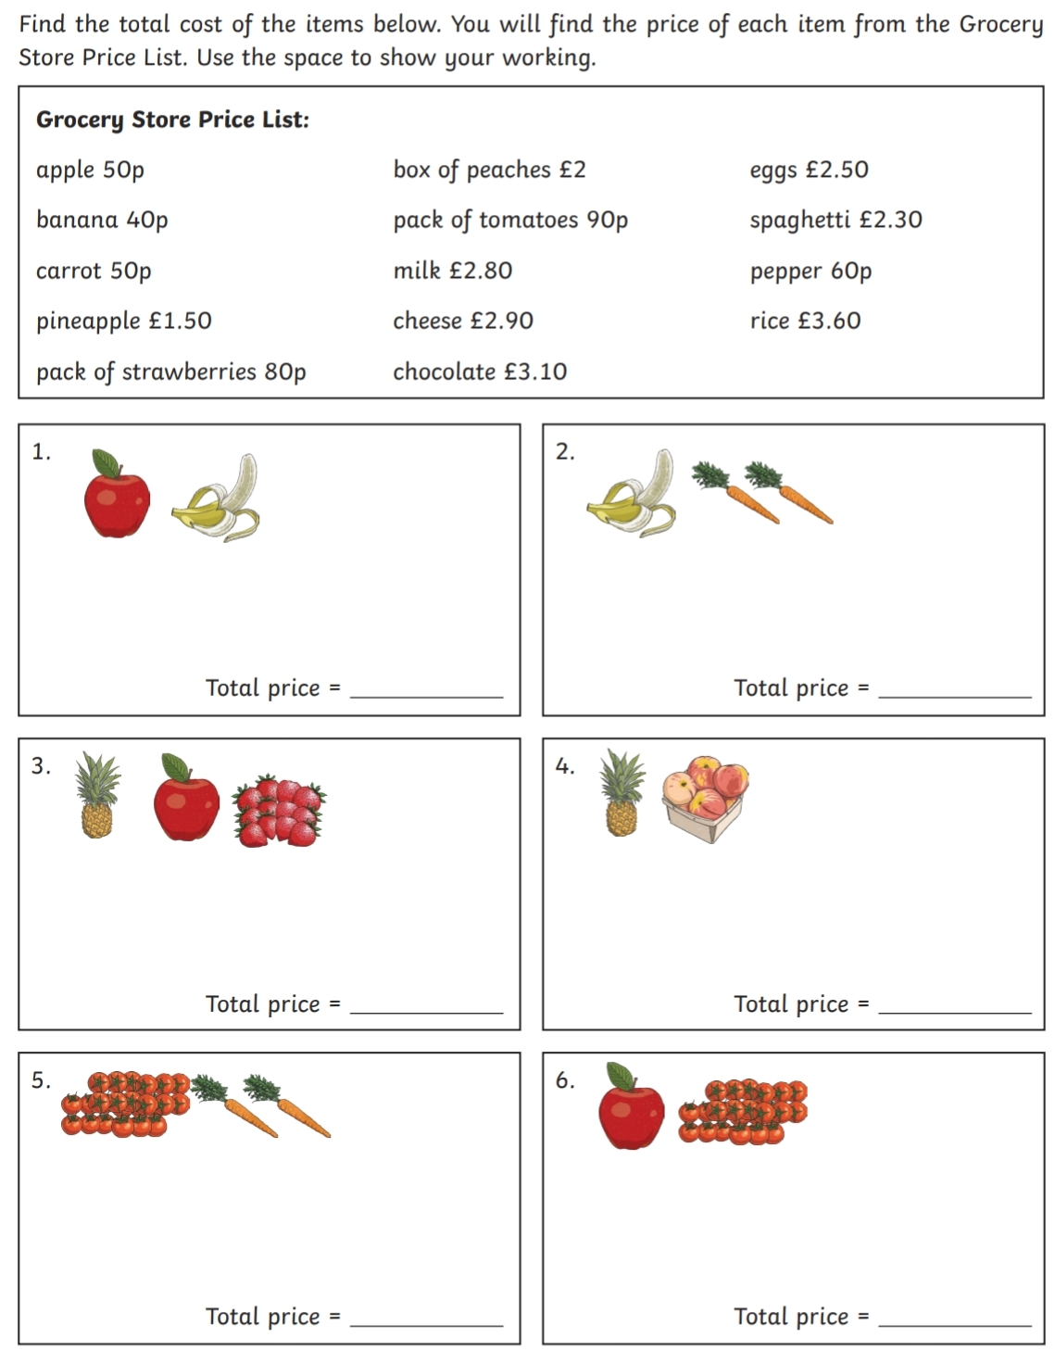
Challenge Task
Money Word Problem Cards (addition and subtraction)
1 star = easy 2 stars = medium 3 stars = challenge
Show your working next to each problem
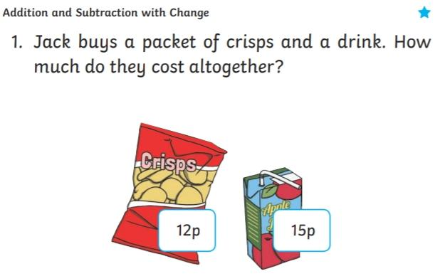
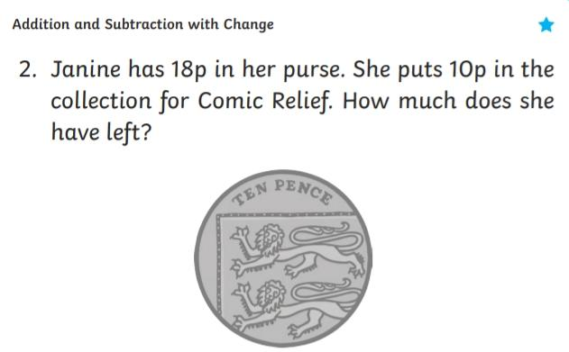
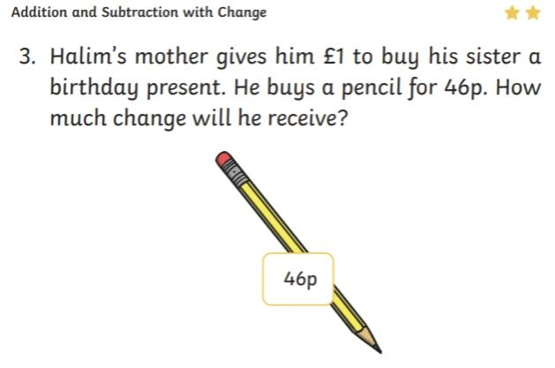
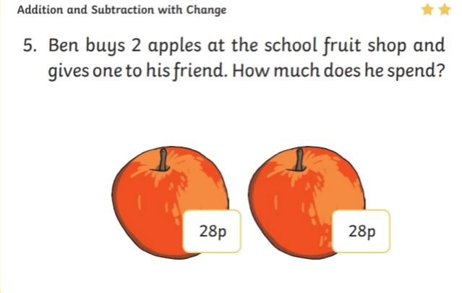
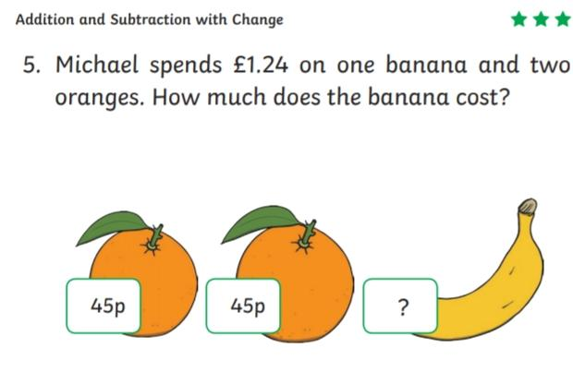
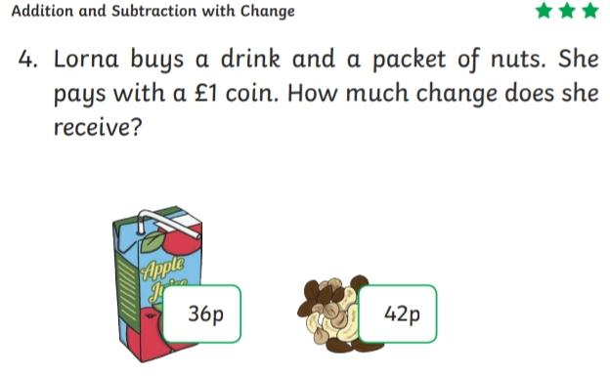

Relationship between x and ÷
Example: 6 x 2 = 12 as a division calculation is 12 ÷ 2 = 6
7 x 5 = 35 as a division calculation is ____________________
10 x 10 = 100 as a division calculation is ____________________
2 x 8 = 16 as a division calculation is ____________________
3 x 10 =30 as a division calculation is ____________________

English
Reading:
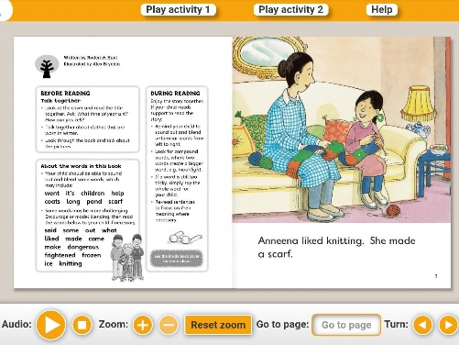
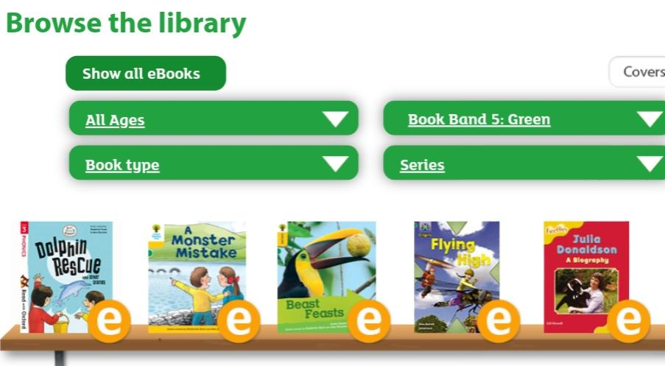
- Oxford Owl books https://www.oxfordowl.co.uk/for-home/find-a-book/library-page/
Filter by book band colour

- Phonics 2Do on Purple Mash
- Re-read sentences to practice fluency and expression
- Highlight phonic sounds when reading
- Ask/answer comprehension questions about a book
- Read books, magazines, shopping lists, signs, subtitles, recipes
- Phonic games and activities - www.phonicsplay.co.uk (phase 3-5 sounds).
Writing:
- Write spellings in sentences
- Remember: full stops, capital letters, finger spaces, handwriting
Spelling:
- Spellings – write in sentences
- Spellings – speed write (children have 1 minute to write one spelling word as many times as they can)
- Spellings – word search (template below)
Below are ALL the spellings for KS1. Please practice the highlighted words for this week.
KS1 Spellings
Year 1 Year 2
the  a  do  to  today  of  said  says  are  were  was  is  his  has  I  you  your  they  be  he  me  she | we  no  go  so  by  my  here  there  where  love  come  some  one  once  ask  friend  school  put  pull  full  house  our | door  floor  poor  because  find  kind  mind  behind  child  children  wild  climb  most  only  both  old  cold  gold  hold  every  everybody  even  great  break  steak  pretty  beautiful  after  fast  past  last | father  class  grass  pass  plant  path  bath  hour  move  prove  improve  sure  sugar  eye  could  would  should  who  whole  any  many  clothes  busy  people  water  again  half  money  Mr  Mrs  Parents  Christmas
Spelling Tests
Year 1: You will have a spelling test in school
Year 2: Weekly Spelling Test videos on Google Classroom.

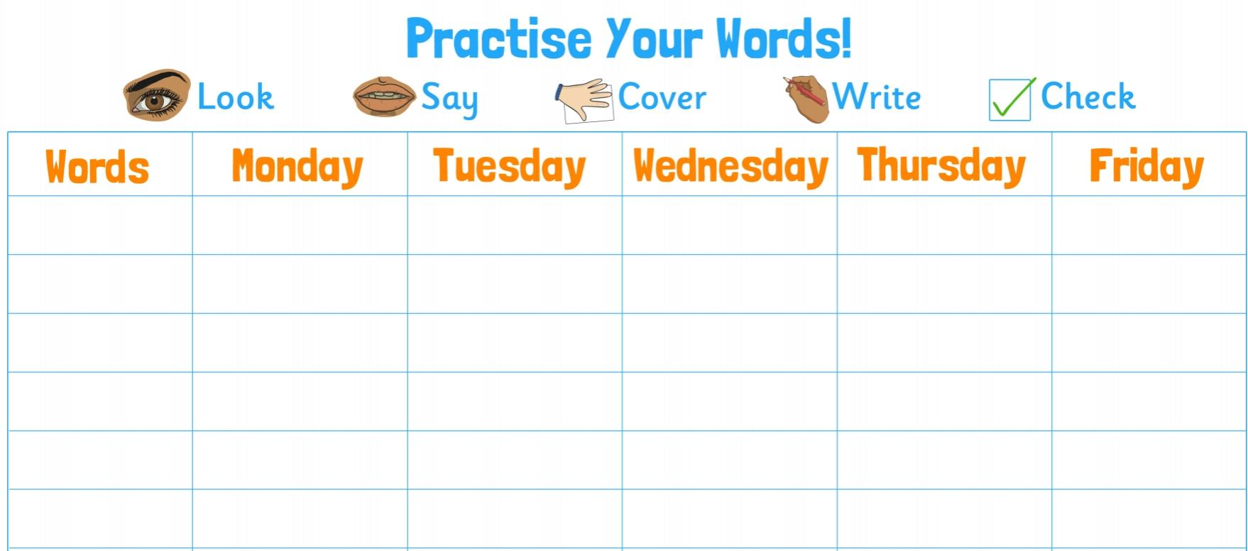

Blank word search for spellings:
My Words Search

Words hidden in my word search
Art – Me, Myself and I Project
It’s time to get creative!
You can use any form of media to create a piece of artwork that represents you or your feelings. You could use pen, pencil, paint, chalk, charcoal, pastel, crayon, markers, highlighter or anything else you think of. Here are some ideas to represent you:
- Draw a self portrait
- Digital self portrait (PopArt App)
- Picture/digital collage
- Sculpture (play-doh, clay, natural objects)
Here are some ideas to represent your feelings (use colours to represent your emotions eg, pastel colours = calm or relaxed. Bright colours = happy or excited. Dark colours = sadness or anger):
- Paper Collage
- Abstract painting
- Zen doodle
- Abstract photography
You can do more than one if you wish. You all know I love Art and so I am very excited to see all your wonderful creations either in your homework book, via email or uploaded to Google Classroom.
Ready, steady, CREATE!
Enjoy! From Miss Chandler

Here is what I have created:
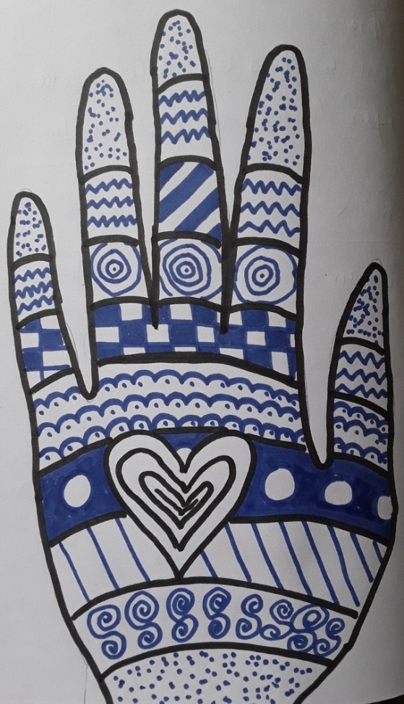
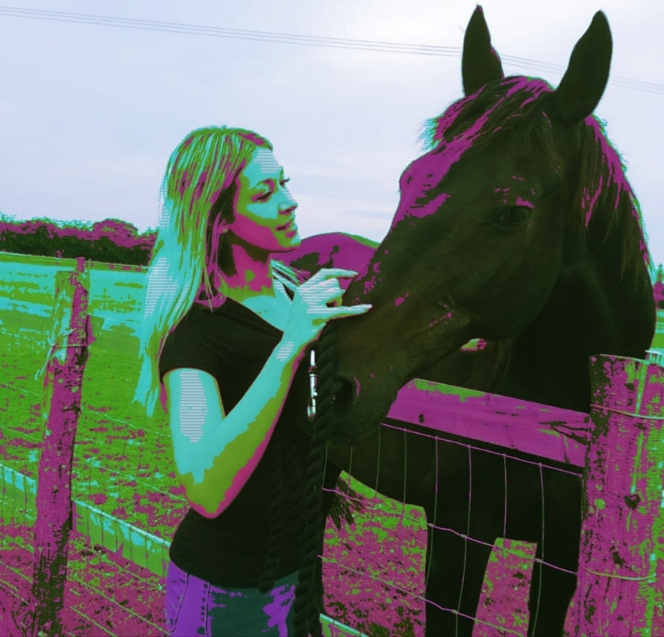
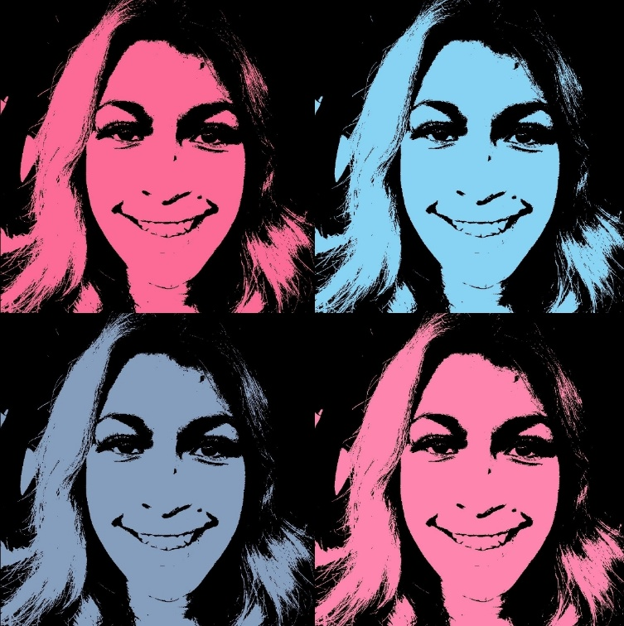
Me, Myself and I
Art Project

Useful websites

All Subject Areas:
www.purplemash.com
Support videos and daily lessons -https://www.bbc.co.uk/bitesize/primary
Online lessons - https://www.thenational.academy/online-classroom/
English:
Oxford Owl - https://www.oxfordowl.co.uk/for-home/find-a-book/library-page/
KS1 SATs - https://www.gov.uk/government/publications/key-stage-1-tests-2019-english-reading-test-materials
Phonics Revision - www.phonicsplay.co.uk
Maths:
KS1 SATs - https://www.gov.uk/government/publications/key-stage-1-tests-2019-mathematics-test-materials
Homework site - https://www.mymaths.co.uk/

